Australian Community Resettlement Program

Project Completion Report

WATER AND SANITATION FOR HEALTH-11

1. Basic Project Data

Project Water and Sanitation for Health II (WASH II)

Geographical coverage Batticaloa District

Target population 1,200 Households

Project implementation CARE Sri Lanka

Partner Organizations Paddipallai Development & Rehabilitation Organization Batticaloa, YMCA, Medical Officers of Health -Kaluwanchikudy and Eravur

Time frame January 2001- July 2002

Start up date 1st June 2001

Completion date 31st July 2002

Approved Budget LKR. 9,398,263.00

Actual cost of the project LKR 9,398,263.00

2. Map(s)

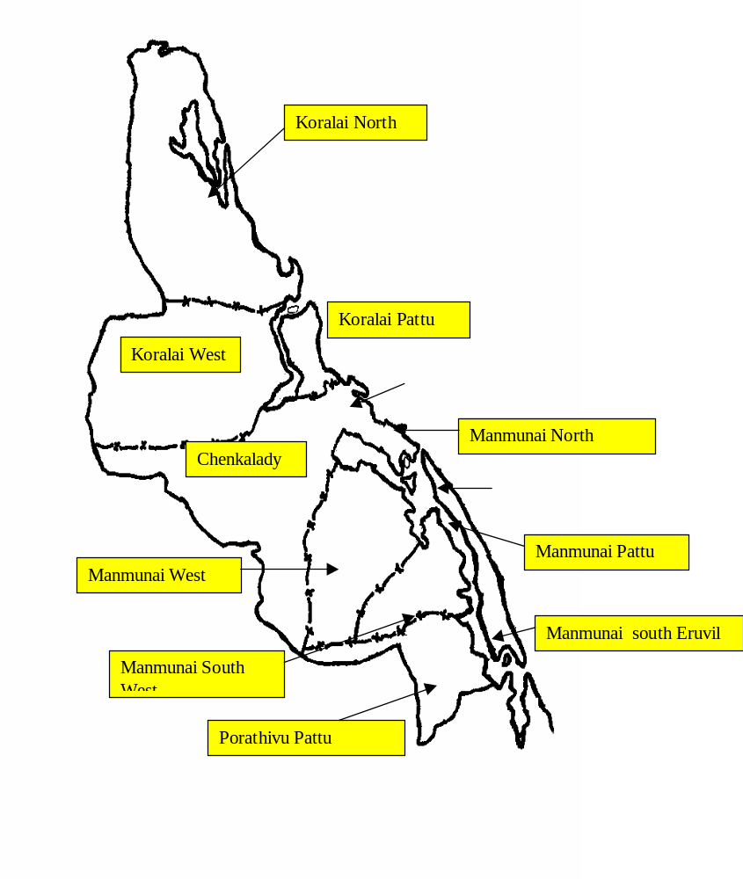
BATTICALOA DISTRICT MAP BY DIVISIONAL
SECRETARY DIVISIONS

INDEX

PROJECT AREAS

TOILETS

COMMON WELLS

SMALL WELLS

WATSAN GROUPS

Eravur
25

50
2

Kattankudy
75

100
3

10

3. Summary

The overall purpose of the Water and Sanitation for Health Project (WASH-II) was to decrease the incidence of water and excreta related diseases in 1200 households of the Batticaloa District over 18 months and support self-reliance by developing and strengthening durable community structures. The project was implemented in both ‘Cleared’ and ‘Uncleared’ areas of Batticaloa. (‘Cleared’ and ‘Uncleared’ are the colloquial terms. Cleared refers to government-held areas and Uncleared refers to a range of conditions from LTTE controlled to a situation of on-going conflict.)

A major component of the project was the construction of wells and toilets. It was envisaged in the project to construct 100 small diameter wells, 10 large diameter wells and 150 water seal latrines. More than 1200 households were expected to benefit from the new facilities.

The building of basic infrastructure was linked to a health and hygiene education program. The WASH 11 Project trained 30 community health volunteers to run information campaigns that promote better hygiene practices, such as encouraging children to wash their hands both after using the latrine and before eating.

The communities were identified based on the principles of greatest need, feasibility and demand. The new infrastructure will be managed and maintained by community members. The project staff helped each community to establish Water and Sanitation User Groups and trained the group members on their roles and responsibilities. In all 5 Water and Sanitation User Groups were formed. Establishing WSUGs had dual purpose. Bringing people together around common resources helps to re-establish some of the lost sense of community which promotes underlying CARE goal of improving community cohesion.

While the project is intended to benefit both men and women in the participating communities, WASH 11 placed particular emphasis on reducing the workload of women. The responsibility for collecting water traditionally falls to women or girls. Before the project undertook any interventions, project staff looked into the needs of the people of the area, paying particular attention to the distance between a village and the nearest water source. Furthermore, women are usually the main caretakers in a household, which means their workload is increased when children fall sick. Community participation in the project and community management of the new infrastructure was the vital components of the project strategy. While being sensitive to women’s workload, WASH 11 encouraged women’s participation in Water and sanitation groups.

As envisaged in the design objectives, infrastructure construction of 100 small diameter wells, 10 large diameter wells and 150 individual water-seallatrines were completed successfully.

4. Project Description

Batticaloa district in the East of Sri Lanka is one of the areas at the center of Sri Lanka’s on-going conflict. Regular military action in the area has badly damaged infrastructure. Only 20% of the households in Batticaloa have access to clean water and latrines. The most affected are children and women. The responsibility of fetching water in these communities lies with young women who have to walk an approximate average of 1 to 2 kilometers a day for potable water.

Of all the villages in the Batticaloa district, Manmunai South West and Eravur Town Divisional Secretaries divisions were the most affected. The water and sanitation problem in these areas is very acute. The incidence of oral-fecal pollution in these areas is very high resulting in the increasing trend in the incidence of water and excreta- related diseases.

This project was implemented with a view to bring down the incidence of diarrhea in the children less than 5 years by 50%. It was envisaged in the project to build infrastructure to increase the availability and access and use of safe water and sanitation facilities. The provision of facilities alone will not serve the desired purpose. Therefore the hardware part of the project was linked to software where educational activities concerning health promotion were undertaken as an important integral component of the project. In all 30 community health volunteers were selected and trained from 5 villages where project was implemented. The volunteers were trained on Primary Health Care including environmental sanitation and Family Health. After the training, the volunteers began to communicate hygiene promotion messages and work with other community residents and households to solve hygiene and sanitation problems. Rather than promoting a large number of ‘improved’ behaviors, volunteers identified those behaviors most strongly associated with water borne diseases and diarrhea in children and targeted these priority behaviors with locally appropriate interventions.

In addition, CARE facilitated formation of Water and Sanitation User Committees to ensure sustainability of the program. The WSUGs will also increase the participation of the community in managing a community resource. A baseline survey was also conducted to gather information on the households and their communities for documentation of existing knowledge, attitudes and practices related to water, sanitation and hygiene. A series of planning meetings were also conducted with the communities and the other stakeholders to identify water and sanitation needs and select sites and choose appropriate technologies. In the selection of sites for the construction of wells and toilets, CARE sought the assistance of the Public Health Inspectors who visited the households with the project staff and identified suitable sites for construction. It was ensured that required distance between the well and toilet was maintained to avoid underground pollution.

Attention was also paid in this project to identify suitable partners and relevant counterparts and to train them on Institutional Development and Organizational Strengthening. This was undertaken as a capacity building - exercise of the NGOs and communities. Implementation of the project was through local partners.

4.1 Project Background and Preparation

In 1993/94, CARE in co-operation with the Department of Health Services in Batticaloa, implemented the Rural Women Health Education Project in Batticaloa district. This initiative
was aimed at educating rural women affected by the conflict in hygiene behaviors with the overall objective of alleviating their distress and hardship. A group of 100 Family Health Volunteers were trained to function as hygiene promotion messengers who carried out house-to-house visits to bring about desirable changes in the health behavior of the community. During the implementation of this program it was determined that water and sanitation were priority areas in most parts of the Batticaloa district. The Final Evaluation of the Rural Women Health Education Project validated this. Besides CARE in 1998, also conducted need assessment study using Participatory Rapid Appraisal techniques involving the community and relevant stakeholders. During this exercise too, need for water and sanitation emerged as a high priority need. Besides there have been repeated requests from the communities in the district expressing the need for assistance in this sector.

Communities in the Batticaloa district had difficulty in accessing and using adequate drinking water. Due to precariousness of the security situation, many government programs in the region have been adversely affected. There has also been very limited NGO activity in this sector. The Provincial Director of Health Services and his staff did play no mean role in persuading CARE to work on this sector predominantly to contain the outbreak of water-borne and excreta-related diseases.

WASH 11was designed on the basis of WASH1. The intention was to expand the geographic area of implementation to include the Divisional Secretaries divisions of Manmunai South West and Eravur Town. The value added to this project is the benefit from WASH 1.

4.2. Component Objectives and Key Outputs

The overall objective of the project was to decrease the incidence of water and excreta-related diseases in 1,200 households of the Batticaloa District over 18 months and support self-reliance by developing and strengthening durable community structures

To achieve this goal, following objectives were identified:

- To increase access to and use of safe water and sanitation services by target households
- To improve the personal hygiene practices of target households
- To develop water user groups to manage and maintain community water systems

The key outputs were:

- 30 community heath volunteers trained
- 15 village level hygiene programs conducted
- 05 water user groups established
- 10 large diameter wells constructed
- 150 water seal latrines constructed
- 100 small diameter wells constructed
- 05 Partner organizations trained on Institutional Development and Organizational Strengthening

4.2. Key activities and inputs

Key activities undertaken were:

- Recruitment of staff and orientation
- Project planning meetings
- Developing counterpart relations
- Need assessment study using Participatory Rapid Appraisal techniques
- Formation of District steering committee
- Selection of Partner NGOs
- Selection of Communities
- Selection of Beneficiaries
- Collection of Baseline information
- Participatory monitoring of diarrhea
- Mobilization of communities
- Construction of water and sanitation facilities
- Hygiene promotion training to volunteers/ partners/beneficiaries and community
- Institutional Development and Organizational Strengthening training to partners and counterparts
- Establishment of water and sanitation user groups
- Monitoring and Evaluation

Important inputs that went into the project were:

- Personnel
- Provision of infrastructure
- Training on Hygiene promotion/IDOS
- Community mobilization
- Training materials

5. Implementation arrangements

CARE’s Area representative based in Batticaloa functioned as the Project Coordinator and was responsible for the overall results of the project. He was assisted by three Project Officers specialized in the field of health, technical assistance and Institutional Development respectively.

Communities who participated in this project contributed labor and were held responsible for the following activities:

- Surveying for adequate water sources
- Establishing water and sanitation user groups capable of organizing and undertaking activities related to the project.
- Mobilizing resources and collecting materials
- Assisting in the construction of systems
- Maintenance of established systems

This was a community-managed project, where communities decided on the selection of sites, in the selection of water supply and sanitation technologies appropriate for them and monitor the construction and maintain the system. CARE identified two partner NGOs viz. YMCA Batticaloa and Paddipallai Development and Rehabilitation Organization (PADRO) to work in the cleared and uncleared areas respectively. CARE also established a Steering Committee consisting of Deputy Provincial Director of Health Services, Water Resources Board, concerned Divisional Secretaries, Partner NGOs, Medical Officers of Health and CARE. This steering committee facilitated easy implementation of the project by coordinated effort and adopted pluralistic approach to coordinate GOSL, NGO and community to carry out need assessment, selection of communities, selection of beneficiaries and also to collect baseline information.

6. Implementation performance

6.1 Project components and outputs

A major component of the WASH 11 Project was the construction of 100 small diameter wells, 10 large diameter wells and 150 water-seal latrines. The provision of infrastructure construction was linked to health promotion training program. Project staff trained 30 community health volunteers who in turn undertook to run information campaigns that promote better hygiene practices.

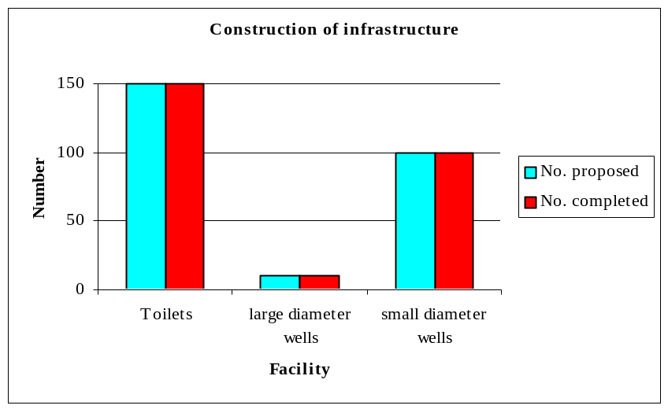

Another significant feature/output of the project was the establishment of water and sanitation user groups to maintain and sustain the constructed facilities. In addition to this group formation, more than 15 village level health education programs were conducted. Under this, CARE tested a number of concepts related to hygiene extension programs and developed and reviewed different activities aimed at improving hygiene behaviors. Since a key feature of improved hygiene behavior change programming is the development of a system for continuous program improvement and development, a model village was maintained. The purpose of this model village was to allow CARE staff to work directly with these communities to continue the testing and improvement of hygiene behavior change programming.

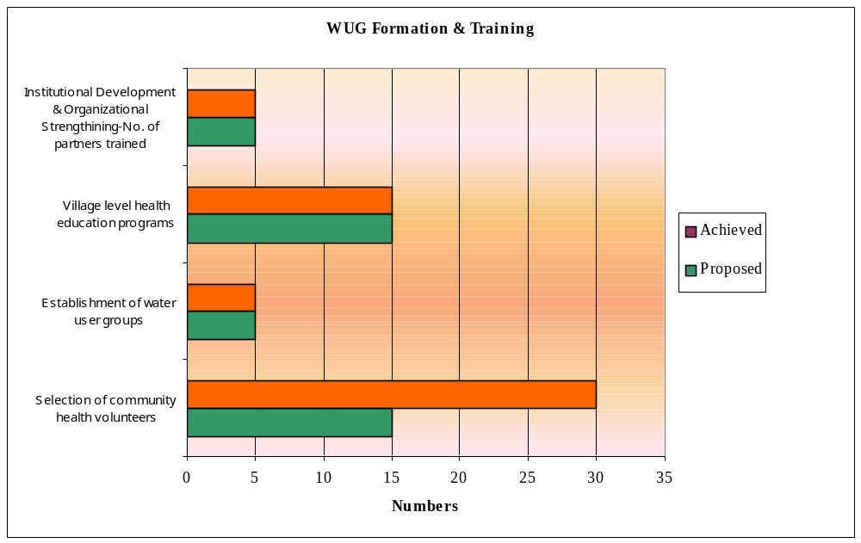

6.2 Project Outcomes

The interventions concerning construction of infrastructure, health and institutional development and organizational trainings, establishment of water and sanitation user groups etc. took off in January 2001.

To get a better insight information on the water and sanitation facilities available in the intervention villages, to establish initial values for the indictors of the WASH logical framework and also to ascertain the hygiene behavior of participants relating to water and sanitation, initial baseline for the WASH Project was undertaken in 2 divisional secretaries areas followed by collection of final information.

Effect level changes envisaged in the project are being dealt in detail under caption attainment of objectives (Item 7).

Improving the health of the poor is a frequently cited goal of water and sanitation projects. At the project level, the relationship is difficult to establish in practice but over the longer term, it can be demonstrated that there are significant health associated benefits form improvements in water supply and sanitation provision, particularly when these are associated with changes in behavior. The WASH 11 project found that during the end of project evaluation studies, the health impact of water and sanitation facilities was high. Project participants were able to save time spent on fetching water from far away places and were able to use the time in productive activities.

Badly damaged community cohesion in war-affected Batticaloa was also improved in the intervention villages as project participants came around common resources, village level education programs and as members of the water and sanitation user groups. Nevertheless, it should be mentioned that the interest level shown by the participants at the initial stages of project implementation was on the decline, once their needs were met.

6.3 Environmental Effects

In the intervention villages impact of deficient water and sanitation services had been numerous. Unreached by adequate water and sanitation facilities, people in the intervention villages were undergoing untold hardship. They were using nearby thickets, open paddy fields and jungles as their defecation ground. Apart from solving this overwhelming social and health issues, the project had it effects on the environment. Prior to the implementation of this project in the intervention villages, human waste had been a major polluter of soil and ground water resources. With the provision of adequate water and sanitation services coupled with hygiene promotion training, the environmental pollution was brought to halt to a greater extent and a marked decrease in the incidence of diseases due to harsh environment was observed in the project areas.

6.4 Costs and Financing

There are no special remarks to be made regarding the expenditures of AusAid funding. The total expenditure was within the budget allocated. Expenditure report for the period January 2001 to July 2002 certified by Director Finance and Administration of CARE Sri Lanka is attached for easy reference.

6.5 Implementation Schedule

Implementation schedule is attached.

CARE requested for one month no cost extension to carry out final evaluation of the project

6.6 Monitoring

CARE placed a very high importance on sound Monitoring and Evaluation and received technical guidance from M & E unit in CARE Colombo. Besides consultants from CARE USA visited Sri Lanka and helped in the development of Log Frame and M & E plan for the project.

Project staffs based in Batticaloa Area Office were doing a regular monitoring of the project implementation. Monthly and Quarterly reports were furnished to AusAid. The Area Office monitored performance of this project continuously and ensured that:

- The transformation of project resources and inputs into the anticipated outputs is efficient and timely

- Participatory monitoring approaches are adopted focusing on target group involvement in the process

- The relevance and validity of the design and its underlying assumptions are regularly re-assessed and the project is flexible enough to be adjusted accordingly

The communities and CARE drew up a monitoring framework jointly. Indicators were set out for each objective. The framework included the data that needed to be collected for measurement of the performance indicators, the frequency of data collection, those responsible for collecting the data and use of the data. Performance indicators included process indicators to determine if resources were efficiently and effectively used to generate the desired outputs and effect indicators to determine if the envisaged impact is achieved. Project officer for health took charge of data collection and analysis and a Baseline Report was prepared by the project.

The Australian High Commissioner and AusAID representatives Messrs. Brian and Dunstan had made monitoring visits to the project sites during the period under review.
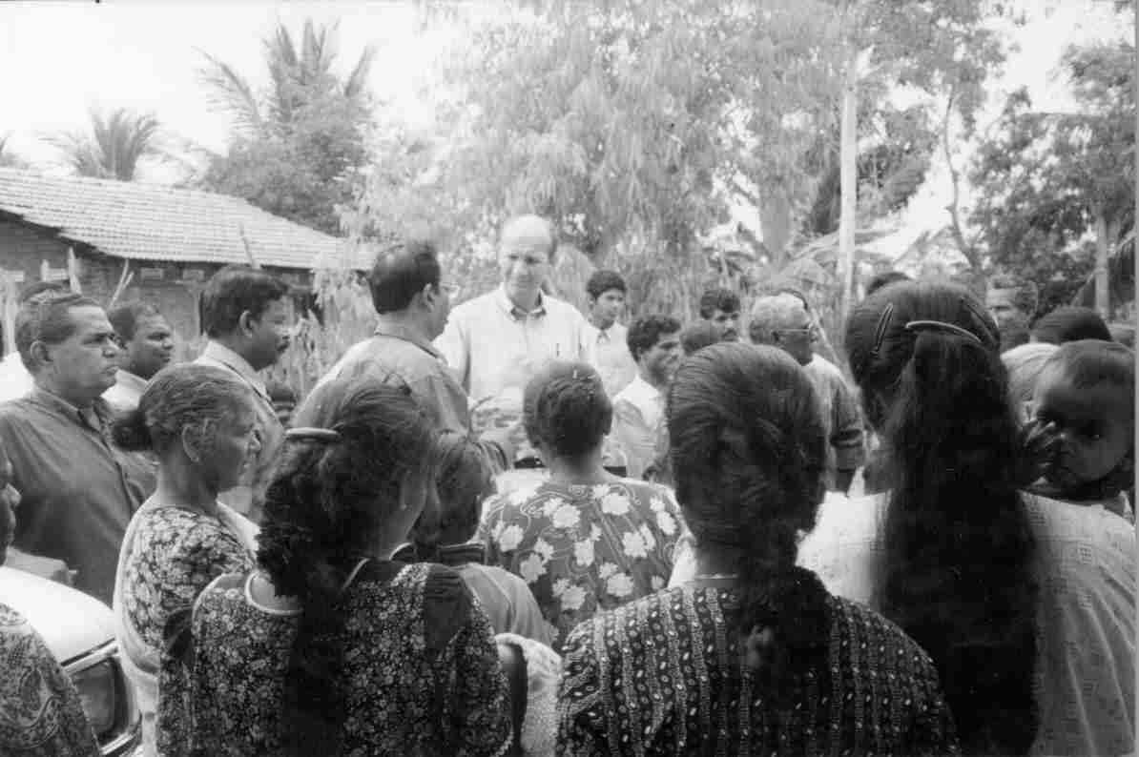
Field visit by the Australian High Commissioner
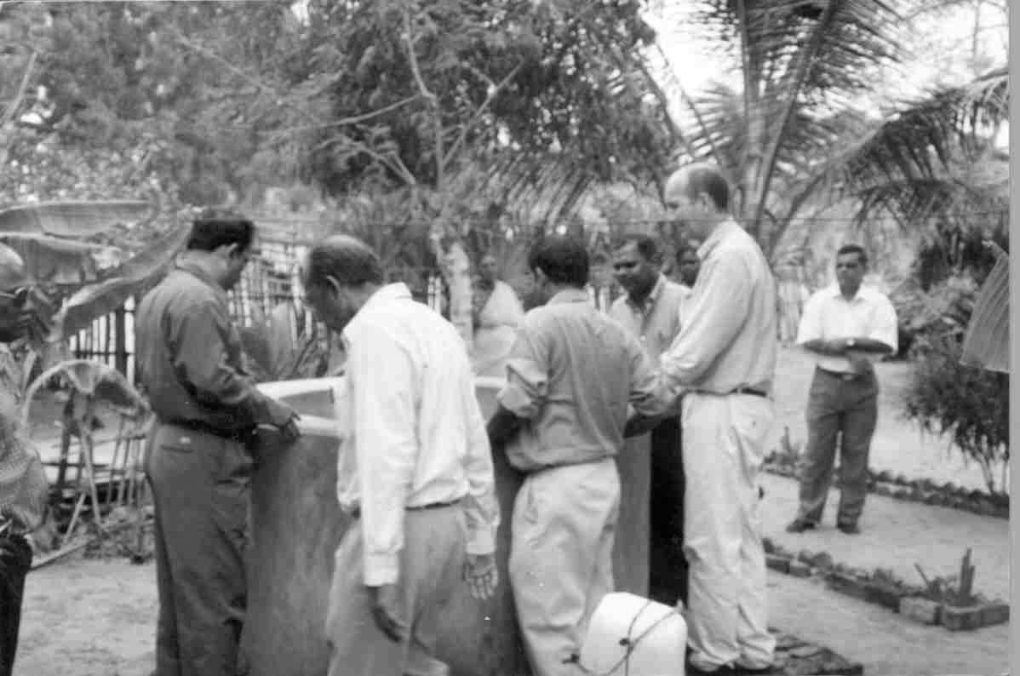

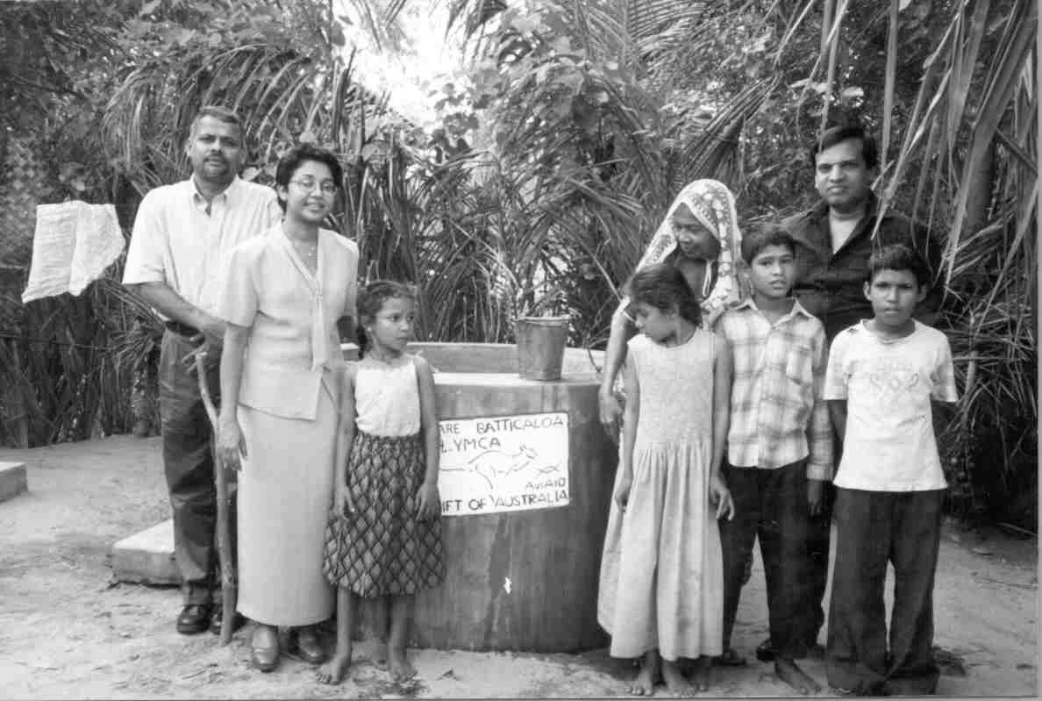
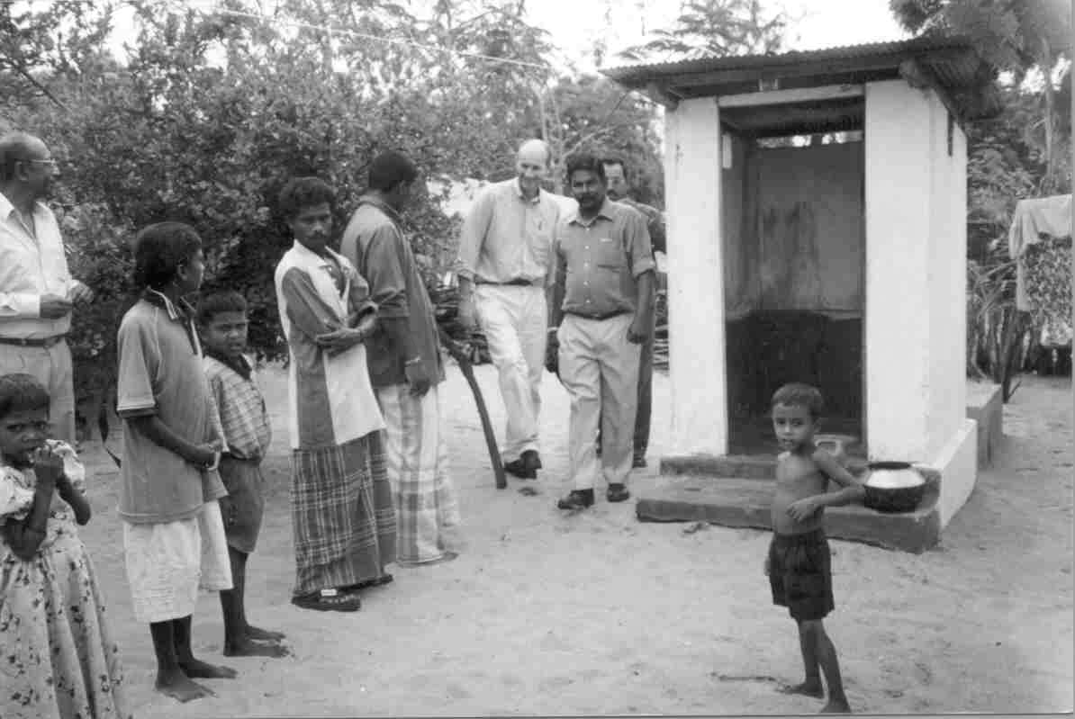
Monitoring visit by Australian High Commissioner
Monitoring visit by care’s senior management staff

6.7 Technical Assistance, Training and Capacity Building

Training of Community Health Volunteers
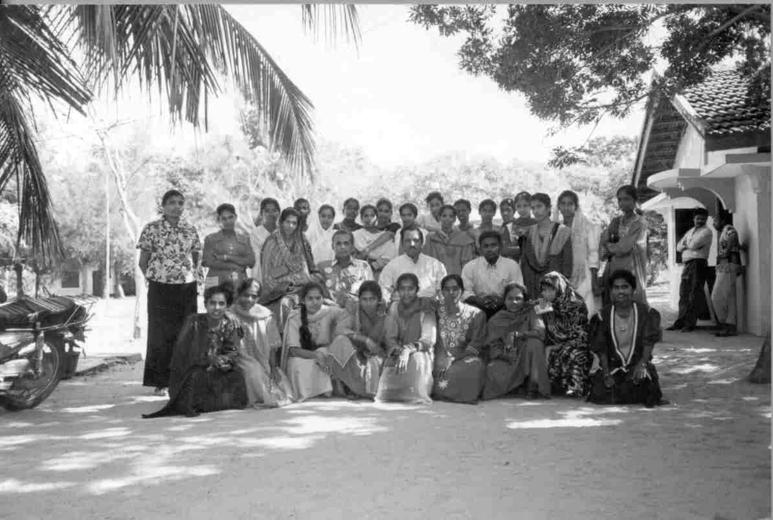
Community Health Volunteer trainees with Project staff on completion of their training

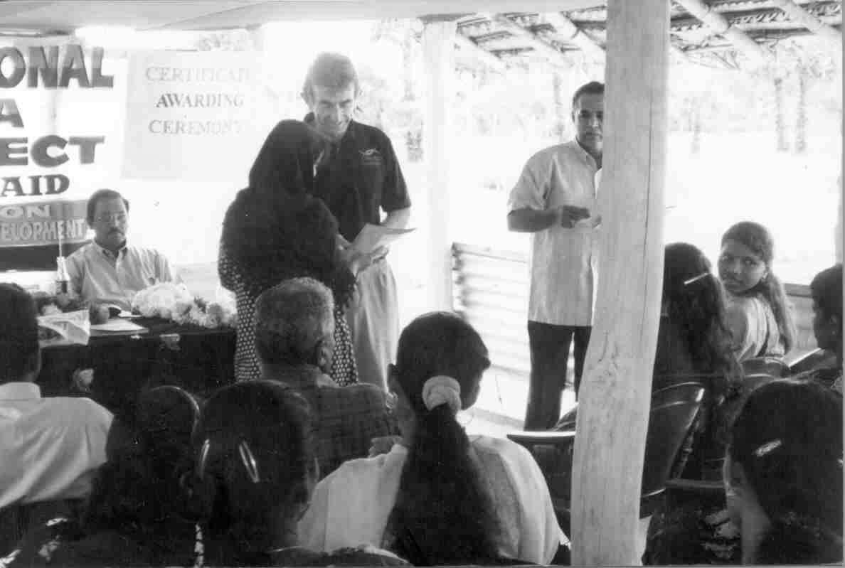
AusAID Projects Coordinator Brian Awarding certificates to the Health volunteers after completion of their training

Training of community health volunteers were undertaken with the objective of improving their knowledge, attitude and skills in understanding the community in which they live and serve, assess it’s needs and to undertake hygiene promotion activities. These community health volunteers after their training were expected to:

- Disseminate health messages to community members
- Ensure the environmental cleanliness of their village
- Increase the proper and regular use of latrine and water facilities provided to the community
- Sustain the water and sanitation services by continuous monitoring in coordination with the sanitation and water user groups established for the very purpose of ensuring the sustainability

CARE’s initial plan was to train 15 community health volunteers. But in all, 30 volunteers were trained making allowance for dropouts and also to accommodate the request of Medical Officers of Health. In the first place, a training need assessment was undertaken and a Training curriculum was developed. After field-testing the training curriculum, the training commenced. Public Health staffs of the Department of Health services were also associated with CARE’s Health Project Officer in this training. Pre and post-tests were conducted to evaluate the training program and 90% of the volunteers performed very well.

Training of Partner Organizations/water user groups and counterparts on Institutional Development and Organizational strengthening

Training on Institutional Development and Organizational Strengthening was undertaken with the objective of ensuring the participants of the training programs to understand the dynamics of different institutions and organizations and also to improve their skills to use ID/OS tools in identifying and working with GOSL and NGOs.

A series of workshops and training were conducted to the officers from the Department of Health, Pradeshiya saba, Divisional Secretaries representatives, members of the water user groups etc. This training resulted in better coordination among all the relevant stakeholders and better net- working and linkages between the beneficiaries and service providers. Capacity building training based on the institutional analysis of each partners was the outcome of this ID/OS training exercise.

Village Level hygiene education programs

The Project Officer for health education in CARE along with Public health staff of the Department of Health and CARE’s trained volunteers undertook village level hygiene education program. CARE employed two models of outreach. One was a more conventional model and was based on courtyard education sessions with the water and sanitation facility users. The second – more innovative – models added additional outreach activities: school programs, child-to-child approaches and involvement of key opinion leaders in the community. The purpose of this comparison was to determine the benefit of a more intensive outreach program to influence hygiene behaviors. The key elements of hygiene behavior change programming included working through different avenues at the community level to:

- Collect and analyze information on existing beliefs, norms and practices.

- Identify and analyze problems and define realistic and achievable solutions with community members

- Develop, test and refine participatory extension strategies and materials

- Create a behavior based monitoring and improvement system

- Target men, women and children

A recent follow up evaluation to the initial WASH baseline survey, shows some exciting results have been achieved. Some of these results are presented below:

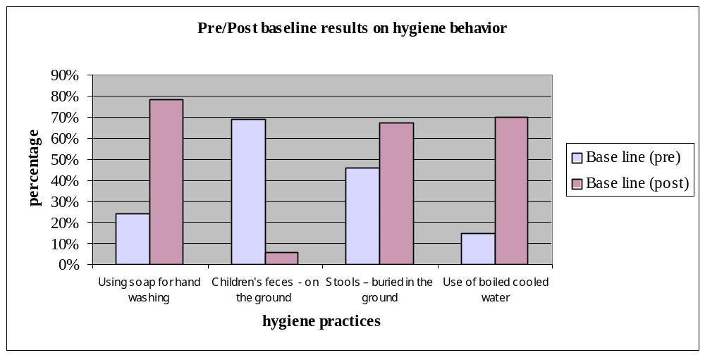

6.8 Procurement of Goods and Services

As the construction work was entrusted to Partner NGOs based on the estimates per infrastructure construction, CARE did not involve in the procurements of goods.

6.9 Risk Management and Management of Change

Prior to peace initiative, CARE had lot formalities to abide by when it came to the question of implementing programs in the uncleared area. Permission of the Military officials was necessary for movement of staff to and from uncleared and also for the movement of materials needed for the infrastructure construction. Though our Partner organization had difficulties in seeking timely approval from the military, CARE because of its cordial relationship with military officials was able to help them in this regard.

In the case of construction of common wells, our partner NGO was finding it difficult to complete it as per schedule due to wet season and water table but CARE was able to accomplish it during the life of the project because of the relentless effort of our staff.

7. Attainment of objectives

The overall objective of bringing down the incidence of diarrhea in children less than 5 years was really attainable during the life period of the project, as CARE did not stop with the provision of water and sanitation system or “hardware” to communities. In addition CARE also addressed hygiene behaviors in an integrated approach, which included (1) safe drinking water supply (2) sanitation and (3) hygiene education. The hygiene education or “software” was developed based on a careful analysis and understanding of existing community beliefs, practices and norms as related to water and sanitation. Continuous engagement of social mobilization workers in the intervention villages coupled with community health volunteers had an effective impact on the community not only to have access to the facilities provided but also to use it and reap the benefit of it. Besides, involvement of the Divisional Secretaries, Health department Officials, Water resources board, and Pradeshiya sabas and the formation of Steering committee under the leadership of the Provincial Director of health Services too went a long way in the success of the project.

Establishment of District Steering committee helped to facilitate easy implementation of the project by coordinated effort where all relevant stakeholders had something to contribute. This provided opportunity for transparency, accountability and collective decision and also to reduce tensions in societies.

Establishment of WATSAN groups on the other hand, facilitated sustainability and in addition brought people together around common resources thereby helping to re-establish and rebuild community cohesion.

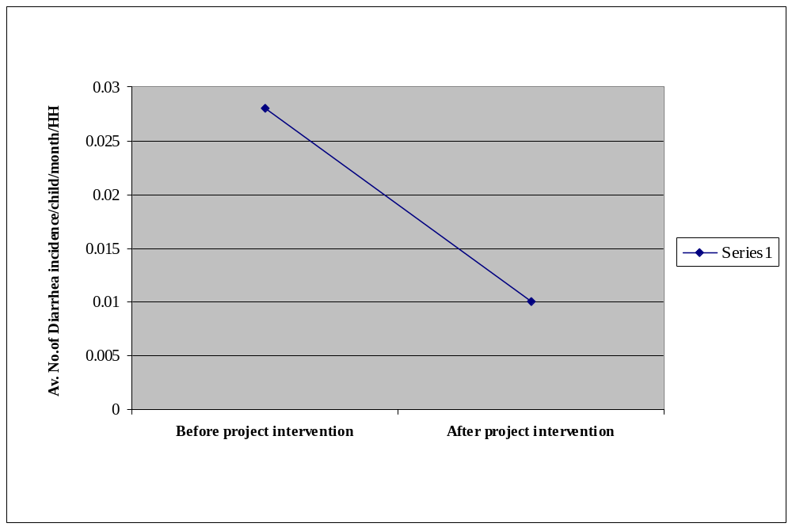

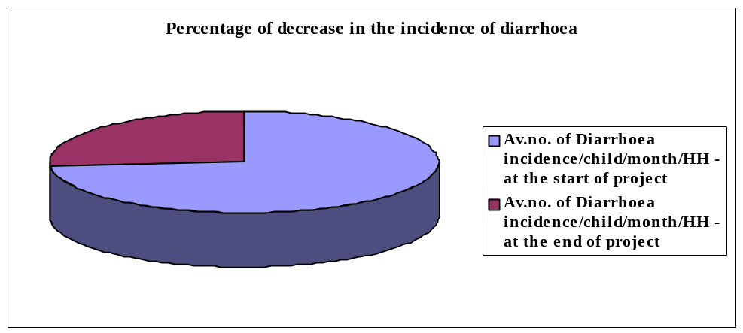

Narrative summary | Indicator | Target | Results
Project Goal  To decrease the incidence of water and excreta related diseases in 1200 households | Prevalence of diarrhea in children 0-5 years (measured as of diarrhea incidences/month /child) | Decrease the incidence of diarrhea by 50% in the households by 2002 | As per baseline, average number of diarrhea per child per month per HH in the intervention villages was 0.028 per month. The end of project evaluation indicates that this incidence has now come down to 0.01, which means the reduction is by 64%.
Objectives  Increased access and use of safe water and sanitation services by target household | 2Number of liters/person/day of clean water consumed for domestic use | 2Increase in the safe drinking water by 75 % households by 2002 | 2As per initial baseline the number of liters /person / day for domestic use in the intervention villages was around 18 ltrs. The end of project evaluation indicates that this has now gone up to 47 liters/person/day, which means the increase in usage is threefold
Improved personal hygiene practices of target household | Number of households properly storing water  % of households regularly using soap for hand washing  % of households consuming boiled cooled water | Use of Proper storage methods by 75 % of the households by 2002  75 % of the households report using soap for hand washing  75 % of households use boiled cooled water by 2002 | According to the initial survey, plastic cans, clay pots and aluminum buckets were used for storing water but the containers were not kept clean. End of Project Evaluation now shows that more than 75 % of the households are using proper storage methods  According to initial survey only 24 % of the households were using soap for hand washing. End of project evaluation indicates increase to more than 75 %.
Increase effectiveness of Water User Groups to manage and maintain community water systems | # of WUGs scoring 75 points or more on the management matrix | 50 % of the Water User Groups scoring 75 points in management matrix by 2002 | According to initial baseline only 15 % of households were consuming boiled cool water. This has now increased to 70%.  When initial survey was undertaken there was no Water User Groups in existence. CARE managed to establish 5 Water User Groups in the intervention villages.. Final evaluation shows that 60% of the WUGs were scoring more than 75 points.

7.2 Financial and economic performance

In the case of infrastructure projects, usually cost per beneficiary is comparatively higher but as far as WASH project was concerned, cost per beneficiary was kept to a minimum as the beneficiaries contributed land, locally available materials and free labor. The project only met the cost of skilled labor and scarcely available building materials. Water, as we all know, is an economic and a social good. The benefits of safe water supply and sanitation went beyond improvements to health, well-being and quality of life. In the intervention villages, due to increased access to safe water and sanitation facilities, project participants were able to save time and energy and enhance their livelihood opportunities. Improvements in sanitation improved the privacy of people and retained human dignity – significant and legitimate social development concerns. These less quantifiable benefits were among the advantages of water supply and sanitation most often observed in low-income communities.

In the intervention villages, prior to the implementation of this project, people have to work hard for their water often fetching it from far-off sources and using it carefully and sparsely. The time spent collecting water was double burden, as it meant less time was available for the productive activities on which subsistence economies depended. Improved water and sanitation facilities really facilitated the social and economic development of the project participants.

There is also an important gender dimension. Improved water supply and sanitation provided particular benefits for women and girls. In addition to the carrying of water, there had been instances of our project participants suffering harassment on the way to and from community defecation areas and water sources.

7.3 Sustainability

Sustainability in the case of WASH means ensuring that water and sanitation services and interventions continue to operate successfully and generate benefits over their planned life. Sustainability has environmental, institutional, financial, technical and social dimensions. In the WASH Project, strategies most likely contribute to the improved sustainability were developed and implemented. These strategies incorporated activities, which ensured that the services provided, reflected the true demand, that the benefits are optimized and hence the users appreciate the value of the services. Those activities included:

- Mobilizing and facilitating the active participation of both men and women in decision-making around technology choice, siting, maintenance and management process
- Taking culture and context into account and understanding local priorities and preferences for water and sanitation as well as formal and informal power structure and institutions.
- Establishing an institutional framework that would effectively manage and maintain water and sanitation systems. Functional water and sanitation user groups are formed and institutional linkages strengthened.
- Enhancing hygiene promotion program which focus in turn on men, women and children to stimulate demand for and use and care improved water supply, sanitation and waste disposal facilities

With the functional water and sanitation user groups that was linked to the concerned service organizations and by working through locally based non-governmental organizations involving the relevant departments and institutions, it is hoped beyond doubt that all project outputs are likely to be sustained.

8. Conclusions

The project implementation went on as planned except in the case of construction of common wells that was little behind schedule due to wet season and high water table. One-month extension was obtained to complete this activity. There had been regular monitoring visits from AusAid from the commencement of the project until its completion and CARE was providing with timely reports monthly and quarterly to AusAid and in turn they provided regular feed back for refinement of implementation strategies.

A SWOT analysis done by the project staff revealed the following:

Strengths

- The project addressed the real need of the people
- Software and hardware went hand in hand
- Integrated approach to develop infrastructure by integrating the social, health, technical, economic, financial, institutional and environmental aspects and planning for sustainable management and operation
- Establishment of a Steering Committee under the leadership of the Deputy Provincial Director of Health Services with concerned Divisional Secretaries, Water Resources Board, Pradehiya Saba, Medical Officers of Health and Partner NGOs for collective decision-making paved the way for the active participation of all relevant stake holders and maximized transparency and accountability
- Establishment of Water and Sanitation User Groups at village level to sustain and maintain the constructed systems
- There was important gender dimension. WASH provided particular benefits for women and girls by reducing their workload

Weaknesses

- There is no mechanism in place to continuously monitor the water and sanitation user groups that are weak after the project period
- Whether community health volunteers will be able to maintain the same momentum and commitment even after CARE’s withdrawal, in carrying out hygiene promotion activities is a serious concern

Out of all the projects in the East implemented by CARE, this had been considered as a very valuable project and CARE has invitation from all DS divisions in the district to further extend this activity. The approach adopted had been demand-responsive and CARE will be submitting a proposal for extension/replication of this project with the little modifications based on the lessons learned form the past implementation experience.

Lessons Learned

From the experience gained from the implementation of the project, following lessons were learned:

- Availability of adequate water increases earning potential and people can actively change their immediate environments with shade trees. Nutrition can be improved through the presence of homestead gardens.

- CARE has a role to play in providing on-going support to communities beyond the life period of the project. Follow up visits of 2 – 3 days per year to the communities are necessary for providing guidance and training to the water and sanitation groups and volunteers.

- Young people are often more innovative and less risk-averse. Their participation can contribute to the implementation of new ideas and activities and should therefore be encouraged

- Use of local materials should be encouraged. The availability of local materials will enable rapid replication and dissemination of knowledge once they are adopted.

- Establishment of water and sanitation user groups brought people together and encouraged community cohesion, which had been badly damaged due to on-going war.

- Mere construction of water and sanitation hardware is not going to change the quality of people’s lives. It is the use of hardware. Therefore the infrastructure construction and hygiene promotion training should go hand in hand to ensure proper use and maintenance of the facilities. One devoid of the other is of no use. The hygiene promotion is a necessary accompaniment to the provision of the water and sanitation facilities.

- Water has an economic value in all its competing uses and should be encouraged as an economic good. Access to convenient and affordable water can save people’s time ad energy and enhance their livelihood opportunities.

- Improved water supply and sanitation provides particular benefits for women and girls. Not only do they do the bulk of the carrying of water but also they often suffer harassment on the way to and from community defecation areas and water sources.

- To have effective W & S Program men too must support and adopt improved hygiene practices. Project contributions of time, labor and money should be shared fairly and not expected of women alone.

- The quality of participation is as important as the quantity.

- Projects should not be designed assuming that men are responsible for the ‘public sphere’ and women for the ‘private sphere’. There is definite need to avoid making such a distinction.

10. Appendices
(Please provide the following appendices)

10.1 Summary log frame

(To output level)

10.2 Key dates in chronological order

(This attachment charts the history of the project. It lists the key dates associated with the project from the initial proposal through to project completion)

Date of submission for funding : 21st August 2001

Date of approval of the project : 20th November 2001

Date of project start up : 1st January 2001

Date of hiring staff : January 2001

Date of completion of the project : 31st July 2002.

10.3 Project costs

Detailed Project costs certified by the Director Finance and Administration is attached.

Table 1: Please provide the information requested in each column for each individual major activity

Activity (& District) | Location | Ethnicity of target group | Number of beneficiaries | Achievements: Physical |  | Achievements: Financial |  | Partners | Constraints | Date activity commenced/ completed | Remarks/ Progress
 |  |  |  | Planned | achieved | Planned | Achieved
Collection of Baseline information/Audit | Manmunai South West and Eravur DS | Tamils and Muslims | 224 HHs. | 02 | 02 | Rs. 23,700. | Rs. 23,700. | DSs Health Department. Local NGOs | Nil | June 2001  Septem.2002
Community mobilization | In 5 villages in the above 2 DS divisions | Tamils and Muslims | 1200 HHs. | On going activity | Went on as planned | Rs.450,000.00 | Rs. 450,000. | As above | Nil | June 1999 May 2002 | This had been a regular weekly activity
Construction of water seal latrines | In 5 villages in the above 2 DS divisions | Tamils and Muslims | 750 | 150 | 150 | Rs. 1,422,000.00 | Rs. 1,422,000.00 | As abov3 | Nil | Jan 2001 May 2002
Construction of small diameter wells | In 5 villages in the above 2 DS divisions | Tamils and Muslims | 500 | 100 | 100 | Rs. 1,264,000.00 | Rs. 1,264,000.00 | As above | Wet season & high water table slowed down the work | Feb 2001 June 2002
Construction of large diameter wells | 6 villages in Manmunai south West DS division | Tamils | 250 | 10 | 10 | Rs. 292,300.00 | Rs. 292,300.00 | As above | Wet season & high water table slowed down the work | April 2001 June 2002
Training of Community Health volunteers and Health education activity | In 5 villages in the above 2 DS divisions | Tamils and Muslims | 30 and  1200 HHs. | 15 | 30 | Rs. 140,000.00 | Rs. 140,000.00 | Public Health staff of the department of Health services | Nil | June 2001 June 2002
Training of partners on Institutional development and Organizational Strengthening | Manmunai South West and Eravur DS Division | Tamils and Muslims | 100 | 5 programs | 5 | Rs. 300,000.00 | Rs. 300,000.00 | MDF/SA | Nil | June 2001  January 2002

IMPLEMENTATION SHEDULE

 |  |  |  |  |  | 2001 |  |  |  |  |  |  |  |  |  |  | 2002
 | ACTIVITIES | J | F | M | A | M | J | J | A | S | O | N | D | J | F | M | A | M | J | J
1 | Staff recruitment and orientation
2 | Awareness meeting/Planning session
3 | Selection of communities
4 | Selection of beneficiaries
5 | Baseline Survey
6 | Construction of wells and latrines
7 | Training needs assessment and
 | preparation of curriculum (Health, ID/OS)
8 | Training ( Health, ID/OS)
9 | Monitoring
10 | Evaluation

Water and Sanitation for Health Project II - Log Frame

Narrative Summary | Indicators | Means of verification | Assumptions
Goal  To decrease the incidence of water and excreta – related diseases in 1,200 households in Mannunai South West and Eravur DS divisions in Batticaloa District over 18 months | Prevalence of Diarrhea in children 0 –59 months ( measured as of diarrhea incidences/month/child) | Collection of participatory monitoring by community health volunteers  Participatory monitoring by random selection of HHs | Political stability  Cooperation of the Pradeshiya Sabah, Divisional Secretary and Department of Health
Objectives  To increase the use of safe water and sanitation services by target HH | Number of litres/day of “clean” water consumed for domestic use  Number of households reporting daily latrine use by all HH members  Number of latrines per capita  Number of HHs properly storing water (storage of water using “ appropriate “ techniques to be determined) | Annual household survey  Annual household survey  Observation  Household visit by CHVs  Annual HH survey  Annual HH survey
To Improve the personal hygiene practices of targeted Household | % of HHs regularly using soap for handwashing  % of HHs consuming boiled cooled water | Annual HH survey  Home visits, discussion  Annual HH survey  Observation
To develop water user groups to manage and maintain community water systems | # of WUGs scoring 75 points or more on the management matrix  # of WUGs having a water/sanitation plan  # of WUGs having maintenance plan  WUG keep minutes of each meeting  # of water/sanitation problems identified and resolved in the previous three months  WUGs have a mechanism in place for cost recovery  WUG maintain an accurate set of financial records and well maintained  WUG have linkages to any other institutions besides CARE | WUG survey  WUG survey  WUG survey  WUG survey  WUG survey  WUG survey  WUG survey  WUG survey
Outputs  15 community health volunteers trained  15 village-level hygiene promotion programs conducted  05 water user groups established  10 large diameter wells constructed  100 small diameter wells constructed  150 water-seal latrines constructed  05 partner organizations trained | Number of CHVs trained  Number of programs conducted/total # of participants  Number of water user groups established (existing) in intervention villages  Number of large diameter wells constructed  Number of small diameter wells constructed  Number of water –seal latrines constructed  Number of partner organizations trained | Progress Reports  Progress Reports  Progress Reports  Progress Reports  Progress Reports  Progress Reports  Progress Reports

