Empowering Women & Communities
A Study of Women Empowerment Outcomes and Best Practices of EMWE & CASI

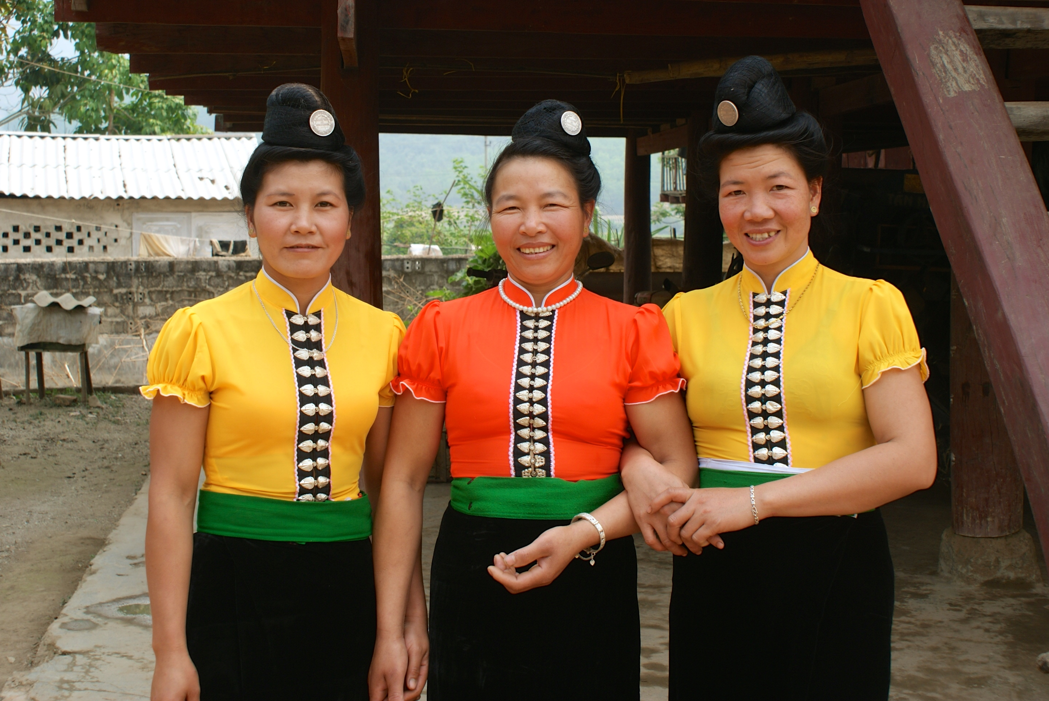

May 2015
Anna Henriksen
Silja Thøgersen

CARE Vietnam

Summary
This report concerns findings on the women’s empowerment outcomes and best practices of CARE Vietnam’s current projects; EMWE and CASI. The report is a result of a comparative study of the women’s empowerment strategies and perceptions of both projects based on two field visits to Dien Bien and Bac Kan. The analysis of the report is structured into two subparts. The first part is structured according to CARE’s Women’s Empowerment Framework and is therefore divided into changes on the agency, structural and relational level. The second part compares and discusses gender strategies and CCA strategies of the two projects.

The analysis of changes on the agency level infers how both projects have been rather successful in creating increased self-esteem and confidence among the women participating in the projects, but to different extents. The second and the third section each elaborates on the spill over effects of the changes on the agency level into the relational and structural spheres - in line with the women’s empowerment framework of CARE. It is here found that CASI has created increased collaboration and respect between husbands and wives participating in the CBO groups. In EMWE wives are experiencing more respect from their husbands and their communities, but when it comes to making decisions it seems to still primarily fall within the sphere of the men and husbands. Structurally, both projects show room for improvement, as the representation and voice of women at local authority level is still lacking in both regions. CASI, however, seemed to demonstrate an enhanced link between civil society and the local authorities, without specifically favouring women.

The two sections discuss how the EMWE project has succeeded in engaging a more diverse range of women with different levels of activity and resources through the VSLA groups, while the CASI project has engaged the more resourceful and active women of the communities into its CBO groups. It was, however, found that the VSLA in many cases created an isolated community for the women, and thus had limited possibilities of creating substantial changes within the relational spheres of the women’s every day’s life and improving their position in the society. On the contrary, it was found that the mixed gender groups of CASI had great possibilities of improving household relations and power balances between husbands and wives, as well as to some extent strengthening the linkage between civil society and the local authorities.

Future projects and research of CARE can hopefully benefit from taking these points into consideration during planning and implementation phases. Therefore, the report is finalised with a chapter of recommendations on both a general and a specific level.

1. Overall objective
The overall aim of this report is to examine the women empowerment outcomes of initiatives related to the VSLA and the CBO groups in the EMWE and CASI projects. The research further attempts to connect these outcomes with climate change adaptation work on a general scale, as well as to develop recommendations on how CARE Vietnam can improve its integration of women empowerment into climate change adaptation work.

Through desk studies and field research on VSLA and CBO groups in the two provinces of Dien Bien and Bac Kan, the empowering effects of participation for the female group members are examined. Since both projects have gone through different degrees of gender integration, we find it relevant to examine both projects according to CARE’s model of women’s empowerment by examining the outcomes on three levels; agency, structure and relationship respectively. This will be elaborated further in the chapter on research methodology.

It should be kept in mind while reading the report, that the research is only based on two field visits and is therefore only covering a fraction of two very comprehensive projects. This means that it was not possible to examine every aspect of the EMWE and CASI projects, and our analysis and recommendations are made on the basis of the elements of the projects that we visited. We are aware that both projects consist of several other initiatives and elements, which unfortunately could not be covered by this specific research. So, when reading through the conclusions and recommendations please keep in mind that some of notions might already be incorporated into other aspects of the project.

1.1 Specific objectives
- Provide information on women empowerment outcomes of VSLA groups in EMWE
- Provide information on women empowerment outcomes of CBO groups in CASI
- Provide information on the level of integration of women’s empowerment goals into the climate change aspects of EMWE and CASI
- Illustrate constraints and benefits that women experience in participating in CASI and EMWE projects
- Propose more efficient ways of integrating practises of women’s empowerment into CASI and EMWE

2.1 Introduction to CASI and EMWE
This section briefly introduces two of CARE Vietnam’s current projects, CASI (Civil Action for Socio-Economic Inclusion) and EMWE (Ethnic Minority Women’s Empowerment). The projects each covers a number of different areas and issues, but are both primarily engaged in climate change adaptation and women empowerment. Firstly, the section elaborates on the contents and objectives of both projects and secondly, it will be summarised how and where they differ in their incorporation of the gender aspect.

2.2 EMWE (Ethnic Minority Women’s Empowerment)
EMWE was implemented in two provinces in June 2013, respectively Bac Kan and Dien Bien. CARE’s role in EMWE is expected to phase out in June 2017 and the implemented CBO groups will from then on function on their own with support from local organisations and unions. The overall aim of EMWE is to address a range of core vulnerabilities experienced by one of the most marginalised groups in Vietnam – remote ethnic minority women (REMW). This group often experiences high levels of economic poverty and have a limited voice at all political levels. This is linked to gendered attitudes in the society, a general isolation from economic opportunities and subsequently limited adaptive capacities in the wake of effects of climate change and natural hazards. The vulnerabilities are further exacerbated by the fact that local governments often are characterised by top-down decision-making structures and gender and ethnicity blind institutional behaviours.

The strategy of CARE Vietnam is hence to engage this group of women to collaborate in local groups (VSLA, CBO) and through these, create communities that are able to identify and adopt climate resilient livelihood improvements. This specific research is primarily based on the VSLA groups and thus mostly the economic aspect of empowerment. The aim of the Village Savings and Loan Associations is to improve the economic opportunities of women, and engage them in decision-making processes at different political levels. Thus, the main aim of the project is to promote the voice of women and secondly, engage them in adopting climate resilient livelihood options and strategies.

2.3 CASI (Civil Action for Socio-Economic Inclusion)
In 2010, CASI became a part of CARE Vietnam’s Ethnic Minority programme with the goal to support the civil society organisations that represent ethnic minorities in Northern Vietnam. The objective of this support is to enable the organizations to strengthen the voice of the minorities at a national level and advocate changes required to ensure that the ethnic minorities have equal opportunities to voice their concerns, exercise their rights and experience sustainable livelihoods. CASI is meant to be a long-term programme focused on strengthening the civil society organisations and with time enabling them to create long-term improvements on their own. In line with this, the programme largely focuses on promoting ethnic minority leadership.

Pham Thi Quy - participant in CASI Banana-farming group, Bac Kan

The main focus areas of CASI are within natural resource governance, climate change and rights to participation and inclusion. This means that CASI and CARE mainly will support the CBO’s in advocating and strengthening initiatives within these areas.

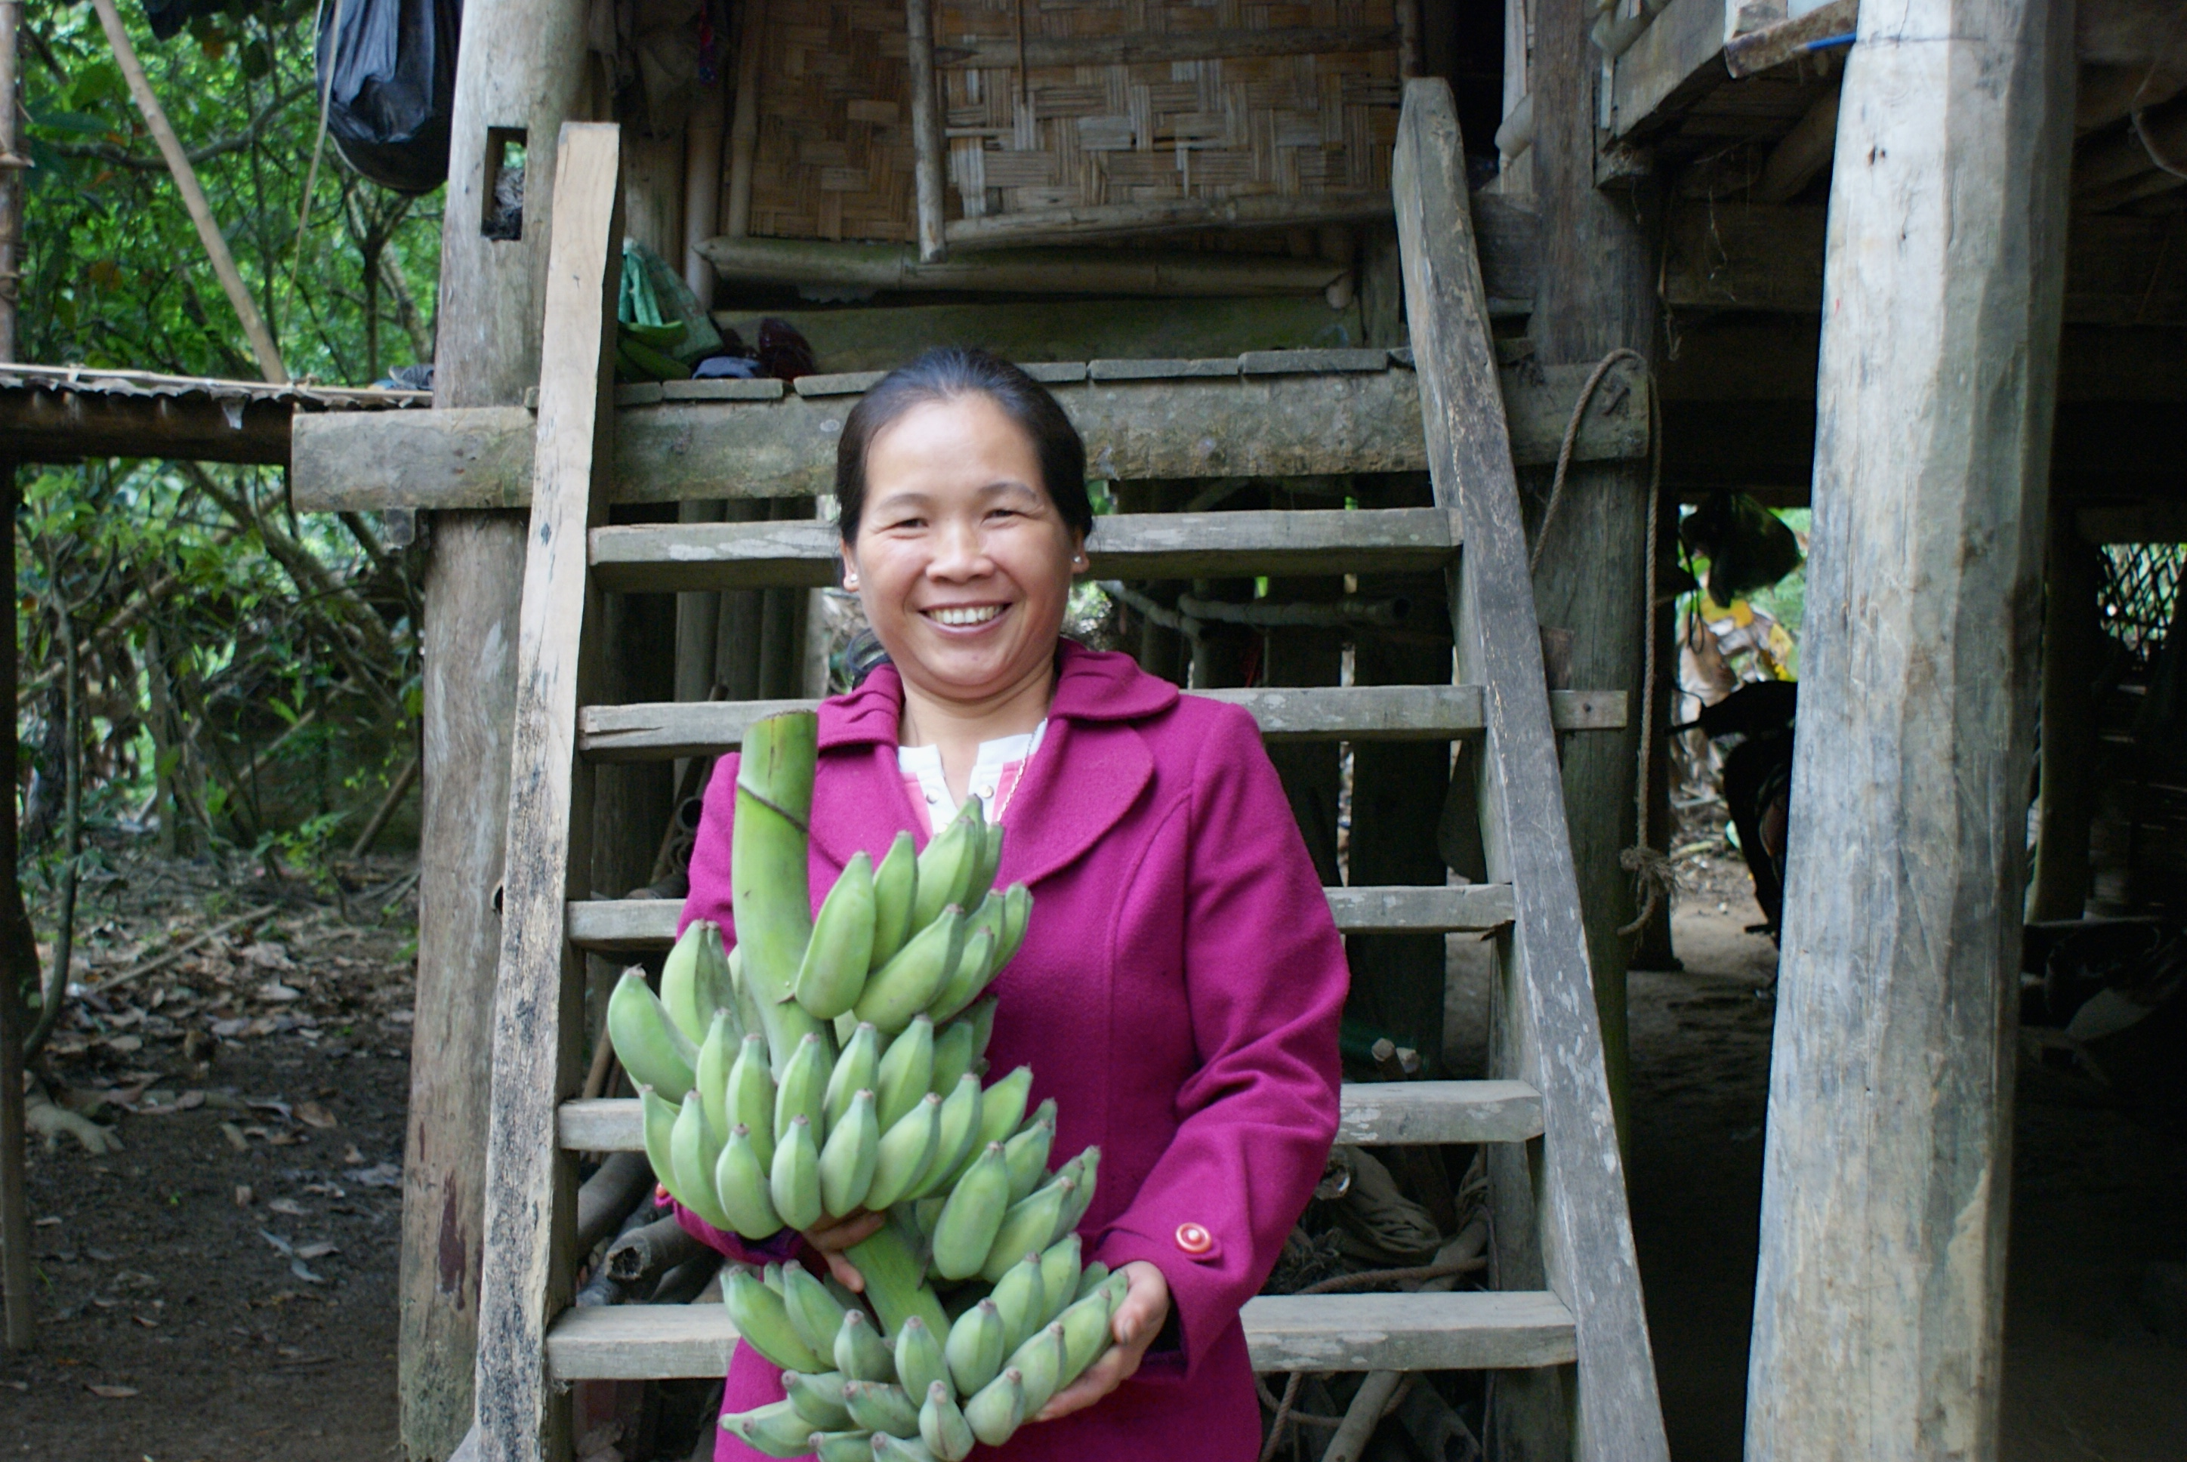
CASI consists of a network of four main partners. The partners have been chosen so that they complement each other in terms of supporting the selected advocacy themes. The partners are; iSEE who specialises in EM inclusion, media and public awareness, CIRCUM specialises in forest management and access and rights for forest lands, SRD focuses on sustainability and livelihood improvement, ADC focuses on Climate Change Adaption. This research focuses on the work and practices by ADC in Bac Kan province, as the organization supported us with all research-related activities in the province. We further had an interview with the organization in order to reach insight into their strategies, and perception of how women empowerment can be incorporated into the climate change adaptation work.

2.4 The gender aspect of EMWE and CASI
The gender aspect is incorporated differently into the work and strategies of EMWE and CASI. While EMWE seeks to empower women of the ethnic minorities as its main objective, CASI instead is characterized by a gender mainstreaming approach. This means that CASI is merely concentrated on the voice of the ethnic minorities as a unity, and is only secondarily focused on engaging women. CASI has initiated integration plans with the partner organisations to ensure that gender is thought into the organizational structure, their strategies and the work in general.

This difference in approaches is important to keep in mind while reading this report. The two projects incorporate gender and climate change adaptation differently, while still having the same overall goals and notions. This will be further elaborated in the fourth part of the analysis, where the benefits and constraints of both methods are discussed.

2.5 Gender in Climate Change Adaptation in International Development
Since climate change related disasters such as hurricanes, floods, heat periods and prolonged droughts affect whole communities, they should presumably affect the lives of men and women equally. However, climate negotiations should be seen as a parody of the unequal world economy, in which men, and the bigger nations, get to define the basis on which they participate and contribute to the reduction of growing environmental problems, while women, and smaller and poorer countries, look in from the outside with virtually no power to change or influence the scope of the discussion. The same goes for the consequences of climate change related weather changes at village level, which affect men and women in line with the existing gendered power structures of the village and the commune. For this reason, climate change adaptation projects are increasingly focusing on integrating gender analysis and women’s empowerment goals.

Women often have to spend more time on unpaid jobs than men, and these unpaid chores are especially expanded when households are affected by climate disasters. Extreme weather events do for example cause more sickness among family members, whom are typically cared for by women. Women are further often responsible for food production, water supply and energy for heating and cooking. As climate change impacts increase, these tasks become both more challenging and essential.

CARE, and other prominent organisations and institutions, do however agree that women have valuable knowledge and coping strategies that give them a practical understanding of innovation and skills in order to adapt to changing environmental conditions as well as to contribute to solutions. These strategies to deal with climate variability are still a largely untapped resource. Additionally, women are often faced with difficulties when it comes to the general accessibility of financial resources, capacity-building activities and technologies. This often stands in the way of women’s empowerment in general and their role in relation to climate change adaptation and mitigation in particular.

Several institutions and organizations are therefore proposing that mitigation and adaptation efforts should integrate gender issues at all levels (e.g. OECD, USAID, UNDP, CARE). Meaning not only striving towards gender equality at all levels of society, but also implementing gender issues and gender sensitivity at all levels and phases of climate change project planning. Examples demonstrate that communities fare better during natural disasters when women take leadership in early warning systems and in reconstruction post-disasters. Both the CASI and the EMWE project should be seen as outcomes of these notions.

3. Research methodology
This section presents and elaborates on the methodology of the report. Relevant aspects of CARE’s gender framework are briefly summarised followed by an assessment of their relation to the EMWE and CASI projects. This is followed by a presentation of the methods used in the data collection for the report.

3.1 Delimitation of research area
This report aims at analysing women empowerment outcomes of CASI and EMWE initiatives. However, fieldwork and field research interviews have solely been carried out in the two provinces of Dien Bien and Bac Kan, and the findings are therefore only based on some of the project activities in these areas. In Dien Bien we mainly observed and interviewed members of the local VSLA groups, while we in Bac Kan focused on banana groups and on local authorities and unions at different political levels.

3.2 CARE Gender tools/ methodology of EMWE and CASI
CARE International has developed an overall Women’s Empowerment Framework. This framework functions as the underlying and overall aim of the Women’s Empowerment goals of both CASI and EMWE. For this reason, the framework of this report takes its point of departure in this model, and aims at evaluating an examining CASI and EMWE Women’s Empowerment outcomes on the bases of this framework. The essence of the model is thus shortly summarized below.

The CARE framework emphasises empowerment as both an outcome and a process comprising three dimensions; agency, structure and relationship respectively. Agency is the actor-centred dimension, which focuses on the aspirations, resources and evolvement of the women themselves. Empowerment at the agency-level means that the individual woman acts and makes decisions in a way that expands her options and challenges gendered power inequities.
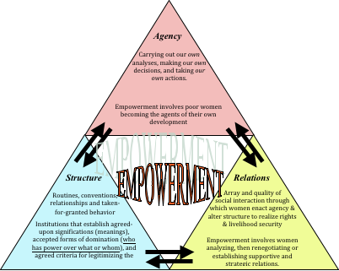
The second dimension is of the broader social structures, which condition women’s choices and possibilities. These structures include routines, patterns and interactions that lead to a taken-for-granted social norm in which specific power structures are considered normal. These structures are of a both tangible and intangible nature, as they comprise both patterns that can be observed but also ideologies that underpin these patterns. Examples of such structures include kinship, economic markets, religion, political culture and other forms of social hierarchies. Through the agency level individuals can produce and reinforce or change the structures.

The third dimension focuses on the character of social relationships through which women negotiate their needs and rights with other social actors. The social actors can be their husbands, communities, families, in-laws and other relations in the overall structure that the women take part in. Both agency and structure are mediated through these relationships between and among social actors, while at the same time relationships are also deeply influenced by agency and structure.

This process is clearly outlined in the model below, illustrating the connection between the three dimensions. CARE’s framework describes empowerment in these dimensions as consisting in individual women building relationships, joint efforts, coalitions, and mutual support in order to claim and expand agency, alter inequitable structures, and so realise rights and livelihood security.

3.3. Fieldwork methods
The methodology is based on two field visits in the provinces of Dien Bien and Bac Kan for observation and investigation of specific EMWE and CASI projects. The fieldwork in Dien Bien lasted a total of six days, from the 18th to the 24th of March. During this time we met three VSLA groups and one livelihood group that have all been initiated through the EMWE project. Firstly, we observed the formal meeting of the VSLA groups and secondly, facilitated a focus group interview with typically three or four women afterwards.

The fieldwork in Bac Kan lasted three days, from the 8th to the 10th of April. While in Bac Kan we attended one CBO group meeting for both observation and a following focus group interview, visited a banana-farming field, and did several individual key informant interviews with husbands of CBO-group participants, representatives from local authorities and unions at different levels.

3.3.1 Field Research Interviews
During the field visits, field research interviews were conducted in Dien Bien in regards to EMWE, and those in Bac Kan regarded the CASI project.

In both Dien Bien and Bac Kan focus-group interviews with women participating in the EMWE and CASI initiated groups were conducted. The group interviews aimed at getting the women to express their opinions on what an empowered woman looks like, and if and to what extend, they themselves have come closer to this vision in their participation in EMWE- and CASI. Further, we carried out individual interviews with selected husbands of women participating in EMWE and CASI related activities to examine their perspectives of the project-outcomes, and also to compare these to the experiences of their wives. This was done because the relationship in the household is found to be a strong indicator for women empowerment.

Adding to this, we also did key-informant interviews with local authorities and the local staffs of partner organisations in order to determine what specific structural changes regarding women’s empowerment goals have been made in relation to the projects. Also, these interviews were valuable in getting an insight into their experience of the progress and status of the projects in their area.

The interview-guides were designed from the CARE Women’s Empowerment Framework, as explained above. This means that we designed the questions with the aim of collecting data on women’s empowerment outcomes on an agency, relational and structural level. The questions regarding the agency dimension were mainly directed towards the women participating in the projects, but also to some extent to their husbands to get their view on changes on the agency-level regarding their wives.

Questions on the relational dimension were mainly directed towards the husbands of participants, but also the women, to get both of their perceptions on ‘normal’ division of workload, decision-making processes and power relations within the household. Further questions on the relational dimension were directed towards the local partners and local village representatives/ WU representatives in order to get their perspectives on changes and women’s empowerment outcomes on both a village and communal level. In doing so, it was possible to get insight into both the perceptions of women in the village, but also the husband's’ views on the role of their wives.

Finally, questions regarding the structural dimension were mainly directed towards local authority representatives on both the communal, district and provincial level in order to examine their views on women’s empowerment, their knowledge on the issues of ethnic minority women in general and in relation to climate change, and specific policies or projects targeting this group.

3.3.2 Observations
We attended three VSLA group meetings during our trip to Dien Bien. During these meetings we were seated slightly in the back of the meeting outside of the circle in which the meeting took place. Here, we had the opportunity to take notes and observe the process of the meetings. In Bac Kan we attended one CBO banana farming group meeting and visited a banana farming field. During the CBO meeting we were also seated behind the group participants to observe and take notes. To some extent during the meetings, we used the CARE Vietnam Gender checklist as a guideline for observing gender related issues in the structure of the meetings.

3.3.3 Choosing informants and interviewees
As our analytical framework is based on the ‘agency-structural-relational’ model of CARE’s Gender Framework, our informants were chosen in an attempt to enable ourselves to answer our research objectives on all three levels. To enable ourselves to draw conclusions about evolvement on the agency level we chose to do focus group interviews with women participating in the CASI and EMWE groups (a total of five focus groups). We furthermore did interviews with husbands of women participating in the groups (four husbands in total).

In an attempt to enable the analysis to cover questions on women’s empowerment outcomes at the relational and structural level, we arranged interviews with several authority representatives and representatives from the Women’s Union on commune, province and district level.

Location | Interviewees | Position
Thanh Nưa Commune Office, Dien Bien | Ms. Dung | General secretary of People’s Committee of communal level
Na Ten Village, Thanh Nua Commune, Dien Bien | Three female members of the CBO group (honey) | Farmers
Pom Khoang Village, Thanh Nua Commune, Dien Bien | Focus group with five members of the VSLA group | Farmers
Pom Khoang Village, Thanh Nua Commune, Dien Bien | Ms Lành | Former representative from the Women’s Union/Volunteer at CCD
Pom Khoang Village, Thanh Nua Commune, Dien Bien | Husband of participant in VSLA group | Village Leader of Pom Khoang
On Village, Thanh Nua Commune, Dien Bien | Focus group with five members of the VSLA group | Farmers
On Village, Thanh Nua Commune, Dien Bien |  | Vice president of the Women’s Union at communal level
Tâu 7A Village, Thanh Nưa Commune, Dien Bien | Focus group with five members of the VSLA group | Farmers
Tâu 7A Village- Thanh Nưa Commune | Husband of participant in VSLA group | Farmer/Representative from Youth Union
Table 1 – Overview of interviews in Dien Bien (EMWE)

Location | Interviewees | Position
Thanh Van Commune, Bac Kan | Three female members of the CBO group (Banana) | Farmers
Thanh Van Commune, Bac Kan | Husband of participant (one) | Farmer
Thanh Van Commune, Bac Kan | Husband of participant (two) | Farmer
Thanh Van Commune, Bac Kan | Ms. Tong Thi Van | Communal leader of the Women’s Union
Thanh Van Commune, Bac Kan | Mr. Ha Van Huong | Vice President of People’s Committee at Communal Level
Bac Kan | Ms. Vo Thi Nghia | Director of the DONRE
Cho Moi District, Bac Kan | Ms. Kim Lien | Director of the DARD
Thái Nguyên | ADC Staff
Table 2 – Overview of interviews in Bac Kan

3.3.4 Constraints to be considered
There are numerous factors that influence the findings during qualitative data collection. Especially during fieldwork observations and interviews, as you influence the everyday normality of the people that you are seeking to study.

During both our field trips the interviewees were chosen by the local partners of CASI (ADC) and EMWE (CCD). This is both a strength of the findings in that the local partners have excessive knowledge on the participants and their relevance and knowledge. It can, however, also be seen as a weakness since it means that we cannot guarantee the representativeness of our informants, since we do not have insight into how or why they were chosen. Potentially, the focus group could have been gathered based on who volunteered and thus who is most active. This is additionally flaw in that the people who volunteer could potentially be the ones who have been the happiest with the project, and we might not have heard some of the more critical experiences of participating in the group.

A second weakness in our data is our own presence during the collection. Obviously, this cannot be avoided. But during both field visits it was quite clear that our presence was interrupting the normality of the women’s groups meetings. Therefore, this is especially a constraint in terms of our observational findings. During several of the VSLA group meetings we attended, the women had dressed up in their traditional clothing because of our attendance. On some occasions they also performed plays and dances for us. This does not mean that what we saw does not also occur on other occasions as well, but it is clear that our attendance meant that the meetings were not proceeding entirely routinely.

Further, when we carried out our interviews after attending the meetings, more often than not the rest of the group would stay in the room with us. This has most likely affected some of the answers from our informants, as most people speak less freely when being watched by others. Adding to this is the fact that during our focus group interviews in Dien Bien, the leader of the group was always among the interviewees. This clearly affected the rest of the interviewees, as the group leader often did most of the talking and was clearly dominating the interview.

Generally, it proved difficult to get the participants to talk about negative experiences in being a part of the CASI and EMWE groups. This is a fourth constraint in our finding, and it is partly caused by the fact that many of the interviewee saw us as representing CARE, which made it uncomfortable for them to speak freely about negative experiences they may have had with the projects. This fact was enhanced, as the local partners were always being present during the interviews. With a representative from the organisation who trained the women in the beginning of the project, it is made even harder for the women to freely speak about potentially negative opinions on the content of the project.

The final constraint regards the language of the interviewees, as the women of the VSLA groups in Dien Bien consisted of ethnic minority women (Thai), who have a different native language than the majority of the Vietnamese population. Most of them have learnt Vietnamese in school, and use the language to communicate with local authorities and outsiders of the minority community, but use their minority language for everyday communication. This first of all means that some of them might lack confidence in their language skills to speak freely to our translator. Second, the language constraint can result in some misunderstandings. It was, however, our understanding that our translator did not have any substantial issues of understanding and communicating with the women or their husbands.

3.4 Clarification of concepts
Following the notions of CARE, it is pivotal to acknowledge that all women are diverse and experiences empowerment differently. This means that our research takes into account women’s diverse interpretations of empowerment, their perceptions of themselves and others, and how their identity and agency shapes the relationships and structures around them. The report consists of different concepts that might have different meanings in different contexts, which is why it is important to define these in the preface of all gender-related analysis. Thus, the following section briefly elaborates on how CARE defines some of the key concepts mentioned in this research.

Women’s empowerment
Empowerment is defined broadly as “the expansion of assets and capabilities of poor people to participate in, negotiate with, influence, control, and hold accountable the institutions that affect their lives.” Notable in this definition is the recognition of empowerment as a process of building capability (and not simply the material outcomes visible in CARE’s impact frameworks to date), and of the importance of structure as represented by the institutions affecting people’s lives. This broad conception can be further grounded in feminist theory as “the expansion in (women’s) ability to make strategic life choices in a context where this ability was previously denied to them” (CARE’s Gender Empowerment Framework).

Gender Equality
This concept refers to the equal enjoyment by men and women of rights, opportunities, resources and rewards. A critical aspect to promote gender equality is the empowerment of women with a focus on identifying imbalances of power between men and women. It is pivotal to emphasise that this does not mean that men and women are the same, but that their enjoyment of rights, opportunities and life changes should not limited by the whether they were born male or female.

Ethnic Minorities (EM)
Vietnam’s ethnic minorities in the northern mountainous region are substantially poorer than the ethnic majority Kinh. Ethnic minorities in Vietnam subsequently lack opportunities to improve their situation, as they are often remote and their livelihoods are reliant on natural resources. These resources depend on weather and climate conditions for productivity, and they often have lower productivity land. Minorities typically have limited access to education, financial services and markets, which limits their opportunities for development. Persistent stereotypes also hold back ethnic minority progress. Importantly, within ethnic minority groups the burdens of poverty tend to fall more heavily on women because of factors including lower levels of education, less access, ownership and control of productive assets and different social networks to men, which all lead to lower economic productivity and income generation as well as weaker bargaining positions in the household. These are the reasons why the projects of CARE Vietnam often seek to target the ethnic minorities, and especially women.

Climate Change (CC)
CARE defines climate change in line with the intergovernmental Panel on Climate Change (IPCC), as “any change in climate over time, whether due to natural variability or as a result of human activity.” CARE further emphasises that the world’s poorest people, though they have contributed the least to causing the problem, are already affected by climate change because of their poverty, marginalisation and lack of access to information and resources.

4. Analysis
The analysis focuses on analysing the women’s empowerment outcomes on the agency, structural and relational level. Thus, the first part of the analysis is structured accordingly with three sections and is focusing on the gender outcomes of our research. Points from the CARE Gender in DDR-CC Checklist will be applied in order to analyse and criticise the level of gender integration and sensitivity in the EMWE and CASI projects. The second part of the analysis consists of two sections. The first section elaborates on the difference in the results of CASI and EMWE in relations to their different approaches to gender integration. The second and last section is linking the gender outcomes with climate change adaptation by discussing the informants’ view on climate change and their coping mechanisms. This section seeks, in line with the rest of the findings, to function as an information tool for future projects were women empowerment is integrated with disaster risk reduction and climate change adaptation.
4.1.1 the capacity of the participating women of CASI and EMWE
In this part of the analysis the women empowerment outcomes in CASI and EMWE is explored on the agency level. The focus is on the individual women participating in the project initiatives in order to determine some of the effects that they have experienced. According to CARE’s Gender Framework, women empowerment at agency-level focuses on achieving change in self-esteem, rights awareness, group membership, skills, decision influence in public space, bodily health and integrity and control over own labour.

4.1.2 Confidence and self-image
Trying to assess developments on self-image and self-esteem is challenging as these factors are of such an individual and subjective nature. We attempted to ask the women in our focus groups from both VSLA and CBO questions on things they felt confident doing now that they did not engage in prior to joining the groups. We also tried to focus on the women’s abilities to comfortably speak up both during the meetings we observed and during the interviews. During our observation of one of the VSLA meetings a few of the women performed a small play for the rest of the group - and us. During the focus group interview following the meeting, one of the women participating in the play used this as an example of something she would have never done before she joined the group.
“Before I joined the VSLA I was very shy and afraid of speaking in public. Now I feel confident enough to get up and act in front of a crowd of people - I would never have done that before” - Woman member of VSLA group, Dien Bien.
In another VSLA focus group one of the informants described how she would previously feel very shy and insecure about speaking to strangers. This has changed as a result of her participation in the VSLA, she said.

“Beforehand, every time a member of the Women’s Union would approach me I would feel afraid and could not speak a word. Now I am more free to share. It works like a circle. When I share it makes me feel confident - so the more I share, the more confident I feel” - Woman, member of VSLA group, Dien Bien.

These examples show a change in self-image as the women express an improvement in their feeling of having something valuable to contribute with. Speaking up in a ‘safe environment’ and getting positive feedback, enhances the women’s confidence and likeliness of speaking up in other situations outside of the meetings.

However, during our observations of the VSLA meetings we noticed that each meeting went through the same ritualised procedure. During all three meetings that we participated in, the leader of the VSLA group did almost all of the talking. Other members who spoke out through the meeting mostly did so in ritualised sayings on either money counting or loan requests. Rituals can function as a kind of ‘hiding place’ for the group members. Meaning that the ability to speak confidently and freely is not nurtured as much because you lean on ready-made rituals. This was also evident in all of our focus group interviews with VSLA members, where the leader of the group was the one who mostly answered our questions freely and confidently, while the other members were shyer and needed more time to voice their opinions, and only did so rarely throughout the interviews.

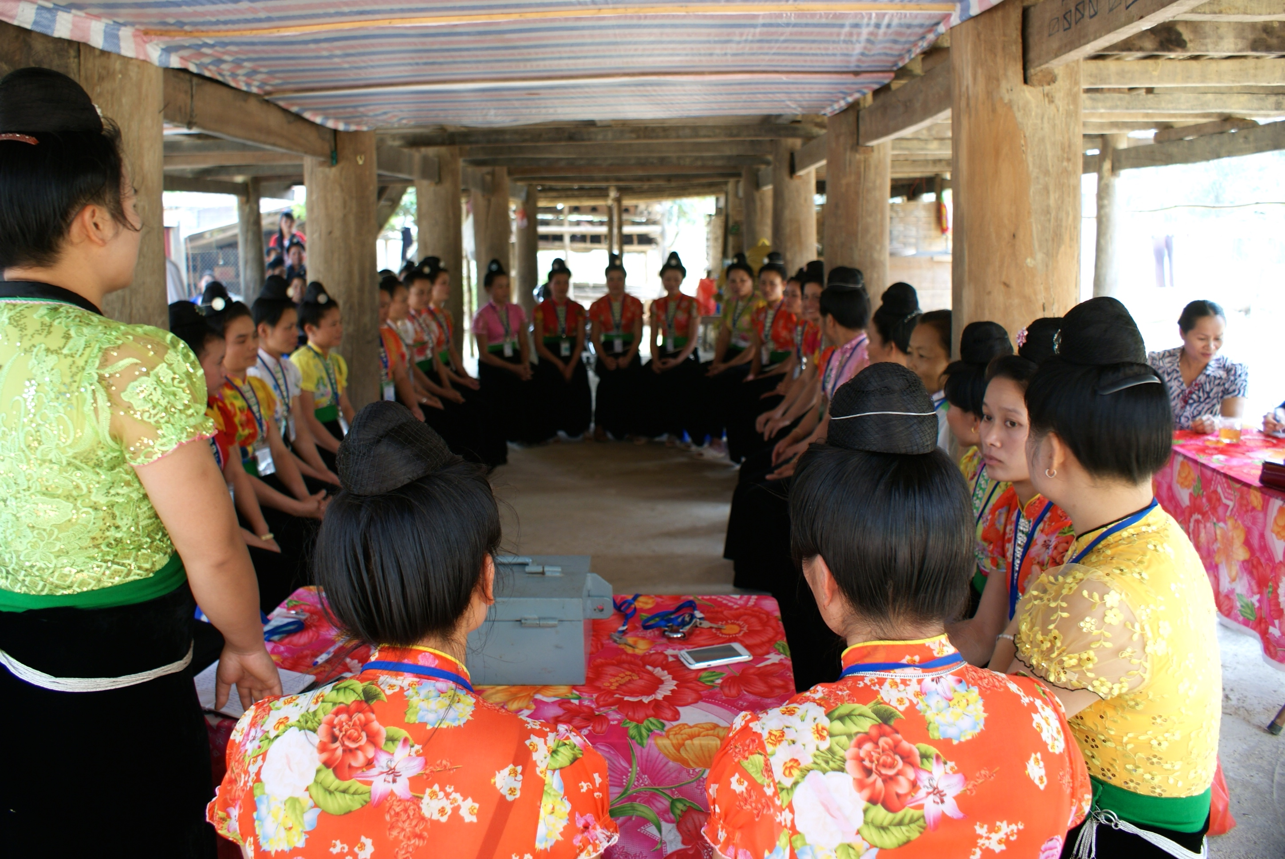
Meeting in a VSLA group, Dien Bien

When interviewing members of a CBO group from CASI, the women highlighted the positive effects of participating in a group of both men and women.

“It is very good that both men and women participate, so that men eventually will have a better understanding of women’s experiences and workload. Also participating in a group of both men and women makes it feel like we are more equal in trying to succeed with the project”
- Woman, member of mixed gender CBO group, Bac Kan.

This clearly states an improvement in the women’s self-esteem and self-image as a result of participating in the CBO group on equal terms with the men. Talking in front of a mixed gendered group enhances the women’s feeling of importance in the community, which greatly improves their self-image.

The CARE Gender integration into DRR-CC Checklist suggests that incorporating gender into CC work requires gendered consideration at all levels, including details as logistics of meetings. During our observation of the CBO group meeting in Bac Kan (CASI) we noticed that all the men of the group were seated in front of the women. The group had five male members and eight women, and the meeting took place in a communal building. The chairs in the room were placed, as they would be in a typical classroom, in front of each other facing the same way. The five men sat in the front rows, while the eight women were seated in the back rows, except for the female group-leader, who said in front, facing the rest of the group. The ADC field staff member stood in front of the group, and moved around during the meeting. These logistics meant that throughout the meeting the men had more direct contact with both the leader and the ADC representative.

During the meeting only one woman spoke up, apart from the group-leader. This lack of oral participation can stem from a number of different things e.g. lack of knowledge, interest or experience among the women about the exact things discussed at the specific meeting we attended. However, since the meeting went through eight different points on the banana-farming that they all participate in, it did seem telling on the level of confidence among the women in speaking out. Even though the three women we spoke to in a focus group interview after the meeting said they felt more confident to speak publicly as a result of their participation, it would seem that there is still progress to be made in engaging the women in speaking freely about their experiences during the meetings.

It is based on these findings possible to infer that both projects have been rather successful in improving the level of self-esteem and confidence of the women. The focus on further research, and also for the two next sections of this analysis, is whether these agency changes are creating spill over effects in the relational and structural spheres of the daily lives of the participants.

4.1.3 Rights awareness and skills
The framework of CARE also highlights improvement on rights awareness, skills and knowledge of bodily health as a mean of women’s capacity building on an agency level. In the VSLA groups of EMWE in Dien Bien, several of our interviewees mentioned how the VSLA meetings not only entailed economic discussions but could also function as a forum for other discussions. However, they mostly referred to information and training provided by the Women’s Union, who uses the VSLA meetings as an opportunity to speak to the women collectively.

“An important part of being in the group is also the spiritual support - when talking to the other women about issues and stressful things in my life, it helps to know that I am not alone”
– Woman, member of VSLA group, Dien Bien.

Several of the women also said that they sometimes had discussions on family planning and farming amongst each other. E.g. a woman in a focus group interview mentioned how she had educated other group members on pig-farming techniques.

However, during the VSLA meetings we observed no such discussions, which made it difficult to imagine informal discussions amongst group-members, as the tone of the meetings was formal and ritualized. It seemed that the VSLA meeting mostly functioned as a forum for providing information rather than discussion. Many of the interviewees did, however, express that sharing and talking about personal issues often took place outside of the meetings in smaller groups. Since joining the group the women felt it more natural to approach each other with problems of their everyday life.

The CBO-group in Bac Kan has gone through a number of training sessions facilitated by CARE and the local partner ADC. The women we interviewed all said that they felt much more confident in their farming activities, since having obtained skills and knowledge that they lacked before.

“Before joining the group I already wanted to start cultivating bananas. But I was afraid to invest and start doing it because I did not have sufficient knowledge and skill”
- Female member of CBO/banana farming group.

ADC also explained that the CBO group had gone through training on how to structure a meeting, which was clear during our observation. The woman leading the group seemed very confident in her leadership, and very sure of the structure of the meeting.

4.1.4 Feeling of group-membership
Building and expanding women’s feeling of strength and self-esteem is closely connected with a feeling of support and belonging. In all the groups we visited, whether it was banana farming, bee raising or VSLA, they all emphasised how being a part of the group had greatly enhanced their feeling of collectiveness and community. Several of the women mentioned how they had felt isolated before, and how taking part in the group meetings improved the social environment for the entire community.
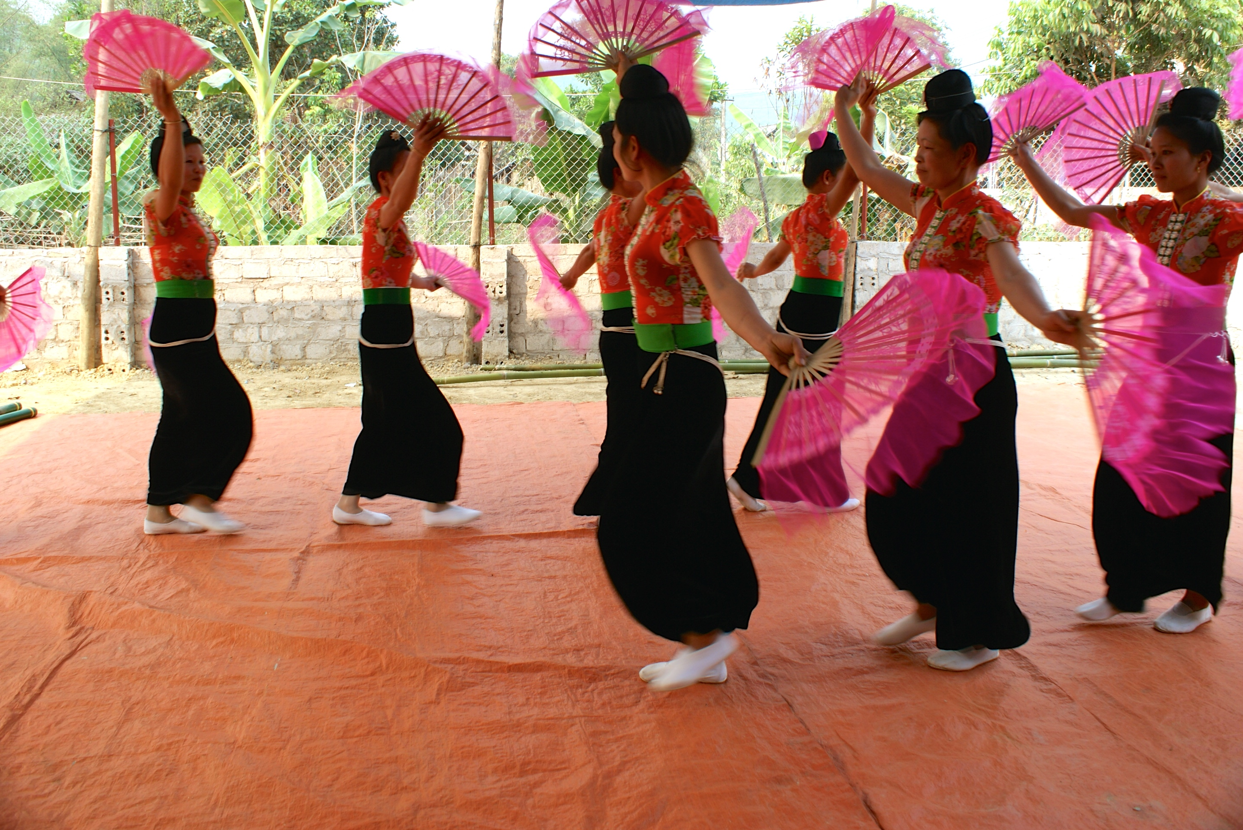
Dance performance at VSLA meeting, Dien Bien

A participant in a VSLA group said that she felt that it had become easier to confide in other members of the group outside of the meetings, as the group had created a stronger bond among the women in her village. She had experienced that a group member could reach out to other group-members for assistance if they knew another group-member was having trouble. This clearly shows a growing confidence and strength both for the women who have the courage to confide, and for the women who have the courage to react. These points will be further elaborated in the following section on changes on the relational level.

The women participating in the banana-farming group of CASI said that the group-membership gives them a sense of security to move forward and expand their banana farming. Knowing that other household in their surroundings are doing the same as them makes the expansion feel more responsible.

In order to sum up, it is possible to infer that there are several indications of improvement of increased confidence, improved self-image and a new sense of community in both the EMWE and CASI initiatives that we visited. Many of the women had specific examples of things they did not do or were afraid to do before joining the project, which they now felt was a natural thing for them to do. This tendency was further confirmed during interviews with both the husbands of the women, as well as local representatives of the Women’s Union.

4.2 Changes on the relational level - Structure and decision-making within households and on the community level
This section concerns the relationship level of the Women’s Empowerment framework, and is especially focused on the relationship between women and their husband, as well as women’s overall relation with the community that they live and function in. As the previous section, this section seeks to define changes in relations through which the women negotiate their needs and rights. CARE’s official Women’s Empowerment Framework defines outcomes at the relational level as changes in social norms, altered relationships, and altered conditions of negotiations.

4.2.1 Increased respect – Changes within household relations
It has, both in CASI and EMWE, been evident that the husband’s views on their wives’ participation in the projects have improved. Initially, the majority of all husbands were sceptical towards the women groups and the fact that their wives should represent the household at a ‘formal’ gathering. This was expressed both by the women we talked to as well as the husbands, and to some extent also the local authorities and representatives from the Women’s Union. However, in our talks with both the husbands of the participants in the EMWE and in CASI it was expressed that since experiencing the benefits and changes related to their wives’ participation, they have become supportive and encouraging of the projects. This is, on the one hand, a positive example of how both projects has succeeded in changing a social norm that was prior marginalising for women. On the other hand, there is still room for improvement as the women are still expected to ask for permission to join a group or participate in a meeting. In the second focus group with members of the VSLA group in Dien Bien, the women laughed and answered yes unanimously when asked if they were expected to ask their husbands for permission to join the group, which underlines how deeply rooted this power relation is.

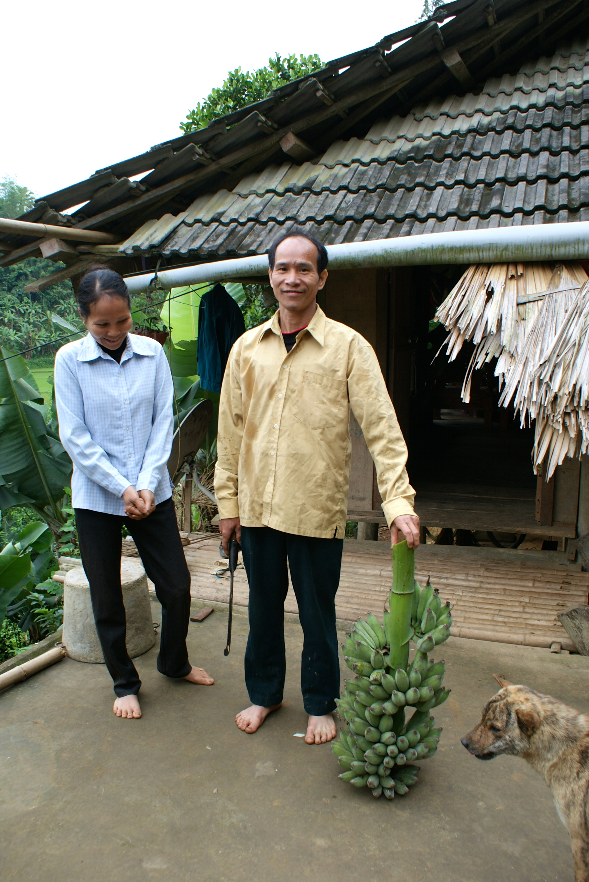
The show of support is therefore hard to define as a direct empowerment indicator as it to some extend shows a power relation where the women need their husbands’ accept in social and economic activities more than the other way around. It should, however, be noted that men most often would let their women participate and that asking for permission might be more a sign of a respect than a sign of superiority of the men. For example, when we asked the women about who in the household decides when to take out a loan from the group, they would all respond that it was a common decision that they almost never disagreed on.

It was further possible to detect some positive changes in the power relationship between men and women on a general level. One example was evident in the CBO group in Bac Kan where the banana-farming project has increased the daily cooperation between wives and husbands. In the two households that we visited, the women had participated in farming training and then passed on their acquired skills and knowledge to their husbands. This positions the wife powerfully in relation to her husband, as she is suddenly the source of information and knowledge. Both the men and women in the group told us that working together all day meant more respect for each other.

“Earlier my wife would take care of all things related to the household. But now when we both have more work to do in the fields, we share more of the tasks”
- Husband of woman in CBO group, Bac Kan.

The wife agreed, and told us that her husband now helps more with cleaning, cooking and taking care of the pig than before. She spends time with the group and has responsibilities and activities outside of the home, and therefore the husband has to take over the household responsibilities when she is out.
Wife participating in CBO group and her husband, Bac Kan

Some of the same patterns were visible in the VSLA groups of the EMWE project, but not to the same degree. The members of one VSLA group told us that the meetings of the group always takes place just after lunch and never lasts more than an hour, as this time is traditionally reserved for resting and therefore does not intervene with household chores. Meaning that the women do not burden their husbands with household chores when they are to attend meetings. It is, however, difficult to compare the two projects in regards to this, as they have different time scopes and aims. The VSLA-groups are about empowerment of women in financial and spiritual matters and concerns only women, while the projects by ADC and CARE have a different methodology in how to create changes for women in their relation with their husbands. It does, however, seem that there has been more substantial changes in the way women are perceived in the CASI project in Bac Kan. It is again important to underline that this notion is based on our research solely, and that other findings on the same projects might contradict this point.

Several participants of CASI told us about the positive results of the increased income at household level. The Vice President of the People’s Committee at Communal Level also said, that CASI has led to the women and men working more together, and that family relations have improved because of it, which in his opinion creates mutual respect and coherence in the community.

The changes in the relationship between wives and husbands involved with the CASI project are illustrated in the figure 1.1 below. These are based on the answers by both the husbands and wives themselves, as well as by the local authorities.

Figure 1.1 Factors of Changes in the Relations between husbands and wives

The figure illustrates two pivotal factors of change within the CASI project. The first one is the fact that the banana farming has created a substantial increase in income for the involved participants and communities. The second one is that women in several of these cases have been the facilitators of the increase. This both changes the way they perceive themselves, and are being perceived by their husbands. As valuable and knowledgeable individuals that are able to create income for the household. It should, however, be noted that it is not possible for us to say if this change can be applied to all CASI-involved households, as we only talked to the ones where the woman was the member of the CBO group. The results might have looked different if we had talked to the members where men represented the household.

The point concerning how women are perceived is important, and we will return to this in the third analysis section concerning the empowerment outcomes on a structural level. In regards to the EMWE project and the VSLA groups, similar tendency can be traced. Even though we did not find evidence of major changes in the way women are perceived by their husbands or the community, it was possible to see changes in the way perceived themselves, which to some extent reflects the way they are viewed by their surroundings. Also, it was to some degree possible to see that men see women differently, because they are now more ‘knowledgeable and trained’.

“My husband would not previously allow me to attend to village meetings, because it was not ‘normal’. But that has changed since the project implementation. Now I have knowledge to contribute with, which makes it more sensible for me to attend”
– Woman member of VSLA group, Dien Bien.

Again, this connects with the first point mentioned in this analysis. The fact that the social norms has changed in regards to women now being able to participate in village meetings, but the power relation between men and women has not changed substantially, as men are still the ones to ‘allow’ their wives to participate. This makes it possible to claim that the two projects have succeeded in changing a social norm, but not the underlying power relation between men and women. It is further possible to detect in both projects, more visible in CASI, that the increased income has created substantial changes in the both the financial and spiritual relation between husbands and wives.

4.2.2 Workload
The findings of the research in regards to the workload inferred that both projects have been sufficient in not creating burdens for the participants. The VSLA participants told us that there has not been any substantial increase in their daily workloads. The meetings only take place once a month and always at times where it does not interrupt with their work schedule. Also, they emphasised that the workload in the household is divided equally with their husbands. Some of the women responded that their husbands are working hard in the field or in construction, and that they are pleased with this division of chores and work. It is important to note here, that many of the women might not consider their household work such as cleaning, cooking and taking care of their children as ‘real’ work, and that the division of work might be more unequal.

The women of the honey group in Dien Bien emphasised that the honey production had not created any significant increase in their daily working hours. One of the participants told us that it would only take a few minutes a day to check on the bees. Also, the meetings of the bee group are a part of the VSLA meeting that takes place every two weeks in the resting time after lunch. This means that the production of honey creates a rather large income compared to how little effort it takes to produce. For the participants in CASI in Bac Kan, the workload has increased substantially. This is caused by the fact that the villagers prior to the project only were cultivating rice two times a year, and thus had a rather limited workload. This left a lot of free time that the men in some cases would spend on drinking, which caused tensions and frustrations in the household.

“Now we have a lot more work with both the meetings and taking care of the banana farming. But it is not a burden to us – quite the contrary. When you compare it to doing nothing, the added work is welcomed!”
- Woman, member of CBO group, Bac Kan.

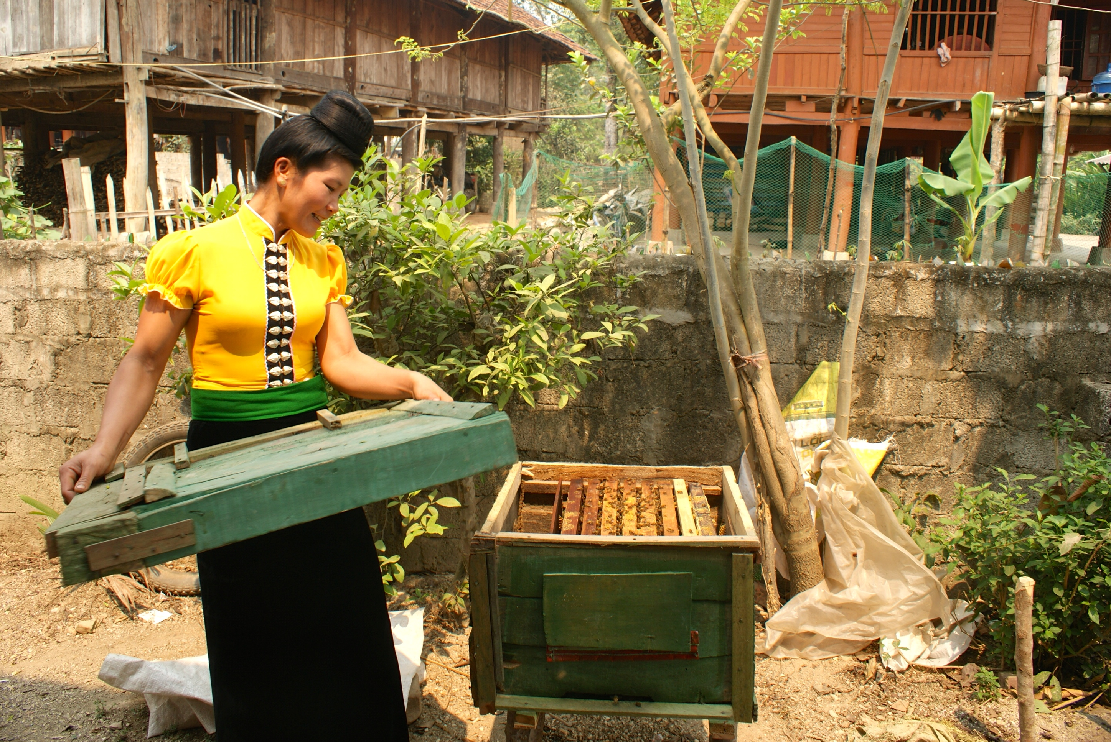
Woman participating in VSLA and Honeybee group (CBO), Dien Bien

They all expressed, both husbands and wives, that the added activities of the banana farming had increased their income significantly and that they are now able to pay for motorcycles, televisions and university tuition fees for their children. As aforementioned, this has created increased respect and harmony in the relation between husband and wife.

These findings point towards the fact that both projects have been rather successful in terms of not creating unnecessary burdens for the participants, which is in line with the aims and considerations of the projects.

4.2.3 Changes within the Community
The main improvement at community level concerning both CASI and EMWE is the increased visibility of women in the communities and their increased participation in formal events like, such as village meetings.

As previously mentioned, the VSLA and CBO groups provide a certain ‘glue’ to the society by providing more understanding and collectiveness in the communities that they are based in. The VSLA are, however, mainly creating a sharing space and a sharing culture for the women of the community. In one VSLA group, interviewees expressed how they have developed a space to talk about sensitive issues. Furthermore, the group functions as a platform for learning and training. Both the women and the Women’s Union expressed that the training and education by the union have better conditions now when the women are gathered as a cohesive group – both physically and mentally. One VSLA-participant expressed that the women previously did not pay much attention to training of the Women’s Union, but now when the women are a ‘strong and coherent’ group and have a platform for learning they are more keen on listening. This means that they are not only getting the benefits of having a strong group, they are subsequently acquiring knowledge and skills on subjects such as domestic violence and representation. One woman from the VSLA groups even said jokingly during the interview that the women of the village are now so knowledgeable and powerful that men will have to watch out for them.

The research of CASI additionally indicated positive changes in the community, but these were merely directed at the community society as a whole and not so much the women-based community. Both the villagers and the local authorities pointed to the fact that the increased income have created positive changes in the community, as there is generally less frustration and less alcohol consumption by the men, which has created a more cohesive community. Also, a lot of the villagers are now working together in the same banana fields and are sharing ideas and knowledge on farming techniques and how to treat diseases of the banana trees.

In terms of the relationship between men and women, they can be perceived as more equal in the community as they are participating in the banana-farming group on equal terms. This is further evident, as the group started out with male members only and now it counts eight women and five men. The fact that the women are in majority in a group that is viewed, by both the villagers and the local authorities, as a success in terms of economic development is a great change in the way women are perceived.

4.3 The perception and involvement of women at community and authority level (structural level)
This section examines women empowerment outcomes of EMWE and CASI at a more structural level than the social reality of community/villages in which the project initiatives are carried out. Where the two previous sections focused on ‘unofficial changes’ meaning changes in norms and perceptions, this section focuses on changes of specific practices in a more structural and official understanding. According to the Women’s Empowerment Framework of CARE, changes at the structural level for example include changes in laws and practises of citizenship, political representation, information and accesses to services, enforceability of rights, market accessibility and changes of official marriage and kinship rules.

4.3.1 Information and access to services
The structural empowerment of women strongly relates to women’s integration into their surrounding society, and their familiarity with how to access specific skills and information needed. As aforementioned, the VSLA groups (EMWE) have provided the Women’s Union with a more successful platform for providing the women with information and training, along with the specific economic skills they gain from the VSLA training itself. The CBO group primarily brings information on farming and does not function as a forum for other learning or training.

Another point of having access to official services and information is knowing what to do if questions or doubts arises. This question was left fairly unanswered in several of the VSLA groups. Several of the informants did not know who to approach or what to do exactly, if wished to raise an issue at a higher level than within the group. This points to a lack of information on how to raise an issue, and therefore also to a smaller empowerment increase at the structural level than the one we found at relational and agency level.

However, a representative from the local partner CCD or Women’s Union is present during most meetings in the VSLA groups, and it should therefore be possible to receive guidance on how to move forward with questions or issues - but the fact that several seemed uncertain reflects insecurity in the access to information and services of the local authorities.

The picture was a bit different in regards to the CBO group that we visited in Bac Kan. Here, it seemed that there was a higher level of certainty on how to gain access to specific information and services.

For example, a woman participant explained that they had been having trouble with theft among the banana fields. The buyers often come unannounced and unexpectedly, which sometimes resulted in villagers selling whichever bananas are ripe and ready - even though it may not be theirs to sell.

“This is a serious issue for us, and we need more security for our fields and we need to organise the selling of the bananas better. So I will raise this issue at our next village meeting so that the village leader can raise it at the next meeting with the local authorities.”
- Woman member of CBO group, Bac Kan.

Furthermore, ADC emphasised that the CBO group had regular contact with the organisation, especially with the field staff who sometimes stays in the villages for longer periods of time in order to support the villagers with technical support. Also, the group can reach ADC staff by phone if anything urgent arises. This means that the CBO group might be dependent on the support of the ADC, but that this in several cases can be seen as a positive sign as the organisation can serve as a legitimate partner or supporter in raising issues to the local authorities.

This proves a far stronger knowledge on how to gain access to the needed services and information, than what we found to be the case in Dien Bien and the EMWE project.
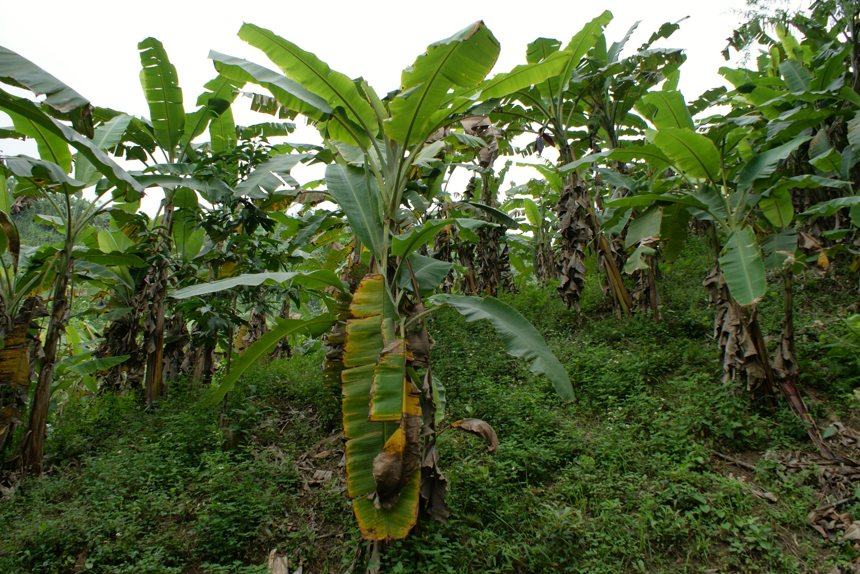
Banana field, Bac Kan

4.3.2 Women’s voice at local authority level
Another indicator of increases of women’s empowerment is the level of influence on authority level that the women potentially possess. Meaning, if the voice of ethnic minority women is heard, respected and considered by local authority representatives.

When interviewing DARD at the district level and DONRE at the provincial level, they both used the word ‘bottom-up approach’ about their approaches. The district level representative of DARD said that her job was to balance the wishes of the villagers at community level with the national directives when designing projects and annual plans at the district level.

“The directives of the government at national level are very generally formulated annual goals. How to achieve these goals is where the needs and knowledge of villages and people at community level plays a role”
- DARD representative district level, Bac Kan.

The representative from DONRE at the provincial level described the same process. They both described the process as having a starting point in the villages, meaning that the village leaders are discussing the issues and situations at village level, then raising these issues at community level. The representatives at the community level are then responsible for raising the issues and wishes further up in the political system. This is expressed in the figure below.

According to DONRE and DARD monthly meetings facilitate this process as specific issues and requests of villages travel up through the chain of authorities. It is, however, important to keep in mind that this version of the political progress is only expressed by the two representatives from DARD and DONRE. It is on the one hand possible to argue that they may have wished to show progress on key elements of the project that we as interviewers were representing. On the other hand, several of the CASI participants did describe this chain of influence as one they would make use of to gain influence within the political system.

However, these mechanisms regard the inclusion and the voice of ethnic minorities at community level as a unified group. When asked about the specific engagement of ethnic minority women, both DARD and DONRE said that they had no specific policies or tactics on targeting women. This was the answer on both the chain of information from village level and on the projects led by DARD and DONRE themselves.

“If women wish to be involved we welcome that, but we do not do work on specifically targeting or engaging the women”
- DARD representative, district level, Bac Kan.

The DARD representative further emphasised that initiatives to empower and engage women is the responsibility of the Women’s Union, rather than the local authorities and DARD. The DONRE representative at provincial level also kept underlining that gender was not a part of her expertise or daily work, when the interview turned to questions on women’s empowerment. In regards to the EMWE project we unfortunately only had the opportunity to speak to a female Peoples Committee communal leader, who was the former leader of the communal level of Women’s Union of Dien Bien. Because of her long relationship with the Women’s Union we found her less as a representative of the general opinion on PC’s responsibility on women’s empowerment, and more as a spokesperson of the union. She did, however, tell us that the commune did not have any specific policies or strategies that specifically were aimed at engaging women.

This proves a lack of success on the structural level of women’s empowerment outcomes. Especially on the data from CASI in Bac Kan. Here, it is evident that the authorities have not been successfully increasing attention on the specific vulnerabilities of women towards climate change, or on how to specifically target this.

However, the vice president of PC at the communal level in Bac Kan did express a wish for extended gender training in his commune. Training by the People’s Committee has previously mainly engaged the men of the community, and he would like to change that, even though he had no plans or tactics on this to report from.

The leader of Women’s Union at communal level does not directly represent the local authorities, but as seen in the quotes from DONRE and DARD they are greatly depended upon the legitimacy of the Union when it comes to engaging the women. The Women’s Union worked closely with ADC in setting up the CBO groups (CASI) as women had already expressed a wish to receive training on banana farming in WU meetings. Women’s Union thus played a rather significant role in determining who should receive training by ADC and CARE in the early process of starting the CBO groups.

“The criteria were that these women needed to be very active, strong in business, and influential to others. Selecting women who meet these criteria will help with successfully spreading the ideas of the project wider in the community”
- Women’s Union communal leader, Bac Kan, (CASI)

The leader of the Women’s Union told us how she was responsible for together a putting of women who live up to the criteria. These women were meant as potential candidates for the training, and the People’s Committee was then responsible for the final picking of participants. This process highlights the tendency within the CASI project to mainly target the already active women of the community, risking an exclusion of the less active and perhaps more vulnerable women. This both has benefits and constraints, and these are elaborated on in the comparison of the process of EMWE and CASI in the following part of the analysis.

4.3.3 Representation of Women
Structural empowerment of women also relates to their political representation at different authority levels and thus directs access to political influence. In Dien Bien the only authority representative we met was the General Secretary of People’s Committee from Tan Nua Commune Office. She said that she was one of only two women in her position at the province of Dien Bien, which means that only two out of 25 General Secretaries are women. This proves a rather poor representation of women, and thus also a lack of access for women to gain political influence. However, the general secretary did say that she felt that the trainings she had gone through with CCD/CARE and Women’s Union were largely the reason for her gaining the abilities to access her current position.

In Bac Kan the Vice President of Peoples Committee at Communal Level said that the representation of women in communal authority level was only 15 per cent. This proves a very low access to political influence for the local women as well. He further told us that they currently had no strategies to change this percentage and engage more women in powerful positions within the authorities. He explained that the criteria for getting a position in the communal office were very excluding for women, as the level of education and training was very low among the local women. He did however not have any tactics or strategies to improve the women’s ability to gain access to these positions.

The representative from DARD told us that 50 per cent of the employees at the district authority level are women. This was due to a close collaboration with Women’s Union on successfully engaging women in trainings and capacity building projects. This makes it easier for the women to enhance their capacity and work their way up in employment at district level. This proves a greater focus and prioritisation of engaging women and helping them to gain access to authority employment and influence. This did, however, seem to be more related to a strong relationship with women’s union rather than a strong gender awareness within the district level authorities.

4.4 Differences in WE approach of CASI and EMWE
This fourth section of the analysis concerns how the CASI and EMWE projects are emphasising the gender aspect differently. EMWE presents women’s empowerment as it’s core goal, whereas CASI firstly emphasises the strengthening of civil society as a whole and only secondly - the empowerment of women. The difference is even more visible in the groups we observed during this research, since we only visited women VSLA groups from EMWE, and a mixed gender CBO group from CASI. This difference in the gender approach can also be detected in the process of establishing the groups on a practical level. General secretary of People’s Committee of Dien Bien explained that they are working with the CCD (local EMWE partner) in choosing a village and then set up a pilot VSLA group. When this first VSLA group is set up, the commune is working closely with the Women’s Union in promoting the group and it’s benefits to other women and villages in the area. This means that local authorities, WU and CCD/local partner work actively in collaboration in trying to encourage and engage women to get involved with the groups.

The process of the establishment of the groups is different in regards to the CASI project. No measures of engaging women in particular are taken in relation to the CBO groups we visited in Bac Kan. It is important to note here that we can only state this based on the experiences of one CBO group and the strategies and processes of ADC, which they shared with us during an interview.

This means that the targeted village with the CBO group was chosen based on technical requirements such as soil appropriateness for specific farming, as well as the demand of the local villagers.

“We have no specific policies or tactics to engage women in the area. The groups are set up on demand, so it is the people who wish to participate who join the groups. But everyone is welcome” - Vice president of ACD, local partner of CASI, Bac Kan

This clearly underlines how the CASI project is more focused on engaging and strengthening the civil society as a unity, rather than focusing specifically on gendered relations. It also shows how CASI mostly targets the people who already have a strong demand for the livelihood/farming option they are providing training on. This is a very pivotal aspect of the CASI project in Bac Kan. On the one hand, this means that the project risks not engaging the less active and socially isolated women, where the VSLA group seemed to grasp a wider range of all women in villages whether they are already active at village level or not. On the other hand, it seems to be a very important part of the success of the project that the women who are engaged in the project are motivated and engaging in the training, and therefore getting as much out of the capacity building as possible.

This is should however also be kept in mind about our data from Bac Kan. We only seemed to grasp the most active women participants of the area, and the findings might have indicated a very different tendency if we would have been able to talk to some of less active women in the community.

These differences in approach also result in differently composed groups - all female (VSLA) or mixed gendered (CBO). The nature of these groups was clearly different when we visited them. The participants of the all female VSLA groups describes the group setting as safe and encouraging, resulting in a greater coherence among women in the village and a stronger sense of self-worth. The mixed gendered CBO group on the other hand said that being a part of a mixed gendered group made them feel more equal and integrated into the village society. However the observations of the group meeting presented some clear gendered power structures where the men spoke freely and the women were close to silent.

Furthermore, the difference in gender prioritisation is clear in the way the local partners handle the process of the project and setting up the groups. CCD (local partner, EMWE) works closely with Women’s Union when setting up the VSLA groups. CCD has both male and female staff, and always sends female field-staff to take part in the all-female VSLA groups when needed. ADC (local partner, CASI) only has male field-staff to participate in CBO meetings and support in the implementation of farming techniques at local level.
“It is not possible to have female field staff. Field staff has to be able to go and stay in the villages with scarce facilities for days at a time to support the project. That is not suitable for women”
- Vice President of ADC, local partner of CASI, Bac Kan.

The mixed gendered CBO group as previously mentioned seemed to present a challenge for women’s participation. The presence of the male ADC field staff to some extent seemed to add on to this challenge. Please bear in mind that this point is primarily based on our observation of one meeting within one CBO group and does not necessarily represent the rest of the CBO groups of CASI. However as mentioned in the first section of the analysis the men of the group were all seated in the front and the women in the back. The ADC representative was standing up in the front close to the male-group members throughout the meeting. This meant that whenever the ADC representative intervened and offered technical explanations, he mostly spoke to the men, as they were closest. On several occasions a discussion seemed to form solely among the men and the ADC representative as the women sat passively in the back of the room. This did seem to establish a certain difference in influence between the genders. As mentioned earlier only one woman raised an issue during the meeting.

So in regards to the facilitation of the meetings in CASI and EMWE it seems that the VSLA groups of EMWE are much more successfully inclusive of women. But this task is off course also easier when only engaging women in the groups.

So the all women’s group may reach a wider range of women, and also strengthen the confidence of the most shy among them. But even though it strengthens the female community risks only empowering women in this parallel all-female collective.

Whereas the mixed gendered groups mostly reach the already active women of the community and risks leaving the shy and less confident ones behind. The mixed gendered meetings also represents challenges for the women to feel free to speak up, but it does seem to strengthen their equal integration into the village community as a whole.

4.5 The Informant’s Views on Climate Change Adaptation
This section of the analysis is focused on the villagers’ and local authorities’ knowledge and perception of climate change and adaptation. This research might be an important tool of information in CARE’s further work on how to integrate gender into disaster risk reduction and climate change adaptation work, as it sheds light on the people’s own perception of how they most efficiently can adapt to the changes in their environment. Thus, these perceptions might be valuable to consider and include in future projects.

4.5.1 Information and technical skills
We interviewed our informants on their views and experiences on the changing weather and climate in their area and how it affected them and their crops. We did this in order to link women’s empowerment goals with initiatives on climate change in both the EMWE and the CASI projects. All the interviewed informants expressed that the weather, in general, have become more unpredictable with heavier floods and a longer drought period, which often results in vast consequences for the rice cultivation and their livestock.

Ms. Lanh, a former representative of the Women’s Union that we spoke to in Dien Bien, emphasised that the drought period was now harsher and lasted for a longer time compared to earlier, which created substantial issues for the rice cultivation. She also mentioned an increase in diseases among the cattle as a rather comprehensive issue for the villagers. She further explained that the villagers needed more information and training in how to raise the cattle and how to keep them from getting sick. Usually, the villagers would use their instincts without having substantial knowledge on how to treat the animals.

The same point was present in Bac Kan. Here, both the women of the focus group and the husbands expressed issues of drought and an increase in the diseases among the cattle, as well as weather impacts of the rice cultivation. A representative from the Women’s Union at communal level that we interviewed emphasised the need for training and knowledge – especially in terms of how to take care of cattle to prevent diseases. She further talked about previous support from both ADC and CARE and how pivotal it was to maintain it. When asked why the support was needed, she told us that CARE and ADC have a comprehensive technical knowledge, which is essential as the local authorities and union often lack exactly this.

These notions make it possible to infer that information and knowledge is a pivotal need for the villagers in both Dien Bien and Bac Kan in order to adapt to the weather change and its impacts.

Village in Bac Kan

4.5.2 Needs and investments
Ms. Doung, the general secretary of the commune that we visited in Dien Bien, told us about several climate change related issues in the area. The most pressing issue concerned how to cope during the drought season, as the area needed a better watering system for the rice fields. This is a rather large investment. This notion was further evident in the interviews with the women from the VSLA groups. One woman told us, that she as well needed larger investments for watering systems in order to take care of the rice during the drought period.

“The loans that I can take from the group are small, they cannot cover the needs”
- Woman, member of VSLA group, Dien Bien.

She further expressed that the small loans only helped her in treating the less invasive symptoms of the climate change, while larger loans and more comprehensive investments were required if her rice cultivation is to remain sustainable and stable.

This is connected with a main point of climate change impact in poor areas; that the impacts require resources and coping strategies, both of which is often limited in these areas. This means that the impacts are creating an even larger need for both material and knowledge-based resources.

This leads us to another pivotal aspect of an efficient adaptation process for the villagers; namely, that the local authorities are speaking the needs of the population to higher levels within the government system. A watering system and large infrastructural investments and projects are the government’s responsibility, but it is essential that they know what the needs are in the rural areas. This is one of the reasons why it is important that CARE is focusing on empowering individuals – both in CASI and EMWE – to make them capable of speaking their needs and issues regarding the climate change to the authorities. CARE’s contribution in this matter should therefore focus on strengthening the voice of the ethnic minorities and train them in representation, so that they eventually will be capable of speaking their own needs and wishes to the authorities.

4.5.3 Diversity in income-gathering activities
The lack of knowledge on how to cope and adapt to the impacts of the weather changes was visible during almost all of the interviews. Many of the interviewed women mentioned a lot of different issues that was caused to weather changes, e.g. increased number of epidemics and a longer drought period, which impacted their rice cultivation. When asked how they would cope to these issues, many of the women did, however, had valuable suggestions. The most common answer to the question was that they needed to diverse their income sources, so that they could depend on different crops if e.g. the rice cultivation would fail or their pigs die from diseases. This shows that several of the women are aware of their issues and capable of coming up with valuable solutions, which made it visible that several of the women have a strong entrepreneurial spirit, which is a valuable thing to acknowledge and make use of in future projects.

In the interview with the three women from the CBO group in Bac Kan, different ideas were mentioned. All three of them seemed eagerly engaged in coming up with new project ideas, and were generally motivated to start up new businesses in order to diversify their crops. In the end of the interview, when we asked them if they had any last comments, they mentioned that they would like training on how to grow fruit, so that they could expand their income. When asked why they needed support from ADC and CARE in regards to this, they responded that they needed knowledge and training on how to grow the fruit trees and how to sell them.

The same thing was mentioned several times during interviews with women in Dien Bien. Here, the women mentioned that they wished to obtain crafting skills, so that they could depend on other things than agriculture. They did, however, emphasise that they needed training in both how to do the crafting and how to sell it. As access to buyers and markets are often limited in rural areas, the women need information and introduction to steady buyers so that they can rely more on their products being sold. This was mentioned as an issue among the female banana farmers in Bac Kan as well. It is thus essential to acknowledge that the introduction to new businesses is two-dimensional; it requires both the technical skills on how to produce it and the business-related knowledge on how to sell it.

5. Conclusion
This report has investigated the outcomes and practices on women’s empowerment of the two projects of CASI and EMWE in Bac Kan and Dien Bien respectively.

The first part of the analysis contained three different sections. These primarily concerned the gendered outcomes of the two projects with point of departure in the agency, relation and structural model of the CARE Women’s Empowerment Framework.

The agency level of the analysis inferred how both projects have, so far, been rather successful in creating substantial changes of the women in terms of self-esteem and self-perception. In the VSLA groups, the women gave specific examples of their increased confidence since they’d started participating in the project. These examples were, for example, to feel more comfortable with speaking in public, talking to strangers and local representatives from the Women’s Union as well as participating in meetings and social events. All of these examples show a change their self-image, as the women expressed an improvement in their feeling of having something valuable to contribute with in different contexts. However, the ritualised and closed-space nature of the VSLA meetings make us wonder if their confidence will translate into situations outside of the group. In the CBO group in Bac Kan, the women expressed confidence mainly in terms of feeling more sure of their business and farming skills, but also a confidence in participating in meetings with men. This led the women to feel more confident in participating in village meetings and representing their household. However, when observing the meetings the women did not seem as active as the men in the discussions, which means that there is still room for improvement in engaging the women further.

At the relational level we investigated the changes in the nature of the relationship between husbands and wives since participating in the project. In both CASI and EMWE the women expressed that participating in the projects had strengthened their position in decision-making within the household, since they now had farming techniques and economic skills to contribute with. However, the VSLA participants said that they still needed their husbands permission to join the group and to take out loans - but they also expressed that the husbands would never say no, which makes the need for ‘permission’ more of a need for ‘agreement’. The women participating in the CBO group said that since they started up the banana farming they are collaborating with their husbands all day in the field. As the women were the subjects of training, they are also the ones to train and educate their husbands on the skills that they have gained through the CBO group. This new collaboration between husband and wife have led to an improved equality in the division of housework, and in the husband’s view of them - because of their acquired skills. Participants in of both projects also said that the increased income generally improved the situation in the household, leading to less frustration and more harmony and thereby greatly improved the general relationship of the households.

On the structural level there is still room for improvement in regards to both projects. Both Dien Bien and Bac Kan greatly lack representation of women within the communal authorities. None of the authority representatives that we talked to had strategies in regards to improve the representation of women. At the district level in Bac Kan the representation of women was 50 per cent as a result of strong capacity building programmes for women. However, this seemed to be due to a strong collaboration with the Women’s Union, and the district level representative we spoke with expressed that women’s empowerment work was the responsibility of the Women’s Union rather than a responsibility of the authorities.

In Bac Kan, several of the authority figures stressed that they applied a bottom up approach meaning that the wishes and needs of the villagers played an important role in the formation of authority strategies and plans. They did, however, not have any policies on ensuring the representation of women’s voice specifically. The informants from Bac Kan (CASI) also seemed very sure on how to voice their concerns to the authorities. In Dien Bien (EMWE), however, several of the interviewees seemed unsure of what to do if they wanted to raise concerns further than to the group.

The second part of the analysis comprised of two sections. The first one concerned the differences of the gender approaches by CASI and EMWE, as the two projects differ vastly in their perception of how to integrate gender. EMWE targets women specifically and actively tries to engage all women in the areas, both the active and the less active ones. CASI, on the contrary, acts on demand and tries to build capacity in civil society on the specific capabilities they wish to attain. This risks leaving out women who do not have the resources to actively seek participation in the group. However, women participants in the CBO groups gain great integration into the society via participation in the groups on equal terms with men, while the VSLA groups are running the risk of empowering women within an isolated women’s community.

The second section elaborated on the perceptions of climate change and coping mechanisms by the informants. It was firstly inferred that all interviewees were expressing that the impacts of climate change were creating issues and obstacles in regards to their agricultural production and thus income. Several of the informants did, however, express that the loans (VSLA) and the banana farming (CBO) was not enough in itself in being able to adapt to their new situation, but that they needed larger investments. Lastly, it was inferred how the participants in the project did have valuable knowledge in how they, to some extent, would be able to cope with the impacts. They all mentioned how being able to diversify their income would make them less vulnerable to extreme climate events and unstable weather.

6. Recommendations
This section attempts to move further with the findings of the conclusion and offer recommendations based on the desk studies, interviews and observations of this report. However, it is important to stress that we only had the chance to visit a limited number of groups and project sites, and that our recommendations are based solely on these. It is thus highly possible that other findings and recommendations could be have been made if we were able to expand our research further. The recommendations are divided into two sub-categories. The first one lists the general recommendations pointed towards project implementation and aims, while the second category focuses on more specific and logistical recommendations. We do hope that future research or project implementation can utilise these recommendations in working with the complexity of how to integrate the gender aspect into climate change adaptation.

General recommendations
This section contains a list of the overall recommendations that we have arrived at. This means that the recommendations are of a general and macro level character and concern Women’s Empowerment goals and the integration of these into climate change adaptation work.

Advocacy to promote gender awareness

Local authority representatives in Dien Bien and Bac Kan largely believe women’s empowerment work to be the responsibility of the Women’s Union, and show no activities or strategies to increase the employment rate of women. This is a concern to consider, as awareness of this issue is important - both for the local authorities themselves and for the population. It is relevant to look into cases where the gender employment rate is equal, such as the district level in Bac Kan where they have employed 50 per cent women and thus learn how strategies, training and awareness can pivotal tools in promoting gender equality within the authorities.

Engagement of men in projects

This point is especially relevant in regards to the VSLA groups of the EMWE project. We found that men would be sceptical towards the groups prior to their wives joining, which is often caused to a lack of information and a feeling of being excluded. Several men of the ethnic minorities do not view it as a norm that women should represent their household in meetings of financial matters, which is why involvement of men from the beginning is a crucial factor in creating the best results possible of the VSLA groups. In doing so, the participation of their wives might create less frustration and more respect from the husbands. Also engaging both men and women alongside each other helps prevent the establishment of parallel women-communities. This will be elaborated below.
Mixed gender groups

As we have mentioned in both the analysis and in the conclusion, our findings showed that there were great potential in having mixed gender groups. The benefit is firstly that the groups are reflecting the community to a greater extent and are thus less isolated from the society than the VSLA groups. Also, as mentioned in regards to the engagement of men in the prior recommendation, men are more reluctant to view women as valuable and respected individuals if they have more insight and information into the activities of the group. This means that mixed gender groups have greater possibilities of creating spill over effects into the rest of society, than those only comprising women. Furthermore, ensuring a joint project-ownership between husbands and wives means a greater collaboration among the two, which ensures greater understanding for each other’s workload.

It is, however, important to note that the women-based VSLA groups are necessary in order to engage and active all women in the village, and not only those active. Mixed gender groups, additionally, require great attention to gender awareness - by the local organisation, the trainers and those involved with establishing the group, which is elaborated further in the recommendation on logistics of meetings.
Diversified income sources

It is essential to promote diversified agricultural production as a coping mechanism. Several of the group members of both the CBO and the VSLA mentioned this themselves as something they greatly wished to expand on in terms of ensuring a more climate resilient income.

Indigenous knowledge

To promote indigenous knowledge is a valuable tool within the CBO groups, as it creates greater levels of legitimacy and inclusion to consider the villagers’ own experiences and knowledge as useful. Our findings inferred that to consider this during training sessions and meetings greatly increases the level of engagement of the group members, as they believe more in what they are applying when it is based in their own knowledge. Also, it creates a consensus that their own perception and knowledge is just as valuable as the technical assistance and know-how of the trainer, which makes the training sessions less lecturing and more based on mutual respect and learning.

Project ownership

Ownership of the project is valuable. Especially, if both men and women attain joint ownership of the project, as we saw in CASI in Bac Kan. This may be achieved by ensuring that the livelihood option is something that both men and women can engage in, and further ensure that they both receive proper training and inclusion.

Specific recommendations
This section elaborates on some of the more specific recommendations based on the research.
These recommendations are thus on the micro level, and focus on alterations or comments on specific processes of meetings, and project implementation and planning.

Target less resourceful women

In order to meet the goal of empowering remote ethnic minority women, active measures should be taken to not only empowering the already active and resourceful women. Either project staff or local group-members should actively promote the group and make sure that joining the group is easy and accessible. This regards the location and timing of the meetings, but also concerns re evaluating the criteria for joining the groups.

Ensure knowledge of how to voice concerns

In CASI the women seemed very confident on which procedure to turn to in order to raise concerns with local authorities. This did not seem to be the case in EMWE. Ensure that group training also involved knowledge on connection to institutions outside the group.

Logistics of meetings

These recommendations concerns the specific settings during the meetings in both the VSLA and CBO groups, and regard how to create the most comprehensive environments for both women and men.

- Non-ritualised events and social gatherings besides the group meetings is a valuable tool in several ways. In regards to the VSLA groups, this would create a further space of sharing personal and sensitive issues apart from the formal meetings, while also enhancing social, and not only, economic empowerment of the women. In terms of the mixed gender groups, social gatherings and events would create more coherence in the community and might also be a contributing factor in spreading information on the CBO groups, which might enhance the possibility of engaging the less resourceful and active women and men

- Equalising settings (gender training for meeting facilitators), making sure that everyone has equal opportunities to speak. Sitting in a circle gives everyone a greater access to speak. Taking turns in voicing concerns/experiences on specific issues, rather than just letting the most confident people speak up - may be a way of ensuring that everyone feels comfortable to participate

- The role of field-staff (based on CASI), when field staff attends group meetings they should make sure to sit down among the group members. Standing above the group members looking down at them and moving around during the meeting creates an atmosphere of being watched and judged. Making it less free for participants to join the discussion.

- Gender representation among field staff and local partners should also attempt to meet gender equality goals within their own staff. Field staff working directly with the communities should be both men and women, so that authority figures are not only associated with men.

