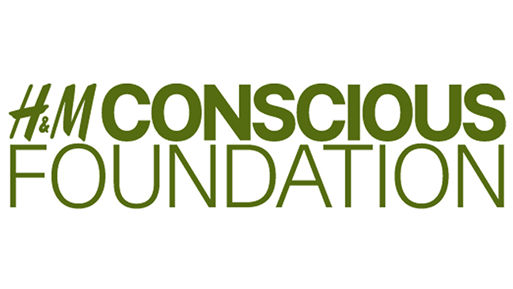

Final Report

"Women Economic Empowerment Project"

1st July 2016 – 20th April 2017

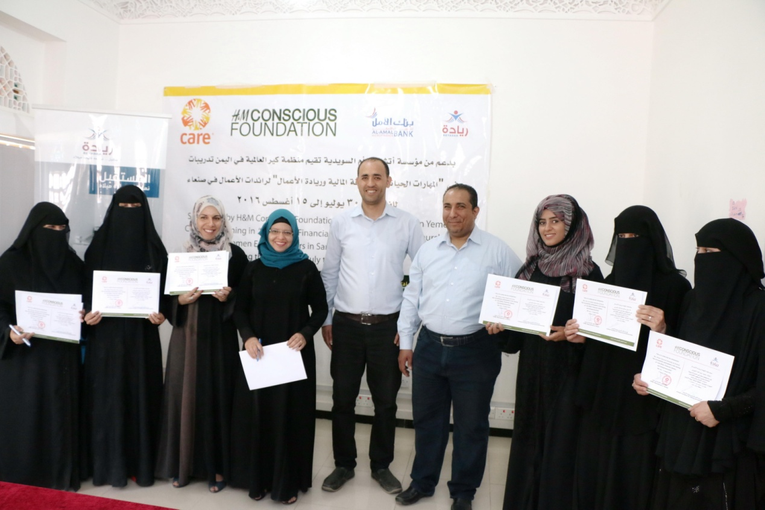

Project Summary Sheet

Project's title | Women Economic Empowerment Project in Yemen
Implementing Partner | CARE International in Yemen
Country | Yemen
Geographic areas | Sana'a and Aden governorates
Target beneficiaries | 310 Women
Budget | EUR164,447
Project ID | CN798
Reporting Period | 01st July 2016 – 20th April 2017
Contact information:  Primary Contact Name:  Position/Title:  Address:  Phone:  Fax:  Email: | Jolien Veldwijk  Assistant Country Director - Programs  Hadda Area, off Iran Street, Sana’a, Yemen  +967717686815  +9671433463  jolien.veldwijk@careyemen.org

Table of content

Section 1: | Executive summary
Section 2: | Problem description and justification
Section 3: | Project objectives
Section 4: | Project outcomes
Section 5: | Challenges and action taken
Section 6: | Lessons learned
Section 7: | Sustainability
Section 8: | Expenditure and resources utilization
Section 9: | Annexes:  - Financial summary  - Human interest stories  - Documentary film

1- Executive Summary

CARE has been implementing the pilot project of "Women Economic Empowerment" funded by H&M Conscious Foundation - Lasting Change Fund for a period of ten months from 1st July 2016 to 20th April 2017. The overall objective of the project is to empower the Yemeni women economically and socially through providing set of activities in awareness raising, training, coaching and mentorship related to the entrepreneurship and enterprise development, in addition to provide an opportunity for entrepreneurial women who lack access to funding with interest-free loans to start up or growth their small businesses to overcoming poverty and improve livelihoods.

The project successfully implemented all the planned activities whereby, by the end of the project's period, 327 women benefited from various components of the project. 67 women received package of training in life skills, financial literacy and entrepreneurship followed by coaching and consultancies; 260 women attended awareness sessions on the importance of women economic and social empowerment; and 13 women have been financed with interest free loans and started/developed their small businesses and created job opportunities for about 64 persons, most of them are women.

The targeted women were selected according to specific criteria that included minimum age of 18 year-old, disadvantaged women, work experience of not less than six months of the supposed business mentioned on the application form, innovation and creativeness of the business with contribution for creating job/employment opportunities for other women, commitment to start up or grow an existing business with focusing on sustainability, and women-managed business.

This report provides detailed information on achievement of project objectives and outcomes; challenges and actions taken to address; sustainability; lessons learned; and expenditure and resource utilization. The annexes of this report includes financial utilization, human interest stories and a documentary film produced under this project.

2- Problem Description and Justification

Yemen is considered the poorest country in the Middle East and North Africa, with a population of almost 25 million and a population growth rate of almost 2.6%, according to 2011 estimates. According to the Global Gender Gap Index report of 2014, Yemen ranks 142th out of 142 countries; and since 2006 it has been consistently ranked last. The report also highlighted that women earn $1,751 compared to $6,343 earned by men; 50% of women are literate, compared to 83% of men. In terms of education, 79% of girls and 84% of boys are enrolled in primary education; 34% of girls and 51% of boys are enrolled in secondary education; and 6% of girls and 14% of boys are enrolled in tertiary education. The average lifespan for a woman is 55 years and for a man 54 years. Nearly 54% of all Yemenis, who number about 25 million, remain below the poverty line; and unemployment rates have risen to 40.3%. Yemen’s population has doubled in size since 1990 and is projected to almost double again by 2025, from 19.7 million in 2004 to 38 million in 2025; and it ranks 160th out of 188 countries in the Human Development Index (HDI)³.

Women’s economic rights and opportunities in Yemen are undermined by social barriers, patriarchal tribal customs, widespread illiteracy, and women’s ignorance of their economic Rights. Women’s financial dependence on their male relatives or husbands continues due to a combination of cultural and economic factors, and the gender gap in education remains as large as ever. According to the gender assessment conducted by USAID, there are large gender gaps in terms of labor force participation between adult men and women (74% vs. 24%), and male and female youth (53% vs. 37%), and both adult and young women are much more likely to be unemployed as compared to their male counterparts (12% of adult men vs. 55% of women; 26% male vs. 74% female youth). Furthermore, harassment and difficulties working in the formal private sector, the lack of access to capital or credit, lack of awareness of economic empowerment programs for women, and social and cultural norms that discourage women from practicing key entrepreneurial behaviors like competitiveness have been other barriers that hindered women from participating in economic activities.

This situation has been deteriorated tremendously due to the severe conflict and war that escalated since March 2015, leaving women and youth with even fewer opportunities for formal employment in the public or private sector. Thus, their potential, inherent optimism and energy remains unrealized and their active participation in decisions that affect their lives and communities is limited.

Through Women Economic Empowerment Project funded by H&M Conscious Foundation, CARE International in Yemen aims at creating economic opportunities for women and enhancing their inclusion and participation through increasing their skills and knowledge and enhancing their self-employment/entrepreneurship potential to improve their livelihoods in this difficult economic situation.

3- Project Objectives

- 60 women receive training in life skills, financial literacy, and entrepreneurship with receiving mentorships/consultancies in business development.
- 10 women receive interest free loans to establish/develop their own small businesses.
- 250 women receive awareness sessions about the importance of WEE and entrepreneurship.
- Conduct a WEE workshop to come out with set of recommendations to empower women economically and socially in Yemen.

4- Project Outcomes

The project has reached 327 women with various activities, exceeded its target of supporting 310 women. 67 women received training package in life skills, financial literacy and entrepreneurship followed by coaching and consultancies in business development; 260 women attended awareness sessions on the importance of women economic and social empowerment and entrepreneurship, and 13 women have been financed with interest free loans and started up/developed their small business with creating job opportunities for about 64 persons, most of them are women.

Outcome 1: The project has provided package of training in life skills, financial literacy, and entrepreneurship and mentorship activities to 67 women. The achievement exceeded the planned target of provision of training for 60 women. The life skills module includes self-awareness, positive thinking, planning, time management, stress management, relationships, initiatives and responsibility, effective communications, and leadership. The training on Life Skills has enhanced the self-confidence of women and boosted their potential capabilities to involve in the economic and social activities in their communities. The curricula used in this training was Stepping-Stone for Business Youth that includes vital subjects in life skills and developed by CARE International in Yemen.

The Entrepreneurship module includes subjects on small and medium business management, marketing, accounting, business plan development, in addition to other themes such as market exploration, market study, risks identification, set up business, sales development, reaching potential customers, planning for the unexpected circumstances including conflict, and expand the business scale. The training on entrepreneurship has enriched the entrepreneurial skills and knowledge of women to have clear, depth, and thoughtful enterprise feasibilities. The curricula used in this training was Stepping-Stone for Business Youth developed by CARE International in Yemen, in addition to Build your Business BYB curricula deigned by International Youth Organization and Microsoft International Company.

The Financial Literacy/Education module includes five main subjects: savings, budget management, banking, debt management, and financial negotiations. Financial Education Core Curriculum is designed by Microfinance Opportunities and Freedom from Hunger through the support of Citi Foundation and it is used by different organizations around the globe. This curricula empowers the beneficiaries to shift from reactive to proactive financial decision making and provides them with the attitudes, knowledge, skills, and self-efficacy that they need to adopt good financial management practices in terms of earning, spending, saving, borrowing, and investing. Ultimately, it enables people with the confidence and ability to take greater advantage of the financial services – formal and informal – that are available to them, giving them a sense of control in their day to day lives.

These training have been delivered through Al-Amal Foundation for Training and Entrepreneurship Institution and also by professional trainers and consultancies.

Outcome 2: The best 13 business plans out of 83 women applicants have been selected by a specialized panel consists of entrepreneurship experts. A designed evaluation form used to evaluate the feasibility of the business plans includes four parts about the technical, marketing, financial and the well-organized business plan written, where the business plan should be logic and applicable and there is demand for the service/project in the market, and also should be distinguished with creativity and innovation, with taking into consideration the grades of attendance, participation, behavior for each participant during attending the training. The 13 female winners received the interest free loans. The loan ranged from YER400, 000 to YER 3,488,250 equivalent to $1,712 to $13,953 (exchange rate 1$=YER250). The loan covered the needs of the operational cost for the first three months of the enterprises such as place renting, water and fuel for the electricity, in addition to other operational materials needed for operating the enterprises. Most of the loan amount was given in kind through Al-Amal micro-finance bank except transferring some cash amount to the accounts of the beneficiaries to assist them in covering the cost of extracting work permits and to cover other expenses such as transportation and communication needed for establishing their enterprises.

Other supports have been provided to the beneficiaries such as provision of grace period of four months from the date of establishing the business, and period of three years for repayment the loan in installment. It is believed that this facilitation gives them enough time to operate their small business for earning income before starting the repayment process. The guarantees varied according the ability of each women where commercial guarantees, civil servant guarantees and simple personal guarantees were accepted. The thirteen selected women have received extensive coaching and consultancies in business development and financial record keeping. They have also been provided with legal consultancies related to the enterprises in terms of the labor law and required work permits, taxations, etc that facilitated their process to establishing/developing their businesses. Accordingly, Seven (7) new small businesses have been established and six (6) were developed (grow the existing business). The type of small businesses includes Tailoring centers, pastries, hairdressing and beauty Salon, medical lab, women café, handicrafts, handmaid accessories, incense and soap making, and trading of cloths.

Bushra Waleed, 26 years old, one of the beneficiaries in Aden governorate and the breadwinner of her family happily said "this opportunity of accessing the interest-free loan enabled me to construct a Pastry Shop in our yard instead of renting a shop, which is expensive and far away from our house. This has alleviated the heavy burden of paying rent. Moreover, I am able to recruit five unemployed members of my family including my father to assist me in operating my 'River Pastry Shop'".

Table (1) illustrates the names of the beneficiaries, amount of the loan, and kind of business

# | Names of winners | loan in $ | Kind of business & Remarks | Governorate
1 | Aumima Nor-Aldeen Al-Dubaie | $1,712 | Developed a small existing traditional handicrafts shop on a corner in a mall | Sana'a
2 | Asma Abdullah Ismail Al-Ghashm | $13,488 | Developed existing tailoring enterprise
3 | Helalah Sadiq Aidh Al-Hakami | $3,767 | Established tailoring enterprise
4 | Asma Ali Al-Domani | $9,380 | Established hairdressing & beauty salon in her at house
5 | Salma Saad Saleh Al-Ferasi | $13,953 | Established Women café
6 | Amat Al-Salam Hussin Abu Talib | $8,000 | Developed existing cloth trading enterprise
7 | Sameera Ahmed Bin Abdoon | $2,800 | Developed sweets and pastries business at house
8 | Bushra Mahmood Al-Faqeeh | $3,400 | Developed tailoring business at house
 | Sana'a total loans | $56,500
9 | Athar Abdulhakim Mahmood Mohammed | $6,080 | Developed handmaid accessories/ jewelries at existing small corner on a mall | Aden
10 | Samar Abduljabbar Mustafa Qasim | $13,953 | Established Fast food shop
11 | Bushra Waleed Abdul-Aziz Mohammed | $12,734 | Established pastries and sweets shop
12 | HebaTalal Mohammed Radman | $9,306 | Established medical laboratory
13 | Asma Mohammed Ali Bukhait | $2,767 | Established enterprise for perfumes, incense and soap making
 | Aden total loans | $44,840
 | Total loans | $101,340

Eight (8) women entrepreneurs in Sana'a and five (5) ones in Aden governorate have been supported, and in return, their small enterprises have created job opportunities for about 64 persons most of them are women (31 permanent employment and 23 temporary employment, depending on the seasons and occasions), In addition, the small businesses benefited 90 persons who are the family members of the 13 direct beneficiaries.

Table (2) illustrates the number of direct fixed and variable labor and indirect beneficiaries

# | Beneficiary Name | Fixed labor |  | Variable labor |  | Total |  | Total no.  F & M | # family members | Total no.  Fam & lab
 |  | F | M | F | M | F | M
1 | Aumima Nor-Aldeen | 4 | 0 | 0 | 0 | 4 | 0 | 4 | 10 | 14
2 | Asma Al-Ghashm | 7 | 0 | 3 | 6 | 10 | 6 | 16 | 7 | 23
3 | Helalah Al-Hakami | 3 | 0 | 2 | 0 | 5 | 0 | 5 | 2 | 7
4 | Asma Al-Domani | 4 | 0 | 2 | 0 | 6 | 0 | 6 | 8 | 14
5 | Salma Al-Ferasi | 2 | 0 | 0 | 0 | 2 | 0 | 2 | 6 | 8
6 | Amat Al-Salam Talib | 2 | 0 | 2 | 0 | 4 | 0 | 4 | 11 | 15
7 | Sameera Abdoon | 2 | 0 | 2 | 0 | 4 | 0 | 4 | 5 | 9
8 | Bushra Al-Faqeeh | 3 | 2 | 2 | 0 | 5 | 2 | 7 | 9 | 16
9 | Athar Mohammed | 1 | 0 | 1 | 0 | 1 | 0 | 2 | 6 | 8
10 | Samar Qasim | 2 | 2 | 2 | 0 | 4 | 2 | 6 | 4 | 10
11 | Bushra Waleed | 4 | 1 | 1 | 0 | 5 | 1 | 6 | 10 | 16
12 | Heba Radman | 0 | 0 | 0 | 0 | 0 | 0 | 0 | 9 | 9
13 | Asma Bukhait | 0 | 1 | 1 | 0 | 0 | 1 | 2 | 3 | 5
Total |  | 34 | 6 | 18 | 6 | 52 | 12 | 64 | 90 | 154

Long Distance Coaching:

CARE Netherlands suggested to conduct a pilot distance coaching sessions on monthly basis (from January to May 2017), to be delivered by Dutch women consultants and entrepreneurs. The aim of the coaching sessions is to provide technical support to the targeted women entrepreneurs to develop their small businesses through providing consultancies on how to marketing their products and services, increase the percentage of selling, attracting customers, and bringing new ideas for business development. So far, four sessions have been held through Skype started on 31st January 2017 with five Yemeni women entrepreneurs of Sana'a governorate. Based on the success of this pilot for the women entrepreneurs of Sana'a, the experience will be rolled out to the ones of Aden governorate. The communication between two sides of Dutch and Yemeni women entrepreneurs is considered to be a good experience and it has positive outcomes as mentioned below:

- Sharing information, knowledge, and culture has boosted the relationship between the Yemeni and Dutch women entrepreneurs. Sound business ideas were suggested to the Yemeni women to improve their businesses and make it distinguished through having special logos and brands, and using social media, flayers, discounts, promotional items for promoting their products and services.
- A Facebook page have been established by CARE Nederland for communication purpose between the Yemeni and Dutch women entrepreneurs. There has been good communication for sharing information, but English language is still an obstacle for some Yemeni women entrepreneurs to communicate in English and CARE Yemen team facilitates the translation.
- One of the important results that CARE Netherlands requested to import a sample of the Yemeni handicraft products, which Yemeni women entrepreneurs produced so as to promote it in different exhibitions through the assistance of Dutch women entrepreneurs. This experience motivated the Yemeni women and made them more enthusiastic to participate in such opportunity to promote their products and also to earn additional income. Aumima Noor Aldeen, one of the women who exported her handcrafts was so optimistic saying "I am so excited! as this is my first time to export and promote my special Yemeni tradition handicrafts in Netherlands, and the revenue from this process will assist me to repay some of the loan I got from the project to develop my business. I am aiming to expand my work to reach the international markets in the future, and I wish that H&M project & CARE International will continue providing support to us.
- The communication made the Yemeni women entrepreneurs feel that they are still connected to the international world in spite of the siege imposed on Yemen since March 2015.

Outcome 3: Eleven awareness sessions delivered to 260 women (153 women in Sana'a and 107 women in Aden) who were selected according to same criteria mentioned in the executive summary for the purpose of targeting them again for more extensive training, mentorship, and other activities in the phase II of the project as a kind of sustainability and improvement. The themes of the sessions were focused on the concepts of small businesses and analysis of the risks accompanied with; the roles of women in running small business to overcome poverty and improve the livelihood conditions especially during the current difficult economic situation due to the war; innovation; and gender related issues. Attendants of the awareness sessions expressed positively about the importance of such sessions among women and they were so enthusiastic to be enrolled in any such economic empowerment activities to assist them in getting dignity life through having small businesses.

Outcome 4: A workshop on women's economic role was held on 16 March 2017 and the workshop aimed to discuss on opportunities and challenges; to share experiences and lessons learned; and to come-up with plausible recommendations to enhance and support the role of women economically and socially in Yemen. 40 people from local and INGOs, microfinance banks, private sector, government offices, CARE, and 10 women supported by this project participated in the workshop, the ten women entrepreneurs shared their experiences and challenges and this has added good momentum to the workshop. They described in detail the challenges that they have been facing due to the deteriorated economic situations in general and also the difficulties of the procedures of the micro-finance institutions - mainly the strict requirement of guarantees - that hindered too many youth and women to take loans for establishing enterprises. The workshop included open working group discussions to identify the challenges and the roles of the government, micro-finance institutions, private sectors, and INGOs to support women and youth economically especially during the current situation of war. The following set of recommendations have been discussed during the workshop:

- Establish effective network that consists of the concerned institutions to share information and facilitate coordination for providing the required services such as technical and vocational training, mentorship, loans, fund guarantees to support the beneficiaries in building their capacities and encouraging small businesses. In addition, the network needs to support entrepreneurs to link them with markets and other that have stakes in the market.
- Development facilitated finance products for women and youth should be promoted.
- Build the capacity of the microfinance institutions' staff in gender sensitivity and customers' service especially towards women.
- Provision of business' incubations for women and youth to access the information, share knowledge, and developing their businesses.
- Raise social awareness to support the role and participation of women in the community.
- Conduct regular workshops to discuss the emerging challenges and working to address/mitigate the challenges.

5- Challenges and Action Taken

The targeted women as well as their businesses have faced different challenges, which included:
Economic and security challenges: The deteriorated economic and security situation was the biggest challenge. Though the WEE project provided good work opportunities to women especially in the time of severe lack of job opportunities because of the war, the negative effects of the war (inflation, absence of salaries for civil servants for the last six months, and poor purchasing power) hindered the women's progress in operating their businesses to earn income, improving their livelihood's conditions. This deterioration of people's purchasing power resulted in low demand for products and services of the project-supported women entrepreneurs and this has eventually made them unable to repay the loans timely. To mitigate this challenge, CARE supported the women entrepreneurs to have resilient business through provision more facilitation on the procedures of loan repayment until the situation gets improved.

Social challenges: Social challenges are connected to the culture and traditions related to negative attitudes to the role of women economically and socially in the community. Following are some examples which have been reported by the supported women during implementation the project activities and establishment the businesses in Sana'a and Aden governorates:

- Two women enrolled the project's activities and were selected to get the loans because of their excellent business plans. However, they were hindered by their husbands to establish their enterprises for the reason that the women would deal with men during the process of taking the loan in the microfinance bank premises and in other government offices for extracting the work permits and other related documents, in addition to dealing with the customers of men. Although CARE team tried repeatedly to support the women, it was very difficult as this could cause more tension between the women and their husbands. Nevertheless, CARE would still consider these women for any future opportunities. On the contrary, it is worth mentioning that some gender transformation have been noticed as many women became the breadwinner for their families instead of men who joined the armed groups or became unemployed, or not receiving their salaries due to the war. Asma Al-Domani, hairdressing and beauty salon worker in Sana'a governorate said "My husband encourages me too much to take this opportunity provided by the project and to participate in every activity and to run my business too especially that he has not received his salary more than seven months and he became unemployed because of the war"
- Discriminatory practices towards the women by men in the workplace has also affected the women entrepreneurs. Women have reported that most of the shop owners refused to rent them a shop in the market as a kind of non-trust and underestimation till the men relatives of the women are presented to sign the contract between the shop owner and the women. In addition, wholesale traders delayed the delivery of good ordered by the women's. Moreover, some women exposed to verbal violence, and to inappropriate behavior by men competitors of putting the rubbish in front of their shops to annoy them. Sammar Qasim, divorced with three children dependents and also running a pastry shop in Aden governorate said angrily with sadness on her face "I find stack of trash at my shop's door every early morning, the sellers around annoying me with putting such things, but it is OK, if they continue putting trash, I will also continue cleaning it and continue working in my sole income source of pastry shop, which I depend on to meet the basic needs of me and my family." CARE is planning to work on enabling the environment through awareness raising activities among men and boys about gender, social behavior and the importance male's support to the positive roles of the women in the society.

Micro-finance banks challenges: In general, accessing the services of micro-finance banks specifically for getting loans was one of the main challenges faced by disadvantaged women and youth due the bank's strict procedures and the requirement of guarantees. Although repayment even during the peace situation has been challenging, it becomes more complicated and challenging after the escalation of the war in March 2015 where most of the micro-finance banks are being stricter and decreased increasingly giving loans due to the potential risks of non-repayment by the clients because of the extreme deteriorated economic situation. The project supported women entrepreneurs in accessing interest free loans through Al-Amal micro-finance bank. Nevertheless, it is worth mentioning that Al-Amal bank has strict policy of financing procedures which has took long time in facilitated the loans and this in its turn delayed establishing most of the small businesses. The project team supported the women especially those who were unable to provide the minimum required guarantees by the bank. Thus, since most of the businesses have been started up or developed in the late period of the project, it is early to give concise information or indicators about the percentage of the selling, revenue, savings, and expenditure of the enterprises. This information will be collected in the next months to measure the success of these enterprises and this information will also assist in the evaluation of the enterprise and addressing any challenges facing them.

6- Lessons Learned
- The project has good impact in the society, which encouraged high number of women to demand for enrollment in the project to improve their livelihood and to overcome the economic challenges.
- Providing life skills, entrepreneurship and financial literacy training to the women assisted much to build their self-confidence, manage their time, to plan and organize their work, and improve their entrepreneurial skills, financial and management skill.
- Provision regular mentorship and consultancies to the women entrepreneurs and evaluation their established/developed enterprises are highly important to enhance the sustainability and resilience and also finding alternative solutions in this very challenging and fluctuated situation.
- In addition to the training and consultancies, supporting women with interest free loans adding real value in enabling women to have their own businesses and to be linked to the market for earning income. This has also assisted them to be linked with the MFI and be aware of the MFI services and procedures.
- The limitation of budget as a pilot project confined the activities on providing technical entrepreneurial training and mentorship support. However, providing vocational training in any future project will contribute highly to the quality of the services and products of the women.
- In addition to the very modest budget and tight time for providing the best business plans to CARE Netherlands on 30th May 2016 in the preparatory phase, the selection process depended only on mapping 13 local institutions - which work on women and youth economic empowerment - to nominate the best women entrepreneurs for applying to the project's opportunity. Ideally, this process should have been announced publicly with having a team to interview the applicants, checking and ensuring the suitability with the criteria. Nevertheless, there was a good selection process through a specialized panel in Yemen in coordination with CARE team for selecting the best business plans received.
- Considering the difficulties in accessing MFI services and according to the participant's recommendations of the workshop held on 16 March 2017, there is a need to develop a special facilitated finance product to empower women and youth economically especially during humanitarian crisis.
- There is a need to build the capacity of MFIs staff in gender sensitivity and customer's services especially with women for more consideration and facilitation.
7- Sustainability
Sustainability is considered as one of the objectives of the development projects implemented by CARE International in Yemen based on the solid ground of the quality services provided to the beneficiaries which enhance the knowledge, skills, confidence and assist in income-generating activities. In addition through partnership with the stakeholders and linkage the beneficiaries with MFIs, the WEE project will work on the following to ensure sustainability:
- Regular monitoring and assessment of the business environment and activities of the supported enterprises to ensure their success and feasibility in improving the livelihood condition of women.
- Al-Amal micro-finance bank will keep following up the financed women for loan repayments and progress checks, while CARE will keep following up with Al-Amal bank for progress reports and any needed support to the women.
- The second phase of the project, which aim to build on the first phase, will work actively on the sustainability objective through expanding its activities to support the targeted women in the first phase, in addition to increase the number of the beneficiaries.
8- Expenditure & Resource Utilization
At the preparatory phase of WEE project during the period from 15th March to 30th June 2016, a modest amount of $3,420 had been spent from Foundation for Peace Project to cover the cost of some activities such as selecting the best business plans, conduct workshop on business plans development each in Sana'a and Aden governorates to 53 women with two days of mentorship, and selecting the best business plans through a specialized panel. In addition, the above-mentioned amount also covered the cost for translation of 19 selected business plans from Arabic to English for the purpose of sending it to CARE Netherlands for the final evaluation and selection the winners to receive the loans for establishment their small businesses. Then the launch of WEE project funded by H&M Conscious Foundation started on 1st July and was planned to end on 31st December 2016 with a budget of EUR153,606 to cover training and consultancies activities, to financing ten women to establish/develop their small businesses, and also to cover the operation cost of the micro-finance bank which implements the financing activity. Since the financing process take considerable time to be implemented and monitoring and evaluation of the established businesses need enough time to follow, the project period has been extended until 31st March 2017. The project secured additional amount of EUR10,841 and targeted higher number of beneficiaries with training and awareness sessions; this makes the total budget of the project EUR164,447. Additional fund added to this project thank to CARE Australian (AUD 5,130 - USD 3,877.25) to co-finance the documentary film and monitoring activities in Sana'a and Aden governorates
Project Total Allocation | Fund utilized during reporting period
H&M Project  EUR 164,447 | EUR 164,447
FFP contribution  USD 3, 420 | USD 3, 420
Australian grant  USD 3,877.25 | USD 2,041.24

9- Annexes:
Annexes I: Financial summary
Annexes II: Nine human interest stories
Annexes III: Documentary film

CIA World Fact book
UNDP, Global Gender Gap Report; http://reports.weforum.org/global-gender-gap-report-2014/rankings; 2014
Ibid
Manea, Elham; Yemen, https://freedomhouse.org/sites/default/files/inline_images/Yemen.pdf; 2010
Ibid
USAID (2014): Yemen Gender assessment
Ibid

