

A Final Report for the Kellogg Foundation
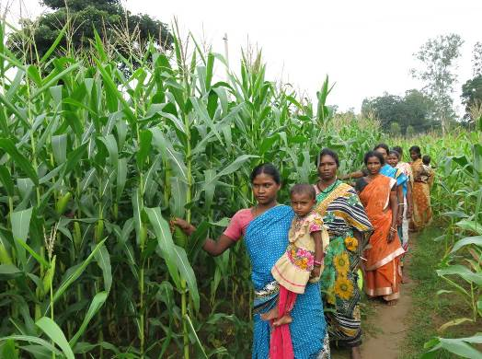

Project Name: Empowering Women Smallholders and Enhancing Maize Productivity

Project Location: Papadahandi Block, Nabrangpur District, Odisha State, India

Project Duration: 15 Months (February 2015 – April 2016)

Reporting Period: February 15, 2015 – April 30, 2016

Grant Amount: $230,000

CARE Contact: Abby Davidson Maffei (adavidsonmaffei@care.org)

Background

The project Empowering Women Smallholders and Enhancing Maize Productivity was implemented with the overall objective to empower women smallholders from the most marginalized communities, namely from scheduled caste (SC) and scheduled tribe (ST) communities. The project set out to increase their farm productivity, along with household incomes and nutritional status, and build a strong and sustainable maize value chain in the Nabarangapur district of Odisha. Papadahandi block of Nabarangpur district was selected for the project interventions, based on the intensity of maize cultivation there, and a high concentration of SC and ST populations. The productivity of women smallholders cultivating maize traditionally is low due to fragmented landholdings; lack of access to quality inputs like seeds, fertilizers, and credit; and lack of knowledge on maize productivity enhancement techniques and information about markets and entrepreneurship opportunities. The project aimed to plug those gaps and address key issues that adversely affect women empowerment along the maize value chain (MVC).

Goal: To empower women smallholders and increase their productivity, income and nutritional status, to build a strong and sustainable maize value chain.

Objectives:
- To promote adoption of improved maize production, post-production and marketing practices and technology by women smallholders.
- To strengthen women’s access to inclusive and equitable input and output markets.
- To foster support and positive attitudes among men in households and other key actors for women smallholders.

Target Population: More than 70 percent of the total population in Nabarangapur district is made up of SC and ST groups. Similarly, ST and SC women constitute 70.6 percent of the total female population of the district. Nabarangapur has been declared the “Zero District of India” because of its lack of most modern amenities such as drinking water, electricity, cooking fuel, education and sanitation. CARE finalized Papadahandi block for interventions after evaluating 10 blocks of the district through a rigorous assessment exercise. Twenty villages in the block were selected for intervention, based on the intensity of maize cultivation and a high concentration of SC and ST populations in those villages.

Project at a Glance

Number of People in Impact Group (Total) | 5,595
Number of People in Impact Group (Indirect Reach) | 4,560
Number of People in Impact Group (Direct Reach) | 1,035
Number of Women Farmer Groups | 90
Number of Project Villages | 20
Number of Gram Panchayats (Village Councils) | 9

Project Goals, Activities and Results

Objective 1: To promote adoption of improved maize production, post-production and marketing practices and technology by women smallholders

Activity 2.1.1: Maize Value Chain Analysis
Project staff conducted a qualitative MVC analysis to fully understand the issues and challenges faced by the impact population and the constraints that hinder their ability to increase productivity and market engagement. Major gaps were identified in all phases of the process: pre-production, production, post-production and market access. Among the issues identified: exploitation by local moneylenders; unfair trade practices; limited access to market information; limited knowledge about quality of agri-inputs; and lack of knowledge on post-harvest management of produce. Solutions and project facilitation activities were identified to address those critical gaps as part of the analysis.

Activity 2.1.2: Gender Analysis
Gender analysis across the MVC in all project villages helped identify inequities in the access to and control over resources and opportunities. The analysis helped in collecting data to track and evaluate project progress and impact related to gender. The analysis found gender inequality in terms of access to and ownership of key resources such as tractors, sprayers, fertilizers and pesticides; unequal division of labor at home; and unequal wages (men: $2.22 per day; women: $1.48 per day). The findings guided CARE in developing and adopting a comprehensive gender integration strategy in program implementation.

Activity 2.1.3: Stakeholder Mapping
A mapping exercise helped identify the major stakeholders from the government as well as private actors connected with maize. Similar programs implemented by other agencies were also identified. Some of the relevant projects that are being implemented in the district are Odisha Tribal Empowerment and Livelihood Program, Mission Shakti for Women and Child Development, District Agriculture Department and Odisha Livelihoods Mission. Initial rounds of meetings and concept sharing sessions were held with key development actors. The focus of these discussions was to identify common areas of interest where collaboration is possible for efficiency and effectiveness. Also, the project team visited the Indian Institute of Maize Research in New Delhi in order to better understand the critical components required for improving maize productivity, disease and pest management practices during pre- and post-harvest management, value addition, etc.

Activity 2.1.4: Baseline Study
A baseline study was conducted to establish qualitative and quantitative values against selected outcome and impact indicators of the MVC in Nabarangpur district. Besides providing information on maize production, post-production, marketing practices, access to finance, technology and gender equity, other important factors were measured, including the Women’s Empowerment Index, food security (about 17 percent of households are facing food shortage in different months), and coping strategy index.

Activity 2.1.5: Capacity Building of Frontline Officers
Five frontline officers known as local resource persons (LRPs) and four members of the project’s field staff were provided a training of trainers (ToT) on improved agricultural practices (IAPs) by CARE’s technical expert on sustainable agricultural practices. The clarity in understanding was critical for effective transmission of knowledge and skill to the women maize farmers from the project area. The frontline officers and the field team also went through exhaustive training on gender issues involved in maize cultivation. Further brainstorming sessions were held to integrate gender into a detailed implementation plan designed for the project. The trainings enabled the field staff and frontline officers to implement project activities in a gender-sensitive and participatory manner.

Activity 2.1.6: Training of Women Farmers Groups on Improved Agriculture Practices
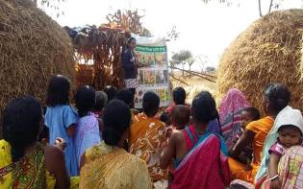
Information, education and communications (IEC) material on IAPs were developed for training in rabi and kharif crops (winter and monsoon seasons, respectively) for sensitizing women farmers on improved maize cultivation practices. In total, 772 women smallholders received training on improved pre-sowing and sowing practices for kharif and rabi seasons. Through these trainings, the women smallholders developed skills on improved pre-sowing practices, including soil testing, deep plowing, seed testing, seed treatment, land preparation, recommended fertilizer doses and application, use of farmyard manure, line sowing and intercropping, for better production and soil fertility conservation. Four trainings were conducted in which a government entomologist trained the women farmers on integrated pest management practices for maize. In total, 617 maize farmers were trained on effective pest management and disease control. Also, 907 women farmers were trained on how to ascertain the right time to harvest maize to get and maintain better quality standards. To overcome poor post-harvest practices, 948 women farmers learned strategies for proper drying, cleaning and grading of maize to increase the quality and marketability of their produce.
Training on improved agricultural practices in Labanyapadar village

Activity 2.1.7: Strengthening the Maize Value Chain Through Capacity-Building Initiatives
To create an enabling environment in which women maize farmers can enhance productivity and gain more value for their produce, MVC trainings were organized in all the project villages. During the project, 170 farmers – about 34 percent of the total impact population – went through MVC training, which provided them information on improved agricultural practices and access to credit; agricultural inputs, equipment and tools; and market facilities.

Activity 2.1.8: Exposure to Krishi Vigyan Kendra (farm science center)
Two exposure visits to the KVK (in Umerkote and Semiliguda) were organized for 125 women smallholders from 20 villages so they could see demonstration plots of improved agricultural practices for productivity enhancement. The farm manager of KVK also offered insight on the importance of organic azola and vermi composting for better yields.

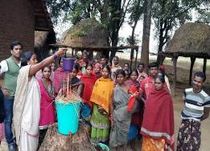
Activity 2.1.9: Exposure Visit on IAPs
Local resource persons and field officers visited the International Maize and Wheat Improvement Center at Baripada in November 2015. After the visit, the LRPs provided training to the communities – focusing on members of women farmers groups – and provided them hands-on support to replicate the best practices to enhance their maize productivity and incomes.

Activity 2.1.10: Training on Vermi Wash
Trainers showed women farmers how to better manage soil without the indiscriminate use of fertilizers to ensure sustainability of yields. During exposure visits to KVK, the farmers acquired an understanding of the potential of using a vermi wash on crops. Subsequently, 377 women smallholders were trained by a resource person in preparing vermi wash liquid fertilizer on their own. In addition to the training, 10 vermi wash demonstration units were piloted in 10 project villages with progressive women farmers. This has enabled them to prepare their own liquid fertilizer at home with locally available materials like earthworms, cow dung, leaves and vegetable peels.
Demonstration of vermi wash in Miriguda

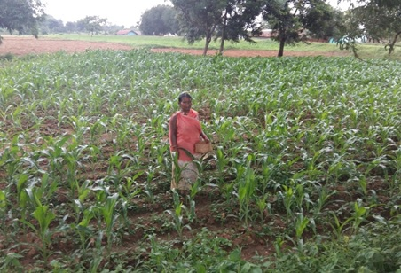
Activity 2.1.11: Demonstration Plots
Thirteen women smallholders from 13 project villages came forward to set up demonstration plots for showcasing the benefits of improved cultivation methods. The project provided all the inputs required, and the landowners contributed their labor and took care of land preparation, seed treatment sowing, weeding, cleaning and irrigating. Ultimately, the maize cultivation in demonstration plots yielded about 65 percent more than the maize grown with traditional methods.
A demonstration plot
A maize demonstration plot in Labanyapadar

Activity 2.1.12: Introduction of Improved Agricultural Implements
Maintaining a recommended percentage of moisture in the product is a critical quality parameter in maize. In order to access irrigation in the winter season, members of 30 women farmers groups were linked to International Development Enterprises to buy 30 pedal pumps at a subsidized cost. Twenty electronic moisture meters were provided to select women farmer groups, along with orientation on how to use them properly. Now all the maize farmers in the project villages routinely measure the moisture level of their crops and maintain the ideal level of 14 percent. Also, massive sensitization drives were held in 10 project villages, where local resource persons used pictorial materials to teach the do’s and don’ts of selling maize. (Pictures are critical to help farmers understand weighing scales, since most have had little or no education and no exposure to such tools.) To further minimize the potential for unfair business practices by village traders, 20 weighing scales (each with a 100 kg capacity) were installed, with project support, in 20 villages, including 10 that were newly selected.

Activity 2.1.13: Rainwater Harvesting Structures
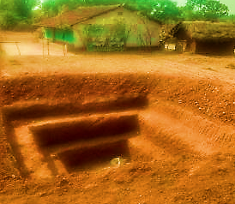
Twenty-eight rainwater harvesting structures were built in 13 project villages. Because the structures are built on 5 percent of the area of the farmland, they are known as the 5 percent model. By capturing rainwater and reducing the spread runoff, 5 percent pits lead to deeper percolation, more reliable refill of groundwater wells and reduction of scouring/eroding risks. The excavated soil is used to build a mound of earth around the pit or to level the field. The 5 percent model of water harvesting has been implemented as a measure for climate change adaptation, since it helps maintain soil moisture content and the water table. Further, these water harvesting structures serve as drought-proofing measures by enabling farmers to access protective irrigation during scanty rainfall or extreme dry periods. Also, these structures will provide irrigation during the rabi season, which will enable tribal farmers to cultivate green, leafy vegetables in small plots adjacent to the structures and help them meet their families’ dietary and nutritional needs.
Rainwater harvesting structure in Nabarangapur

Activity 2.1.14: Market Information Boards
Market information boards were installed in 20 villages (including 10 operational and 10 newly selected) to display the seasonal minimum support price set by the government for various crops, including maize. Now, the women farmers and villagers are aware of the current market rates of maize in the local and distant markets and bargain with buyers for better prices for their produce. Leaders of women farmers groups market information boards and update the information weekly.

Objective 2: To strengthen access of women to inclusive and equitable input and output markets.

Activity 2.2.1: Promotion of Women Farmers Group (WFGs)
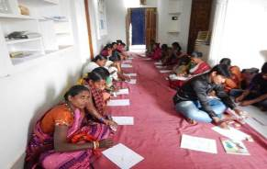
Ninety women farmers groups have been promoted and encouraged to adopt collective marketing as a strategy for minimizing cost and maximizing income. Since most of the impact population are small-scale farmers, their production volume is usually low. The costs of transportation, packaging, labor, etc., drive their meager profits even lower. However, by doing pre-marketing activities collectively, the costs have been equally distributed among the farmers, which leads to a reduction in overall cost of inputs. The increased volume of maize due to aggregation also puts the farmers in a much stronger position to negotiate with traders. Through this project, 387 women farmers were trained on aggregation of maize for collective selling. This strategy increased incomes between 15 and 20 percent.

Activity 2.2.2: Leadership Training for WFG Leaders
With the support of a consultant, the project provided leadership training to 20 group leaders to help foster their skills and confidence in management, leadership, activities and vision-building.
Women farmers group leaders participating in training

Activity 2.2.3: Functional and Financial Literacy Training of Women Farmers Group Leaders
The baseline study of the project revealed that farmers were not keeping proper records of their farming activities, such as cost of production, average yield and income realization. Therefore, they could not be sure of the positive or negative effects of any particular practice. Financial literacy trainings were organized to make women farmers aware of the importance of keeping track of their income and expenditures and maintaining these records. In total, 180 leaders from 90 women farmers groups went through functional and financial literacy training.

Activity 2.2.4: Audio-Visual Shows on Fair Business Practices
Given the low literacy levels among the impact population, audio-visual shows on the maize value chain were presented at the village level to create mass awareness. Video clips on fair business practices were developed, and video shows were organized in all 10 intervention villages to sensitize farmers about common unfair practices and to orient them on fair practices like proper weighing, maintenance of proper quality, standard packaging, negotiation with traders, collecting information on market prices from different markets. Twenty audio-visual shows were organized in 20 operational villages, and 915 women farmers were trained on fair average quality and fair business practices.

Activity 2.2.5: Exposure Visits for Fair Price Negotiation
Eighty women smallholders were introduced to various self-help groups in the neighboring district that had been part of CARE’s Pathways project, which aimed to increase the productivity and empowerment of women farmers in more equitable agriculture systems at scale. Negotiating for fair and competitive prices with market actors has never been easy for women smallholders. For this project, the participating women farmers were taken to the Pathways-promoted self-help groups in Kalahandi district to gain some confidence to handle the traders and to negotiate for fair prices for their produce. This has helped the women farmers learn to manage the economic aspects of the entire maize value chain process by seeing their peers taking part in marketing activities.

Activity 2.2.6: Buyer-Seller Meetings
Through two buyer-seller meetings, 63 women smallholders, along with 24 male farmers, went in two groups to meet and negotiate for fair prices for their produce. They met market actors at the village (Basini and Kadambaguda), block (Papadahandi and Umerkote) and district (Jeypore and Nabarangpur) levels. The farmers got a comprehensive perspective of maize and the related market factors that influence its price. They negotiated with traders about prices, weighing plans, direct procurement of maize from the villages, etc.

Activity 2.2.7: Meeting with the Regulated Marketing Committee

Thirty-four women smallholders, along with 11 male farmers, went to the regulated market committee (RMC) in Nabarangpur to discuss the government’s strategy of helping women maize farmers. The farmers and the RMC secretary had a lengthy discussion about opening a procurement center at the local level. The farmers also applied to open a maize collection point in their cluster villages, where produce can be sold.

Objective 3: To foster support and positive attitudes among men in households and other key actors for women smallholders.

Activity 2.3.1: Meetings with Value Chain Actors
Negotiations with private traders were organized in Nabarangapur, Umerkote and Jeypore for marketing of the produce of 2015-16 kharif season. Institutional linkages with the government marketing institutions – including the RMC, the Tribal Development Cooperative Corporation and Odisha Rural Development and Marketing Society – have helped realize better returns for the smallholders. Women farmers learned about fair business practices and about standardizing and weighing the produce accurately before sending to the market. Also, the project organized three meetings of the WFG members with other value chain actors – including representatives from the banks operating in the block of the Papadahandi, government functionaries from the Agriculture and Technology Management Agency, the District Agriculture Officer, Large Sized Adivasi Multipurpose Cooperative Society – who shared information on programs to aid famers, especially the marginalized women in the area. The women farmers also got a platform to discuss their issues and problems with regard to the availability and accessibility of extension services.

Activity 2.3.2: Financial Inclusion Plan
The project helped promote group savings and account openings in nearby banks, so that women farmers will have access to financial services when needed. Similarly, the project worked with a lead bank to issue Kisan Credit Cards to the farmers in the project villages. Face-to-face meetings were organized with the bank officials and women farmers to disseminate knowledge on different financial schemes for promotion of agriculture in the area. In addition, the project facilitated meetings with local banks so WFG members could open individual accounts.

Project Results

3.1. Increased Maize Productivity
Adoption of improved agricultural practices has led to a significant increase in maize productivity. Before adopting IAPs, farmers reported a yield of 15 quintals per acre. Post-intervention yields are 21 quintals per acre, representing a 40 percent increase. In addition, the quality of the produce in terms of size and number of seeds improved with the adoption of IAPs. The table and graph below give a comparative analysis of the change in productivity after the adoption of IAPs in six villages. (In four other villages, very few farmers cultivated maize in the kharif season due to crop failure in the last year. The remaining 10 villages joined the project after the kharif season, so data is not yet available.)

Table 1: Details of Maize Cultivation (2014 and 2015)
Village Name | Area under Maize Cultivation (in Acres ) 2014 | Volume Produced (in Quintals) 2014 | Average Production per Acre (in Quintals) 2014 | Area under Maize Cultivation (in Acres) 2015 | Volume Produced 2015 | Average Production per Acre (in Quintals) 2015
Kadamguda | 20.20 | 250 | 14.35 | 20.20 | 394 | 17.48
Bhatikot | 96.00 | 1,193 | 12.42 | 96.00 | 1,479 | 15.41
Bariguda | 18.00 | 240 | 13.33 | 18.00 | 280 | 15.56
Miriguda | 2.50 | 43 | 21.20 | 2.50 | 48 | 19.20
Banuaguda | 1.50 | 20 | 13.33 | 1.50 | 26 | 17.33
Labanyapadar | 44.50 | 512 | 11.50 | 44.50 | 765 | 17.19

3.2. Enhanced Income Realization

To help the farmers get better prices for their produce, the project established linkages between the maize farmers and the output-level traders. The following table gives a comparative analysis of income in 2014 and 2015.

Table 2: Details of Turnover and Price Realization

Village | Volume Sold (in Quintals) 2014 | Base Price (in US$) 2014 | Selling price (in $) 2014 | Total Turnover 2014 | Volume Sold (In Quintals) 2015 | Base Price 2015 | Selling Price  2015 | Total Turnover 2015 | Difference in Price Realization
Kadamguda | 250 | 16.09 | 14.92 | 3,730.77 | 394 | 22.31 | 22.31 | 8,789.23 | 5,058.46
Bhatikot | 1,193 | 16.92 | 13.85 | 16,518.46 | 1,479 | 22.31 | 21.38 | 31,627.85 | 15,109.38
Bariguda | 240 | 15.69 | 13.85 | 3,323.08 | 280 | 21.54 | 21.38 | 5,987.69 | 2,664.62
Miriguda | 43 | 15.38 | 13.85 | 595.38 | 48 | 21.54 | 20.00 | 960.00 | 364.62
Banuaguda | 20 | 15.69 | 13.85 | 276.92 | 26 | 21.23 | 20.77 | 540.00 | 263.08
Labanyapadar | 512 | 15.38 | 13.85 | 7,089.23 | 765 | 21.54 | 20.92 | 16,006.15 | 8,916.92
Total | 1,746 | - | - | 31,533.85 |  | - | - | 63,910.92 | 32,377.08

Figure 1: Total turnover (in $) Figure 2: MSP vs. Average Selling Price (in $)
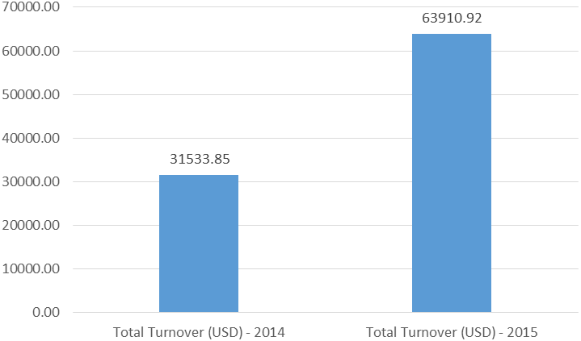
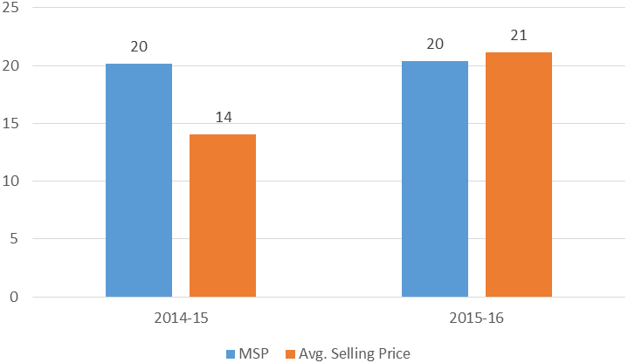

As seen in the tables and graphs above, farmers’ income levels are increasing substantially. In 2014, farmers sold their produce for as little as $15 per quintal; in 2015, they earned $20-$22 per quintal. In addition to improved agricultural practices, many market-related interventions have contributed to this trend, including: post-harvest management methods; maintaining fair average quality of the produce; aggregation marketing; timely dissemination and discussion of market information; exposure visits on market linkage; confidence-building measures; and market negotiation activities.

Challenges and Lessons Learned

Challenges
- Maize farmers have long depended on local moneylenders for crop loans. The cost of maize cultivation is very high, as smallholder farmers use high-cost inputs such as hybrid varieties of seed and chemical fertilizers. To meet the expenses, more than 95 percent of farmers are completely dependent on moneylenders for investment in maize cultivation. Further, the farmers have to repay loans at high interest rates.

- Natural calamities like droughts and cyclones pose continuous threats to maize farmers. About 20 to 30 percent of farmers are not taking up maize cultivation in this kharif season because of bad experiences in the past two crop cycles. The region was hit hard by cyclones Phailin and Hudhud, in 2013 and 2014, respectively. The heavy rains that followed both cyclones affected crops more than the storms themselves. After suffering major crop damage, farmers were compelled to sell their poor-quality produce at throwaway prices.

- Climate change has an ongoing negative impact on farmers in the project area, causing decreased crop production, which in turn has adverse effects on the health/nutrition status of the target population.

- Although much progress has been made, it would be difficult to sustain the activities already initiated without new grant support.

Lessons learned

- Trainings – financial literacy in particular, along with exposure visits and interactions with various market actors – are making smallholder women farmers much more aware of the implications of taking loans from moneylenders and their impact on overall productivity. More and more women farmers groups are using their savings to purchase agricultural inputs for maize cultivation and meeting with local bankers for loan and insurance support.

- In order to reduce the risks of climate variability and natural calamities, discussions need to continue with the agriculture department and individual insurance agencies about providing crop coverage plans.

- Working with existing collectives opens up avenues for collaborating with other development actors, including government departments and other agencies/institutions. Discussions with various development actors are helping to identify areas for potential collaboration.

- For climate change mitigation and adaptation, rainwater harvesting structures (5 percent model) should be promoted with smallholder farmers. The 5 percent reduce the risks posed by climate change and droughts, while enhancing crop productivity.

In Their Own Words: Stories of Impact

‘I want to share my learning’

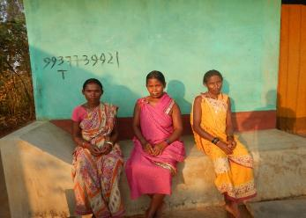
All 150 households in the village of Labanyapadar grow crops for their livelihood. In fact, the Nabarangpur district of Odisha is the largest producer of maize in South Asia. However, the benefits of this proud fact have never extended to the tribal farmers who grow this cash crop. Traditionally, farmers have to take high-interest loans from local traders for seeds, fertilizers and other farm-based inputs. These traders then buy the entire crop from the farmers for very low prices. Because farmers didn’t have direct access to markets, they felt they had no choice but to do business with these unfair traders, locking themselves into a cycle of poverty. Adding to their woes, cyclones Phailin (2013) and Hudhud (2014) wreaked havoc in this village, with more than 80 percent of families affected.

Typically, maize is cultivated between July and October in this area. But after so many difficult years, farmers had nearly given up the crop entirely. In May 2015, though, CARE intervened in Papadahandi block, which previously had been largely unreached by agricultural extension services of both government and nonprofit agencies. Through training and supportive visits, CARE staff members began sowing the seeds of change. Project leaders helped farmers choose tiny demonstration plots, where the inputs from training could be implemented. In addition to sharing agricultural techniques, staff members offered pragmatic guidance on how to increase the profits from growing maize. Among the tips:
Women farmers of Labanyapadar
- Decrease production costs by building on existing savings rather than taking more loans.
- Prepare organic manure and fertilizers that are eco-friendly, rather than spending precious savings or loans on chemical fertilizers.
- Intercrop with arhar (a common legume) to help replenish the soil’s fertility and also to provide an alternative crop in the event of an unprofitable maize harvest.

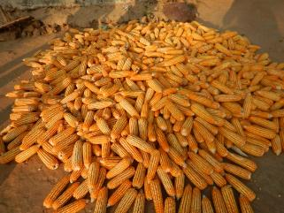
A total of 10 percent of the area’s cropland was dedicated to demonstration plots, and the success was obvious in terms of yield and quality of the harvest. Training was a crucial component of CARE’s project, so that every successful farmer is equipped to share the lessons she has learned. Desired practices – such as deep plowing, seed replacement every three to four years, selection of the right variety of seed for the land type, etc. – soon will become standard practice.
Harvest from demonstration plot

“I started learning the tricks of farming only this year,” says farmer Maansingh Santa. “I know my community. We are like one family, and no family changes in one season. I want to share my learning with the others.”

‘All of this has been possible through women’

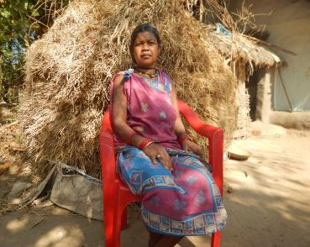
Every year, the farmers of Kadamguda village would go to the local moneylender for cash to buy seed and other agricultural inputs they needed to survive. The interest rate was an exorbitant 10 percent for two months – or 60 percent per year. The moneylender also controlled the prices the farmers got for their produce at harvest, which locked them into an endless cycle of debt and servitude. CARE created a path out of that cycle by empowering women and making them the agents of real change. The strategy builds on an existing women’s self-help group (SHG), which for 10 years has been helping women in this village build strength through their own savings and collective action. Baidi Majhi, one of the group members, said that only 20 households had chosen to cultivate maize this year, following two disastrous years of cyclones and crop loss. All 20 households were poor and had taken loans from the local moneylender. Though the village had always farmed, Baidi said, their knowledge of good agricultural practices was very limited. Two important factors changed when CARE intervened: First, villagers learned about improved agricultural practices, including economic tips; and second, women were fully involved in the training. The women who received the training went home and shared the lessons with their spouses. Together, they implemented the learning from the training in their fields. The results were plain to see: Fields that previously yielded about 15 quintals of maize (post-shelling) now produce about 25 quintals per acre. At the same time, the women farmers have newfound knowledge of how to bargain collectively, how to understand the market and how to negotiate with traders. For the first time, there seems to be a way out of the cycle of poverty. “All of this has been possible through women,” Baidi said. “Our lives have hope.”
Baidi Majhi

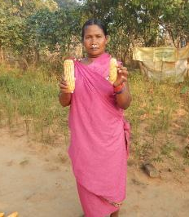
‘The journey has only just begun’

Ratna was skeptical when CARE staff members first came to her village of Labanyapadar and suggested that she and her fellow farmers should go back to growing maize as a cash crop. After two cyclones, in 2013 and 2014, had destroyed virtually everyone’s maize crops, she was hesitant to try it again. Also, she questioned CARE’s advice of reducing the number of plants cultivated – leaving a healthy distance of 2 feet between stalks – and taking out fewer loans from the local moneylender for seed and other farming inputs. CARE staff answered all of Ratna’s questions and left the decision to her. Farmers are accustomed to risks, of course, whether it’s too much or too little rainfall, attacks from pests or natural disasters. Ultimately, Ratna and many of her neighbors followed CARE’s counsel and took the calculated risk of planting maize again. She cultivated part of her 7 acres using traditional methods, and the rest using new, scientifically proven improved agricultural practices. Five months later, even before she had sold her produce, Ratna could see the difference in the two crops with her naked eye. Not only was the produce nearly twice as large, but her yield per acre had increased from 15 quintals to about 25. Now, Ratna wants to do everything she can to encourage other farmers to adopt the new agricultural methods. Also, she wants to use her newfound financial literacy and work with other farmers to get higher prices for their maize. And finally, she said, she wants to continue to learn about better farming practices so that she can pass along knowledge to the next generation of farmers. “The journey has only just begun,” she said.
Ratna shows the difference between maize grown traditionally (right) and with improved agricultural practices.

‘I will have enough money to plan for a better life for my son’

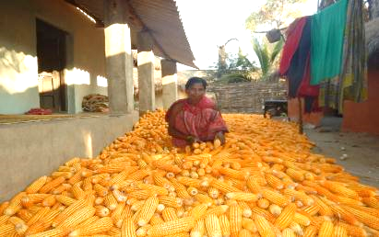
In Usigan, as in all other areas of the Nabarangpur district of Odisha, marginalized farmers routinely take loans from moneylenders at exorbitant rates – often 100 percent per year. Bela Pujhari attended training sessions provided by CARE staff members and learned not only how to find alternative sources of credit, but also how to gauge risks before borrowing. Bela was keen to break out of this age-old trap of debt that had robbed her and other farmers in her community of the rewards of their painstaking labor. Of the 200 households in the village, at least four out of every five were marginalized farmers, living below the poverty line. The LAMPS credit – Large-Area Multi-Purpose Credit Society – provided Bela credit at a rate of 2 percent per year. To make the most of the loan, Bela took everything she learned in CARE’s training session and applied the improved agricultural practices with utmost precision, planting maize in 2.5 of her 4 acres. With her husband, she maintained the prescribed 2-foot distance between the maize rows, pulled out the grass and weeds periodically, and cultivated her field wisely. Bela and her husband harvested 30 quintals of corn, which they plan to sell to the trader who offers the best price. To arm herself with knowledge before negotiating a price, Bela checks the market information board posted on the wall outside a house in the center of the village. “Planting maize when most people were not opting for it was possible due to the encouragement from the CARE brothers and sisters,” Bela said. “They also gave me good guidance on building on my own savings rather than taking loans with high interest rates from the moneylender. I might have fallen into that trap. But now, other marginalized farmers are inspired by us to follow the same path, both in terms of agricultural practices as well as credit habits. This year, even after repaying the loans, I will have enough money to plan for a better life for my son.”
Bela Pujhari with her harvest

‘When she learns, the whole family benefits’
Decision-making in the village of Bhatikote has long been vested in the male members in the community, with women as secondary figures. Only five months into CARE’s intervention, the gender balance in this village had shifted, with women playing a pivotal role in altering the economic scales of the village. After two disastrous years of growing maize as a cash crop only to have it destroyed by cyclones, half of the households in Bhatikote followed CARE’s advice and replanted maize, using improved agricultural techniques. Tulabati Saanta, a 45-year-old member of the women’s self-help group named Maa Sarala, was among the farmers trained not only in how to grow better, more sustainable crops, but also in financial literacy. Focusing on training women was a clear strategy of CARE, as women typically share what they learn with their male counterparts. When men are trained, they tend not to share with the women in their families, which isolates women even more. Tulabati and the other women farmers shared with their husbands their newfound knowledge on how to raise the quality of the corn so that it fetches the highest possible price. The women also educated their entire community on the value of standardizing and aggregating their produce so they could strengthen their bargaining power. Equipped with market information in their village that is updated every two days with the help of CARE staff, this group of women met with vendors until they found one willing to pay the best price for their maize. Kundei Saanta, a young mother of two children, is proud of the women’s success in negotiating the sale, but also in the support many received from their husbands in order to take part in the process. Kundei said her husband, Mahendra, not only encouraged her to participate in these activities, but also took care of the children in her absence, and even cooked food for the whole family. “I now realize how difficult women’s lives are,” the young husband said. “Taking care of children, cooking and working in the fields – all this requires so much effort. I have begun to appreciate my wife more than ever before.” When asked why he is so supportive of his wife’s work, he answers, “When she learns, the whole family benefits. She will be able to make our children wiser, and that will help them in the future.”

‘Our efforts today will bring change tomorrow’

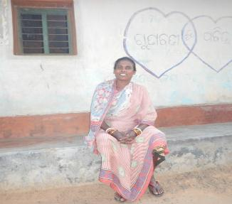
Rajanti Harijan learned about improved agricultural practices through CARE’s training. Though she was inspired to try growing maize as a cash crop, she didn’t have the money to invest in the inputs this year. So, in the time that she would have spent cultivating her field, she began reaching out to 30 other households in her village of Usigan and sharing everything she had learned about financial literacy and farming. As part of her outreach, she created another change agent in Gokul Majhi, a respected teacher in the local school. Gokul disseminated all of his newfound knowledge among young men in informal settings – while having tea together, for instance, or playing cards or enjoying other social activities. Through his efforts, the entire community has been mobilized. “There is a need for intensive effort on the part of many people,” Gokul said, “so that we all move away from poverty.” Rajanti echoes the sentiment, while stressing the importance of two additional project benefits: women’s empowerment and gender parity. “Farming isn’t confined to men,” she said. “It involves both men and women. As women, we need to influence men. We are farmers, too. We must always remember that our efforts today will bring change tomorrow.”
Rajanti Harijan

‘Women have begun to think of themselves as full partners’

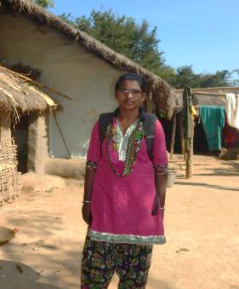
Subasini Harijan dreamed of becoming an educator so she could help empower women from tribal communities like her own. But her family only allowed her to finish the ninth grade, and then a couple of years later she was forced to marry. By her early 20s, she was a mother. Refusing to settle for a traditional life, though, Subasini applied for the program called Odisha Tribal Empowerment and Livelihood Project, which focuses on enhancing food security, increasing people’s incomes and improving their overall quality of life through more efficient natural resource management. Subasini’s desire to explore new frontiers led her to apply for the position of local resource person under this project. In her new role, she sought to mobilize communities in her assigned geographical area. At first, antagonistic men in the communities she visited treated her rudely and refused to cooperate. Women, fearing reprisal from their male counterparts, were not receptive either. But Subasini was not one to give up. She reciprocated the confrontational attitudes with patience and intelligence. She held quiet talks with a few influential women, asking them questions such as: “Can the men do all of the farm activities without the help of the women? If the men saw women’s learning as pragmatic, would they not be open to trying out these ways?” Then she began asking a few questions of the men: “If somebody is offering knowledge on ways to improve your land, produce and profit, free of cost, would it hurt to dedicate some time and just listen to them?” Gradually, men and women both started to listen. After a little time, they even welcomed Subasini into their villages and became eager to participate in the maize training. Now she is able to delve deeper into the issue of women’s empowerment. Maize farming, she said, provided an inroad for her to venture into the villages and talk about broader cultural issues. Today, women in these villages have begun to think of themselves as full partners with men – not secondary stakeholders. “Today, when I go to any village, a crowd of people gathers voluntarily,” Subasini said. “They listen to me, and even ask for my advice.”
Subasini Harijan

Next Steps

- Future project interventions should continue in the same geographic area and in nearby villages to further strengthen the sustainable maize value chain and empower women smallholders.
- Linkages will be done with the Agriculture Department, KVK, OUAT, OLM, OTELP and CYMMIT for leveraging resources and technologies for enhancing maize productivity.
- Further training will empower women farmers groups to undertake aggregation and marketing interventions.
- Collaboration should continue with private traders for input supply and output marketing by fair trade practices.
- Women farmers groups need to be supported to access financial services from banks and other financial institutions to meet their financial requirements.
- Further interventions should continue to seek ways to collaborate and complement programs run by the government and other international donor agencies.
- One master integrator and two local resource persons should continue to work with the impact populations to support women farmers in the area.

Expenditure Report

Item | Amount
Personnel | $44,674
Professional Services | 8,872
Materials, Services and Consumables | 54,170
Equipment | 27,143
Travel and Transportation | 14,292
Rent and Utilities | 23,559
CARE Technical and Administrative Support (13% of gift total) | 29,900
Total Expenditures | $202,610
Fund Balance | $27,390

Conclusion

Arming women farmers with knowledge about improved agricultural practices and better marketing and sales techniques already has made a dramatic impact on their lives and livelihoods. Farmers in the project area increased their productivity by 19 percent, which – along with their newfound skills in collective bargaining and enhanced financial options – has resulted in an increase of 103 percent in their household income. Solid relationships have been built with the government departments, input suppliers and output buyers. Strengthening those connections will help sustain the progress made so far and empower poor tribal women maize farmers to secure more resilient livelihoods, while improving their long-term capacity to adapt to climate change and natural disasters.

Women smallholder farmers play a vital role in agriculture in India, but they have long struggled with inequality in every phase of decision-making, getting lower wages for their work while also carrying an unfair share of the workload. Gender-based violence also remains prevalent. CARE will continue to strive to address those disparities while seeking to improve the livelihoods of women smallholder farmers and their communities. On their behalf, we are grateful for the Kellogg Foundation’s support of this life-changing project. Thank you!

June 2016

Scheduled castes and scheduled tribes are population groups specifically recognized in the Indian constitution as historically disadvantaged.
The Women’s Empowerment Index in Maize Value Chain (WEI-MVC) is being modeled after the Women’s Empowerment Index developed by CARE (WEI-CARE). Similar to the WEI-CARE, the WEI-MVC includes the five domains of empowerment index, which reflects the percentage of women who are considered empowered. But instead of 13 indicators (as per WEI-CARE), the WEI-MVC has 18 indicators within five domains of empowerment: production, resources, income, leadership and autonomy/time. However, for the Kellogg Pathways program, the index was adapted to include some additional indicators, as the women farmers are dependent mostly on a maize-based production system within these broad domains in order to measure social relations dimensions of empowerment.
A frontline agricultural extension center financed by the Indian Council of Agricultural Research
A regulated market committee is a democratically elected body consisting of farmers, traders, farmer cooperatives, etc. An RMC has three major objectives: - Ensuring that farmers’ produce is weighed correctly, so they are not cheated by wholesalers or middlemen. - Ensuring prompt payment to the farmers for their sold produce. - Ensuring that farmers are not exploited by middlemen.
A Kisan Credit Card is a credit card to provide affordable credit for farmers in India. It was started by the Government of India, Reserve Bank of India and National Bank for Agriculture and Rural Development in 1998-99 to help farmers access timely and adequate credit. The card allows farmers to have cash credit facilities without going through time-consuming bank credit screening processes repeatedly. Repayment can be rescheduled if there is a bad crop season, and extensions are offered for up to four years.
MSP is the minimum support price for a crop, set by the government.

