EX POST EVALUATION
EDUBINA

Project:
NEW BILINGUAL INTERCULTURAL EDUCATION IN THE ANDES

Implementing Agency:
CARE PERU - Huaraz Office

Life of Project:
4 years
(December 2003 to
December 2007)

Type of Evaluation:
EX POST
(EVALUATION OF RESULTS)

EVALUATION PERIOD:
December 15, 2007 to
February 10, 2008

EVALUATION PERFORMED BY:
Elsa Carolina Alegre Haro and collaborators

DELIVERY DATE:
February 10, 2007

CONTENTS

ACKNOWLEDGEMENTS …………………………………………………………….. 2

PREFACE ..………………………………………………………………………………. 3

SUMMARY ……………………………………………………………………………….. 5

- INTRODUCTION ………………………………..………………………. 6

- THE EDUBINA PROJECT AND ITS STRATEGIES……………………… 7

- EVALUATION METHODOLOGY…….……………………………………… 12

- SUMMARY CHART OF THE EDUBINA PROJECT …………………… 15

- FINDINGS AND RESULTS OF THE EDUBINA PROJECT:

  - Results in the Girls, Boys and Adolescents
Who Took Part in the Project ......................…………………….… 18

  - Results in the Teachers, Experts and Directors
of Schools That Took Part in the Project ……….… 34

  - Results in the Community..…………………………………………… 39

  - Results in Terms of Education Management and Advocacy…… 49

  - Results in Terms of Gender Equity and Equality of Opportunities……………………………………………………….……….. 53

- OPINIONS ON THE EDUBINA PROJECT…………………………. 69

- CONCLUSIONS AND RECOMMENDATIONS .……………….......... 70
- ANNEXES (Information Gathering Instruments) ………..…………. 72

IX. ACRONYMS AND ABBREVIATIONS……………………………………… 94

ACKNOWLEDGMENTS

We would like to thank the principal stakeholders of the project for their collaboration and patience. By these we mean the members of the rural communities (boys, girls, youth and adults) who shared their time and assistance in the evaluation activities of the EDUBINA Project. We are eternally grateful to them all.

PREFACE

Peru is a heterogeneous mix of geographies, cultures, and languages and has been since pre-Inca times. Its population includes aboriginal cultures, including Quechua, Aymara and Amazonian.

Peru’s multicultural and multilingual situation has ever necessitated an education that meets the real education needs of boys and girls in rural areas. The Peruvian Ministry of Education began to give greater impetus to bilingual education in 1987, and education plans were developed in order to revitalize and interrelate the cultural and social identities of the various groups that make up the population, recognizing the right of individuals to be educated in both their mother tongue and in Spanish, as the country's lingua franca.

Bilingual education in the vernacular language and Spanish plays an important role in the development of valid knowledge for the future student. On one hand, education in the student's mother tongue develops their capacity for thought, reasoning and imagination, as well as enabling them to acquire insights on the social and natural environment that those languages possess. On the other hand, mastery of spoken and written Spanish paves the way for a more fruitful and necessary interaction with the rest of society. Whereas monolingual education obstructs the child's capacity to express themselves in their mother tongue and does not ensure a good mastery of Spanish, bilingual education promotes communicational competencies in both languages. Broadly speaking, IBE offers the child the opportunity to evolve in different communication settings while at the same time strengthening their responsibility as persons and developing their individual talents.

In Ancash bilingual education has targeted specific areas. The 18 communities taking part located in the districts of Taricá, Pariahuanca, Anta and San Miguel de Aco, in the provinces of Huaraz and Carhuaz of the Department of Ancash, were selected in coordination with the respective Local Education Management Units, bearing mind their status as rural and Quechua-speaking communities.

The national and local context in which the EDUBINA project was implemented was somewhat complex. On one hand, the central government was implementing the National Education Program, which included a process of periodic teacher assessments that was met with an outcry from the Education Workers Union of Peru (SUTEP); and, on the other, a prevailing climate of uncertainty and worry among teachers. Coupled with this was the education decentralization proposal, the intention of which was to transfer responsibility and authority over education to local governments, with municipalities taking over the reins of education and technical advisory services supplied by the Education Ministry. This proposal was also rejected by the teachers and the rumor circulated that these were preliminary steps for privatizing education. All of these circumstances created a climate of great tension among teachers, triggering strikes and stoppages that meant that classes were suspended for lengthy periods of time.

The bilingual education syllabus which has been promoted for some time now in our country was not covering all of the communities that met the conditions for -and needed- this type of education. Bilingual education is opposed by the number of teachers, parents, and community leaders, who claim that Spanish is the dominant language and needed for interaction between the countryside and the city, and that Quechua is synonymous with backwardness.

The EDUBINA project has had to devote time and efforts to promote and raise awareness of the importance of bilingual education, in order to gain acceptance in the community and schools. It has also had to work in and adverse climate thanks to the tension and friction brought about by the education reforms. In our opinion, an arduous and complex task.

SUMMARY

The ex post evaluation of the project New Bilingual Intercultural Education in the Andes found that significant strides have been made in terms of the proposal, methodology and awaited results.

There is evidence of development of communication skills in the boys and girls in rural areas, in both Quechua and Spanish. There has been an improvement in negative education indicators, including with regard to promotion, grade repetition and dropping out.

There has been substantial improvement in the capacities of teachers, who have demonstrated a correct use of bilingual education strategies and methodology. Furthermore significant strides have been made toward community empowerment, as reflected in the increasingly active community involvement in the school.

The gender approach is still developing and a certain amount of follow-up and strengthening are needed.

Broadly speaking, in most cases the EDUBINA project has attained positive results that contribute to an improvement in the quality of education in Peru.

I. INTRODUCTION

The project New Bilingual Intercultural Education in the Andes is a pilot experimental project whose purpose is to make a sustained contribution to improving the quality of, and equity in, bilingual intercultural education with the participation of key stakeholders in the education sector, the school, and the community.

The 18 rural communities taking part in the project are located in the districts of Taricá, Pariahuanca, Anta and San Miguel de Aco, in the provinces of Huaraz and Carhuaz in the Department of Ancash.

The project has centered its efforts on primary school students, teachers and directors of schools, experts, education sector officials, community leaders and authorities, and parents.

This report contains the ex post evaluation; that is the results achieved by the EDUBINA project by the end of its lifetime. It includes a description of the evaluation methodology, findings and results, an analysis of results, conclusions and recommendations.

- THE EDUBINA PROJECT AND ITS STRATEGIES

The overarching objective of the project New Bilingual Intercultural Education in the Andes (EDUBINA) is to help improve access to quality bilingual intercultural education for Andean communities. The project got underway in November 2003 under an agreement between regional and local community authorities, the Ancash Regional Health Authority, Huaraz Local Education Management Unit, Carhuaz Local Education Management Unit, and CARE Peru.

PARTICIPATING COMMUNITIES:

DISTRICT | COMMUNITY | SCHOOL
ANTA | Cantar | Multi-grade
ANTA | Pampacancha | Multi-grade
ANTA | Anta | Multi-teacher
ANTA | Paccha | Single-teacher
ANTA | La Esperanza | Single-teacher
ANTA | Huacrán | Multi-grade
TARICÁ | Uruspampa | Multi-grade
TARICÁ | Collón | Multi-teacher
TARICÁ | Pashpa | Multi-teacher
TARICÁ | Shinua | Single-teacher
TARICÁ | Buenos Aires | Multi-grade
SAN MIGUEL  DE ACO | Atocpampa | Multi-grade
SAN MIGUEL  DE ACO | Laborpampa | Single-teacher
SAN MIGUEL  DE ACO | San Miguel de Aco | Multi-teacher
SAN MIGUEL  DE ACO | Quinranca | Multi-grade
SAN MIGUEL  DE ACO | Huapra | Multi-grade
PARIAHUANCA | Ahuac | Single-teacher
PARIAHUANCA | Pariahuanca | Multi-teacher

FIVE CORE STRATEGIES IMPLEMENTED BY EDUBINA:

Having reviewed the EDUBINA project’s logical framework and interviewed the project team, we concluded that EDUBINA implemented five main strategies:

- Strengthening of the education management capacities of local actors.

Community participation is a process that requires capacity building and strengthening, problem identification and prioritization, situation analysis, determination of project capacity, and implementation and follow-up of responsibilities adopted.

As the baseline indicates, community participation in education management has mainly being only through PTAs, which have adopted a passive role and whose function, in the best of cases, has being one of oversight of spending on infrastructure works at the school and monitoring teacher attendance. It should be mentioned that PTAs very often do not include participation of community authorities, leaders, and grassroots organizations because they do not have school-age children.

EBUBINA set its sights on community participation at the highest level, which is joint decision-making with the school.

With that in mind, agreements were reached with the target communities in order to ensure that plans were designed and measures implemented jointly by the education sector, the community, and the project.

For the first time, communities prepared a Community Education Review (DEC in Spanish), which included an analysis of their education needs; the extent to which the school is in touch with local reality, and if it is in tune with local development processes. The community has had significant opportunities to make themselves heard and put forward important proposals.

Based on these DEC, each community, in coordination with the school, presents proposals designed to help improve the quality of, and equity in, education. These proposals are included in the Community Education Plans (PEC in Spanish), in which individuals and organizations in the community adopt commitments for their implementation.

The Community Education Reviews and Plans genuinely reflect the aspirations and needs of the community, as well as involving local authorities, leaders, community-based organizations (CBOs), young people, teachers, and directors of schools. Thus, the community takes on key roles.

The Project has helped make education a priority on the community agenda, generating discussion and analysis about what education management entails. Through activity reviews and planning, the community renews their appreciation, inter alia, for their mother tongue, historic events and cultural values, creating a different vision of themselves, re-thinking what it is they want from their community in that sense, and looking at how education management might contribute to that vision.

This experience has set a precedent: by organizing, the community develops local education management capacities, and brings education more in line with their reality, where the teacher is not only in a position to educate, but also develop strategic partnerships in the community to contribute to that cause, thereby enabling the rural community to develop an even stronger appreciation for their way of life, as opposed to the commonly held belief that their knowledge, attitudes, and practices are worth less than those to be found in urban settings.

In this sense, community participation in education management raises the challenge of strengthening and improving education standards, which is where the project's second strategy comes in.

- Capacity building for teachers in bilingual intercultural education.

The EDUBINA project entails social and teacher-training processes that impart new skills, in particular to teachers, directors, and experts. Having acquired these skills, these actors then have the responsibility to develop a teacher-training plan in which the instruction combines local Andean culture and knowledge with the culture and needs of the rest of the country and the world. Teachers have acquired the skills in specific, innovative training processes (general and ‘micro’ workshops) that are part of the new proposal implemented by mixed CARE-UGEL/DREA teams, refined and strengthened through feedback and monitoring of their practical application.

One strategy of the teacher-training proposal is based on the Community Education Reviews and Plans, the PER and the National Curriculum, and identifies the capacities, values, and contents to be included in the annual and quarterly curricular programs, which are used to design the training sessions. In this way, since the starting point is the community's own culture, the mother tongue becomes a core part of the process.

The EDUBINA project entails its own comprehensive teacher-training planning and development process that was supported by the DREA and UGELs in keeping with a specific agreement, and it was declared a Pilot Regional Project.

- Strengthening of public policy in favor of bilingual intercultural education at the district and regional level.

EDUBINA proposes the promotion of spaces for discussion of innate issues of bilingual intercultural education and gender equity in public and private institutions with the participation of opinion shapers. To that end, EDUBINA has been involved in working groups whose agendas include the issue of education, with particular attention to bilingual intercultural education and gender equity.

Advocacy has being a permanent key component of the project, due to the presence of CARE (through EDUBINA) in the Participatory Regional Education Council (COPARE), the PER Implementation Committee (CIPER), the Carhuaz and Huaraz Local Education Plans, and the Regional Association for Girls’ Education in Ancash (ARENA).

Another line of work in this strategy has been permanent coordination with local and regional bodies in the education sector, by means of agreements, addenda, and specific working guidelines. As a result an adequate interrelationship of shared responsibilities has been built up.

- Development of bilingual oral and written communication skills in boys, girls and adolescents.

Another of the project’s strategies has been the development of oral and written communication skills in Quechua and Spanish, in keeping with each linguistic setting.
For the EDUBINA project, oral and written communication capacity building in both Quechua and Spanish, is crucial for students to attain optimal education levels.
Owing to the multicultural nature of the communities in the area targeted by the project, it is necessary to take the right steps with validated bilingual intercultural education plans that keep in mind the fact that the child must first learn in their own language before incorporating Spanish on a gradual basis as they advance through the regular elementary education system. In this way, the child will progressively consolidate their communication skills, which will result, first, in a mastery of both languages and, subsequently, in the acquisition of significant skills. This plan in keeping with the Ministry of Education's guidelines on bilingual intercultural education
This document takes into account and encloses the results of a specific assessment of skills in Quechua and Spanish carried out by a consultant on a representative sample of second-, fourth-, and sixth-graders in all 18 participating communities

- Gender Perspective.

It is common knowledge that the vast majority of women in rural areas enjoy the status that places them at a disadvantage to men. Male dominance reduces women's development opportunities and creates a great deal of problems of the inequity.

Gender is a crosscutting theme in every line of action of the EDUBINA project as well as being present in its various strategies and settings (school, community, UGELES, DREA, consensus-building fora). There is also a permanent, crosscutting analysis of disparity of opportunities and access, not only for girls, but also, and in particular, for Andean women, who are the first to replicate the inequity model in the home. In the course of the project, events were held to discuss and analyze gender inequity and inequality of opportunities in rural areas.

The events have separately targeted teachers, experts, fathers, mothers, boys, girls, young people, and community leaders. Each of these fora analyzes the triple role of women and the lack of opportunities in each one. These events led to agreements and commitments that the community would adopt in order to help improve gender relations and move toward equality of opportunities.

III. EVALUATION METHODOLOGY

The evaluation is based on a mixed model that combines qualitative and quantitative approaches, according to the level of complexity of the EDUBINA project.

Owing to the dynamism of the process, this study has oscillated between inductive and deductive thought schemes on two fronts: one typically quantitative and the other qualitative. The quantitative study exhaustively reviewed technical and management documents, surveys of teachers and experts, and observation manuals. This work was done in 100% of the participating communities.

In parallel, the qualitative study involved focus groups with boys and girls; parents; community leaders; and other project actors in six of the 18 communities taking part, chosen at random. Each focus group was made up of 10 to 12 persons, who answered questions posed by a facilitator. Their responses were noted and filmed by other persons, whose role was also to observe and record attitudes. In the case of village residents these interviews were conducted in Quechua.

The evaluation was designed based on an analysis and review of 27 indicators measured in the baseline study and upon the project's conclusion.

It is important to mention that this study adopted a predominantly qualitative approach, which enabled us to discover and record in a relevant manner the reality in the participating communities, while attempting to maintain congruence between the quantitative and qualitative aspects. Put another way, our qualitative research has provided us with an opportunity to understand and analyze the processes and phenomena that take place in the communities, exactly as they happen in their natural contexts, as well as how changes in individuals have occurred.

In spite of the fact that quantitative research can have a subjective bias, the effort was made at all times to be impartial and as objective as possible in both the analysis and the interpretation of results.

- The core questions of the evaluation were as follows:

- What improvements could be seen in schoolchildren as a result of the project?
- How much did teachers improve their BIE skills?
- To what extent were the education management skills of local actors strengthened?
- To what extent were the public policies that favor bilingual intercultural education strengthened?
- To what extent did the project contribute to equality of opportunities and gender equity?

- based on the project indicators matrix the following review themes were proposed:

- Intervention and progress in terms of boys and girls
- Intervention and progress in terms of teachers
- Intervention and progress in terms of the community
- Intervention and progress in terms of Education Management and Advocacy.
- Intervention and progress in terms of Gender Equity and Equality of Opportunities.

C. The following information-gathering techniques were used:

Primary Information Sources:
- Survey
- Focus group
- Interview
- Observation manual

Secondary Information Sources:
- Review of project documents, such as:
- Training workshops systematization reports
- Monitoring sheets
- School records and technical/teacher reports.
- Quarterly Project Reports
- Teachers work dossiers

D. Short description of the evaluation methodology:

- Detailed review of the logical framework, indicators matrix, and the baseline study, based on which the evaluation indicators were identified.

- The key indicators to be evaluated were selected and the proposal was presented to the EDUBINA project technical team. These indicators were divided into Review Themes.

- The information-gathering instruments were designed based on the indicators selected.

- A list of key informants and/or information sources were prepared for each indicator, together with their respective information-gathering instruments and techniques.

- A field work schedule was prepared.

- The field work was carried out. It is important to mention that the focus groups and interviews held with community residents were conducted in Quechua.

- Finally, the information was processed according to the predetermined review themes.

Help improve access to quality bilingual intercultural education for Andean communities.
EDUBINA
1. A high proportion of Andean boys and girls who participate in the project improve their basic communication skills in Quechua and Spanish.
2. Enhanced management capacities of the school in order to take into account the needs and circumstances of girls, adolescents, and women.
3. Community involvement in BIE improvement processes and an increase in general equity.
4. Strengthening of the application of public policies in favor of BIE and gender equity at the district, provincial, and regional level
6. Use of BIE methodologies improves in schools targeted by the project.
7. Intensive use by children of educational materials (workbooks, comic strips, etc.)
8. Strengthening of the management capacities of school directors to improve BIE.
9. Awareness of the needs and aspirations of girls has increased.
10. School directors and experts at intermediate bodies have strengthened their skills at promoting gender equity measures.
PURPOSE
MEDIUM-TERM RESULTS
SHORT-TERM RESULTS
IV. SUMMARY CHART OF THE PROJECT NEW BILINGUAL INTERCULTURAL EDUCATION IN THE ANDES

OVERARCHING OBJECTIVE

Make a sustained contribution to improving the quality of, and equity in, BIE with the participation of key stakeholders in the education sector, the school, and the community.

11. Students’ mothers increase their say in their children's education.

12. Parental awareness of the importance of BIE and gender equity for their sons and daughters has increased.
13. Involvement of community and local leaders in school management and local education planning has increased.
14. Local networks or consensus building committees composed of key public sector and civil society stakeholders have increased their capacities for proposing and implementing programs in favor of BIE and gender equity in the school and public sphere.
15. Societal authorities and education-sector experts increase their capacities for enhancing BIE and gender equity in schools and advance their importance in the community.
16. Increase in radio programs and community newsletters in Quechua and Spanish that emphasize the value of Andean knowledge and stimulate debate on BIE education policy and gender equity.

V. FINDINGS AND RESULTS OF THE REGIONAL PROJECT “NEW BILINGUAL INTERCULTURAL EDUCATION IN THE ANDES” (EDUBINA)

The results of the EDUBINA project have been arranged into four main groups, each with their respective indicators:

- Results in the girls, boys and adolescents who took part in the project
- Results in the teachers, experts and directors of the schools that took part in the project
- Results in the community: community leaders, parents.
- Results in Education management and Advocacy
- Results with respect to Equality of Opportunities and Gender Equity.

Results in the girls, boys and adolescents who took part in the project

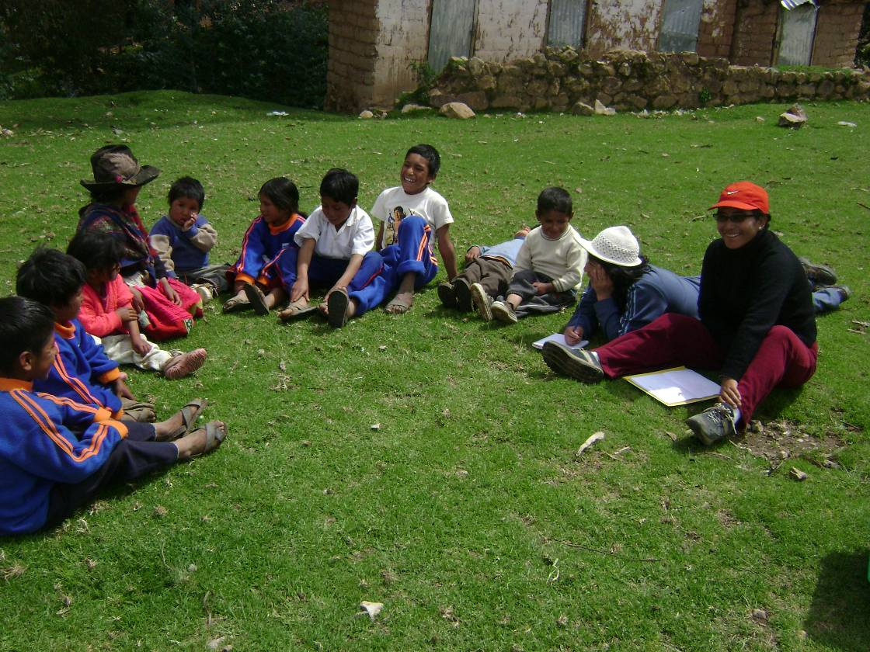
Children’s focus group in Uruspampa

N.B.

The color of the box for each indicator relates to the results proposed by the project in the summary chart (pp. 15 and 16.

END Indicator
Change in the rates of promotion, grade repetition, dropping out and remediation in primary education

Source:
- Technical/teacher reports from the 18 Schools that took part in the EDUBINA project.
- Evaluation records for each school – UGELs Huaraz and Carhuaz.
- INEI

YEAR | Total school-age population | Total enrolled population | Percentage of access.
2003 | 1668 | 1434 | 85.97%
2007 | 1647 | 1465 | 88.95%

SCHOOL-AGE POPULATION (6 - 12 YEARS), BY GENDER, IN SCHOOL IN THE 18 PARTICIPATING COMMUNITIES:

Source:
- Student rolls
- Data from INEI

SCHOOL-AGE POPULATION, BY SEX | 2003 |  |  |  | 2007
SCHOOL-AGE POPULATION, BY SEX | School-age population |  | Population in school |  | School-age population |  | Population in school
SCHOOL-AGE POPULATION, BY SEX | Nº | % | Nº | % | Nº | % | Nº | %
Male | 810 | 48.56 | 719 | 89% | 815 | 49.48 | 734 | 90%
Female | 858 | 51.44 | 715 | 83% | 832 | 50.52 | 731 | 88%
TOTAL | 1668 | 100 | 1434 | -- | 1647 | 100 | 1465 | --

There was a 3% increase in access of school-age students to school from 2003 to 2007.
In view of the increasing number of parents who routinely commute with their sons and daughters, including those at school age, to the city in order to work, before returning to their communities on Fridays or Saturdays, or even daily, means that access to education for boys and girls of school age is not only measured by enrolment in the school in the village where the birth was registered.

BASELINE - 2003 | EX POST EVALUATION - 2007
- In 2003 11% of the male school-age population was not in school  - 17% of the female school-age population was not in school. | PERCENTAGE OF SCHOOL-AGE POPULATION IN SCHOOL  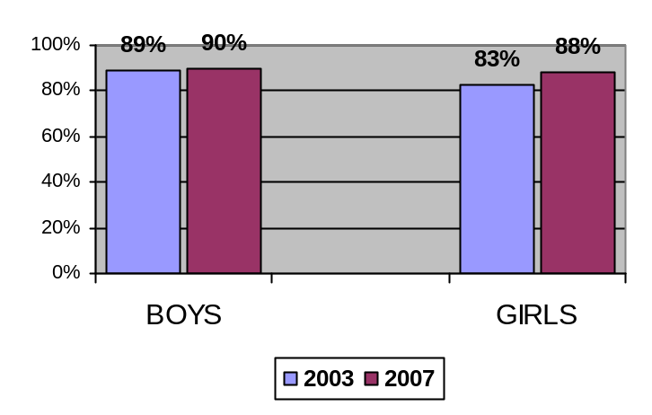  - In 2003, 11% of the male school-age population was not in school; in 2007, 10% of the male school-age population was not in school. Accordingly there has been a 1% improvement in this group.  - In 2003, 17% of the female school-age population was not in school; in 2007, 12% of the female school-age population was not in school. There has been a 5% improvement in this group.  - In Ancash, the average proportion of girls and boys of school age who do not attend school is 23.3% and 9.7%, respectively.  - In the area targeted by the EDUBINA project, the increase in the percentage of girls who enrolled in schools was higher in proportion to the overall population and to the number of boys enrolled. Furthermore, bearing in mind that in the target area the proportion of girls who do not attend school is 12%, this represents a significant improvement over the regional average of 22.3%. Although the percentage without access to school remains critical, the reasons for which do not only have to do with the education system, it would be true to say that the project is helping to improve conditions of access to education.

GLOBAL DATA ON THE SITUATION OF
1ST TO 6TH GRADE PRIMARY SCHOOL STUDENTS
IN THE 18 PARTICIPATING COMMUNITIES:

YEAR | SEX | ENROLLED |  | PROMOTED |  | GRADE REPETITION |  | DROPOUTS |  | REMEDIATION
YEAR | SEX | Nº | % | Nº | % | Nº | % | Nº | % | Nº | %
2  0  0  3 | MALE | 719 | 50.14 | 535 | 74% | 109 | 15% | 72 | 10% | 3 | 0.4%
2  0  0  3 | FEMALE | 715 | 49.86 | 527 | 74% | 101 | 14% | 85 | 12% | 2 | 0.2%
2  0  0  3 | TOTAL | 1434 | 100.00 | 1062 | 74% | 210 | 15% | 157 | 11% | 5 | 0.3%
2  0  0  7 | MALE | 734 | 50.10 | 570 | 78% | 95 | 13% | 48 | 6.5% | 21 | 2.9%
2  0  0  7 | FEMALE | 731 | 49.90 | 565 | 78% | 99 | 13.5% | 47 | 6.4% | 20 | 2.7%
2  0  0  7 | TOTAL | 1465 | 100.00 | 1135 | 78% | 194 | 13% | 95 | 6.5% | 41 | 2.7%

COMPARATIVE TABLE ON GLOBAL DATA FOR PROMOTION, GRADE REPETITION, DROPOUT AND REMEDIATION RATES.

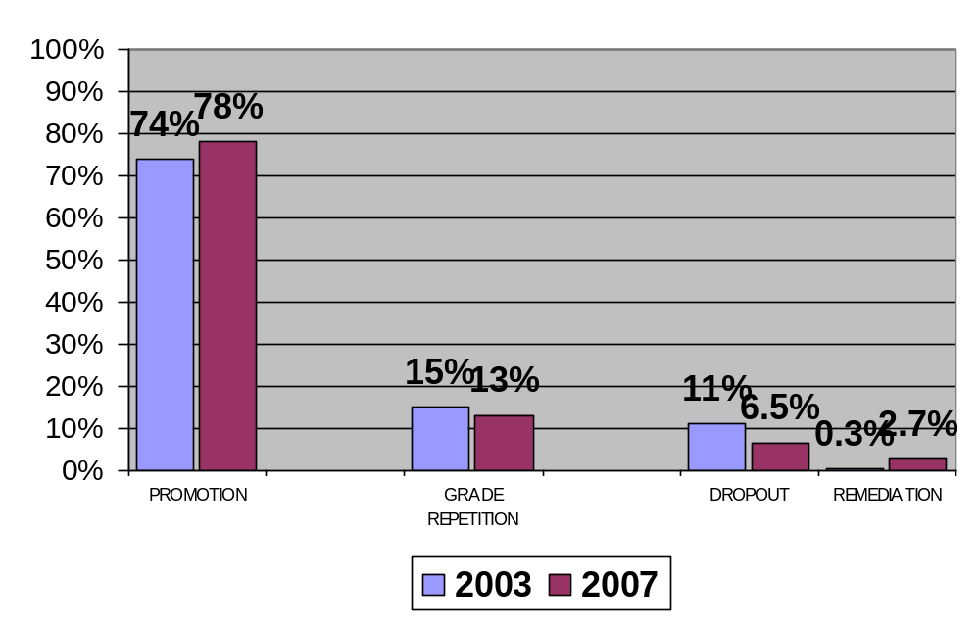

BASELINE - 2003 | EX POST EVALUATION - 2007
- In 2003, 74% of in-school students were promoted.  - The increase in the promotion rate was the same for boys and girls. | PROMTION RATE, DISAGGREGATED BY SEX, IN THE 18 SCHOOLS THAT TOOK PART IN THE EDUBINA PROJECT  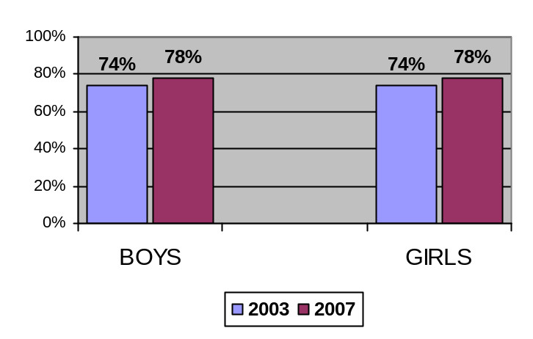  - The promotion rate rose 4% in the project area. Which marks an increase in comparison to 2003 and indicates a downturn in the number of boys and girls of school-age not in school in the area targeted by the project. It also shows that the percentage of female students who attend school as a proportion of the overall school-age population is the same as for boys. This shows that non-access for reasons of gender discrimination is improving slightly.  - In 2007, of the 1465 students enrolled in the 18 schools that took part in the EDUBINA project, 78% were promoted which represents a 4% increase over the baseline.  - The increase in the promotion rate was the same for girls and boys.  GRADE REPETITION RATE, DISAGGREGATED BY SEX, IN THE 18 SCHOOLS THAT TOOK PART IN THE EDUBINA PROJECT  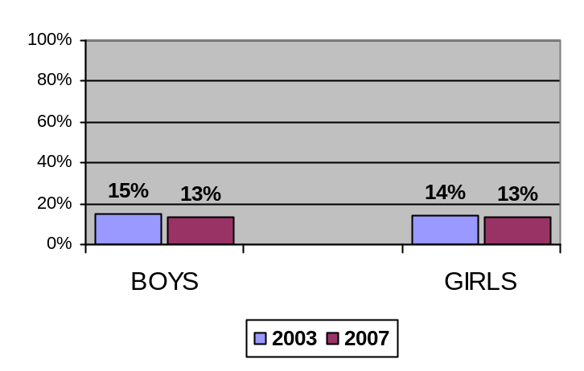  - In 2007, the grade repetition rate was down 2% in boys and 0.5% in girls compared to the data for 2003.  DROPOUT RATE DISAGGREGATED BY SEX IN THE 18 SCHOOLS THAT TOOK PART IN THE EDUBINA PROJECT  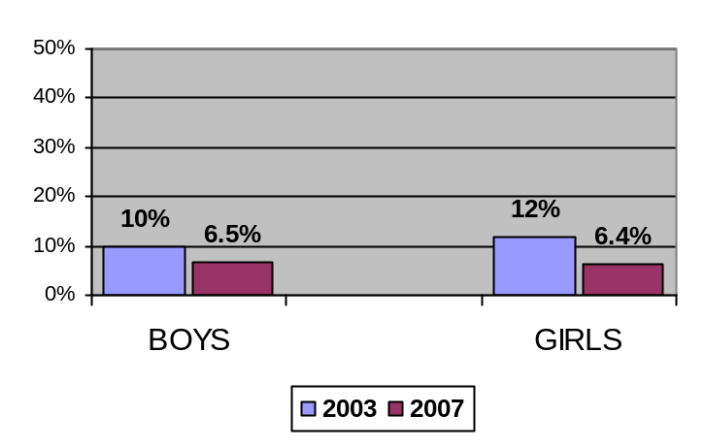  - There was a significant improvement in the dropout rate, in particular among girls. The decline leads us to presume that students are more motivated to continue their studies.  - Finally, the significant increase in the proportion of boys and girls to need remediation classes is explained by the significant descent in the grade-repetition and dropout rates.

Indicator 1.1
Change in the percentage of Andean girls and boys who improve their written communication skills in Quechua by the end of 2nd grade of primary school.

Indicator 1.2
Change in the percentage of Andean girls and boys who improve their written communication skills in Quechua and Spanish by the end of 4th and 6th grade of primary school.

Source:
- Consultant report on skills assessment
(Indicator not addressed in this consultant study at the request of the EDUBINA project; extinct data were considered)

BASELINE - 2003 | EX POST EVALUATION – 2007
96% of girls assessed were unable to produce short texts in Quechua.  100% of boys assessed were unable to produce short texts in Quechua. | GENERAL RESULTS OF THE SECOND-GRADE TEST  OVERALL STATISTICS - SECOND GRADE - QUECHUA  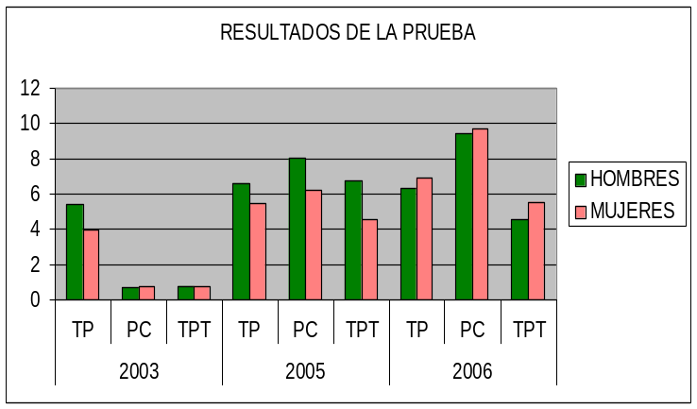  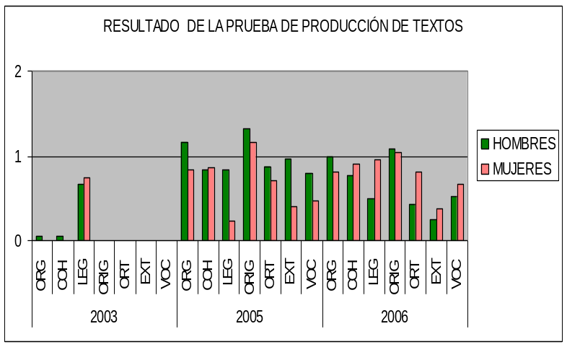  STATISTICS COMPARED WITH NON-EDUBINA SCHOOLS  RESULTS OF THE SECOND-GRADE TEST - QUECHUA  2006  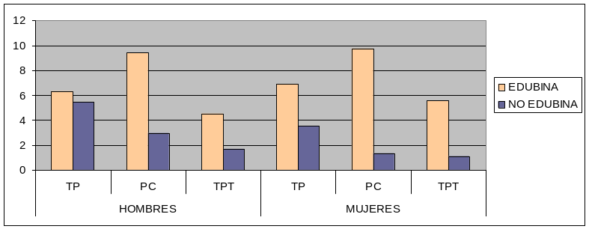  Second Grade – Quechua: 2005 and 2006 saw significant improvements in the Matching, Reading Comprehension and Text Production components in comparison to the baseline position. The improvement in Text Production, was less marked than in the other components because in 2006, 75% of boys and 60% of girls were still below expectation (NL). That said, it is important to bear in mind that in 2003 the NL proportion was 100% for boys and girls.
  TP | Total Matching
  PC | Reading Comprehension Score
  TPT | Total Text Production
  ORG | Organization
  COH | Coherence
  LEG | Legibility
  ORIG | Originality
  ORT | Spelling
  EXT | Length
  VOC | Vocabulary
   |  | EDUBINA | NON EDUBINA
  BOYS | TP | 6 | 5
  BOYS | PC | 9 | 3
  BOYS | TPT | 5 | 2
  GIRLS | TP | 7 | 4
  GIRLS | PC | 10 | 1
  GIRLS | TPT | 6 | 1

BASELINE - 2003 | EX POST EVALUATION – 2007

Fourth grade:  75% of boys and 45% of girls unable to produce short texts in Spanish.  Fourth grade:  90% of girls and 53% of boys were unable to produce short texts in Quechua.  Sixth grade :  11% of girls and 20% of boys were unable to produce short texts in Spanish.  Sixth grade:  90% of girls and 50% of boys were unable to produce short texts in Quechua.  The samples for non EDUBINA schools, correspond to 2006  The samples for non EDUBINA schools, correspond to 2006  The samples for non EDUBINA schools, correspond to 2006 | OVERALL RESULTS OF THE FOURTH GRADE TEST  OVERALL STATISTICS - FOURTH GRADE - SPANISH  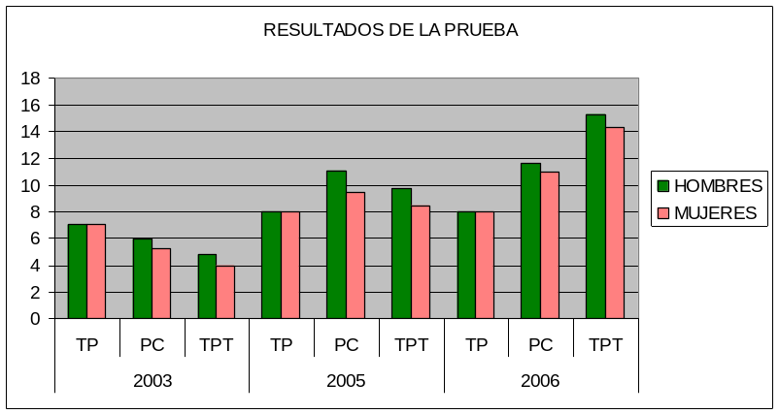  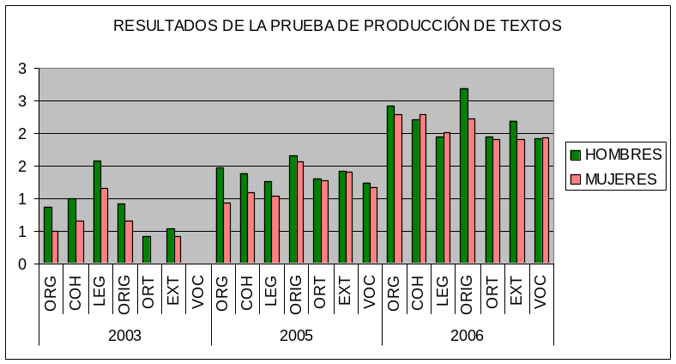  OVERALL STATISTICS - FOURTH GRADE - QUECHUA  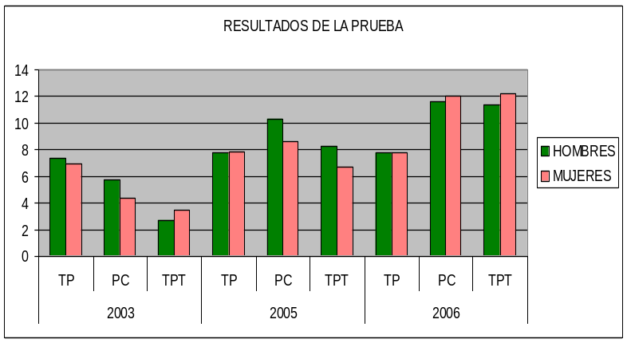  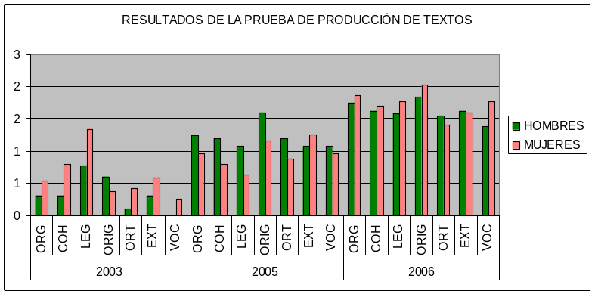  STATISTICS COMPARED WITH  NON-EDUBINA SCHOOLS  RESULTS OF THE FOURTH-GRADE TEST - SPANISH  2006  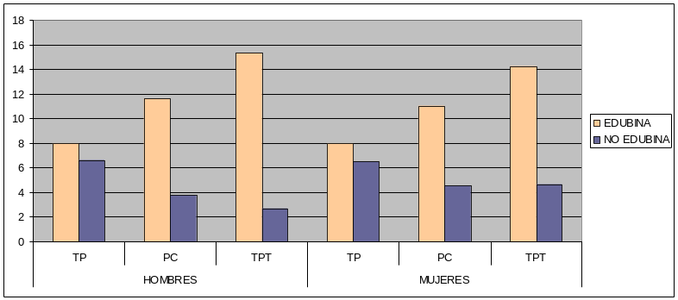  STATISTICS COMPARED WITH  NON-EDUBINA SCHOOLS  RESULTS OF THE FOURTH-GRADE TEST - QUECHUA  2006  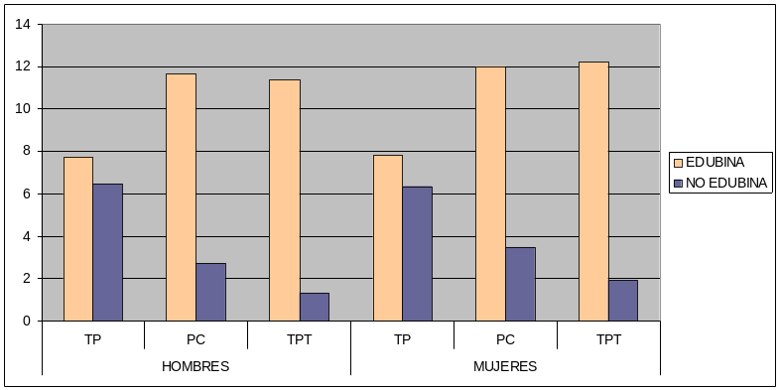  Fourth grade – Quechua: One aspect to note with regard to Matching is that in 2003, 2005 and 2006, a 100% of boys and girls scored AD (Exceeds Expectations). We believe that owing to the contextualized nature of the test, it could have been too easy for fourth-grade students.  The improvements in terms of Reading comprehension were more marked since, for example, in 2006, 92% of boys and 100% of girls scored AD (Exceeds Expectations), compared to only 13% of boys and 10% of girls in 2003. Progress was also very significant in the area of text production, given that 46% of boys and 64% of girls were Developing (B) and only 8% of boys and 9% of girls were Below Expectations (NL). However, no students have yet scored AD or A in this skill.  Fourth grade – Spanish: As regards Matching, the position here was the same as for Quechua; in reading comprehension 100% of boys exceeded expectations in 2005 and 2006, compared to 6% in 2003 - in other words, an improvement of 94%. In the case of girls in the 70% and 85% scored AD in those years, compared to 9% in 2003.  OVERALL RESULTS OF THE SIXTH-GRADE TEST  OVERALL STATISTICS - SIXTH GRADE - SPANISH  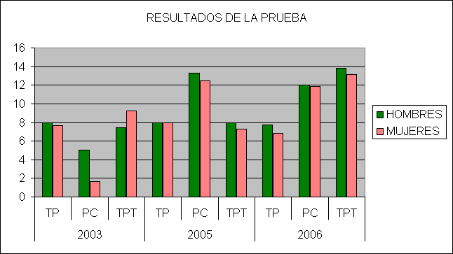  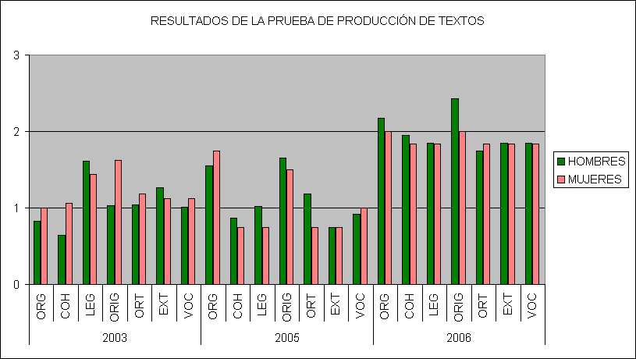  OVERALL STATISTICS - SIXTH GRADE - QUECHUA  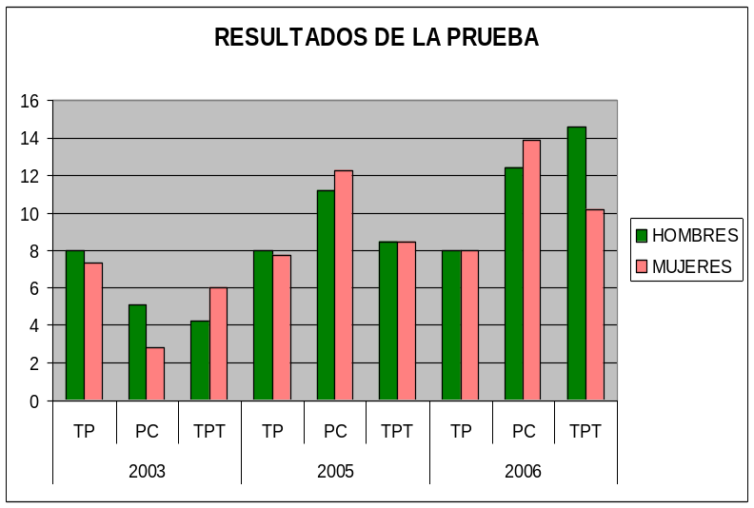  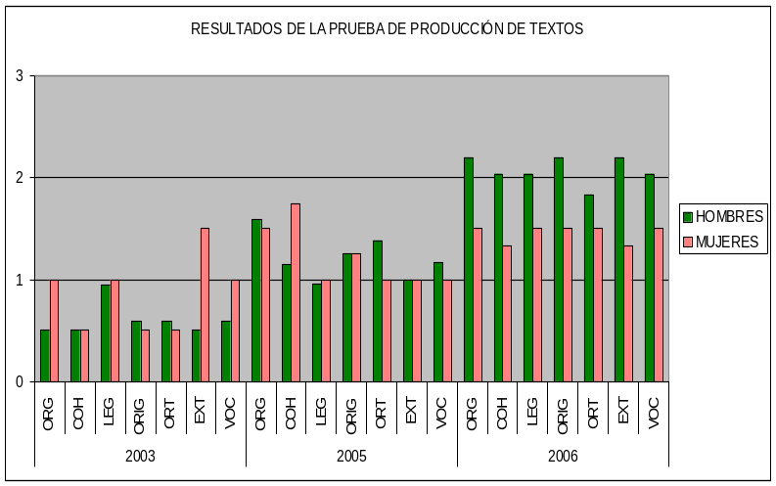  STATISTICS COMPARED WITH  NON-EDUBINA SCHOOLS  RESULTS OF THE SIXTH-GRADE TEST - SPANISH  2006  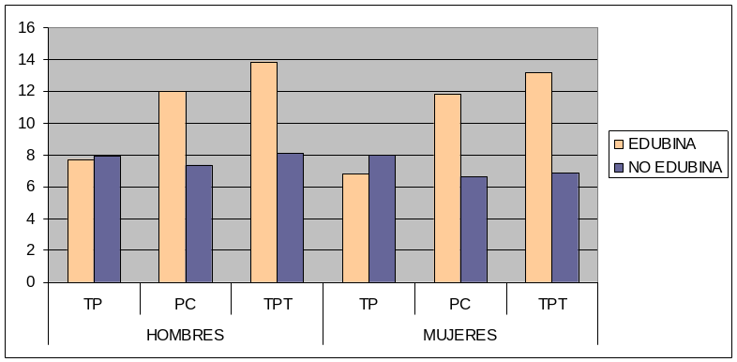  STATISTICS COMPARED WITH  NON-EDUBINA SCHOOLS  RESULTS OF THE SIXTH-GRADE TEST - QUECHUA  2006  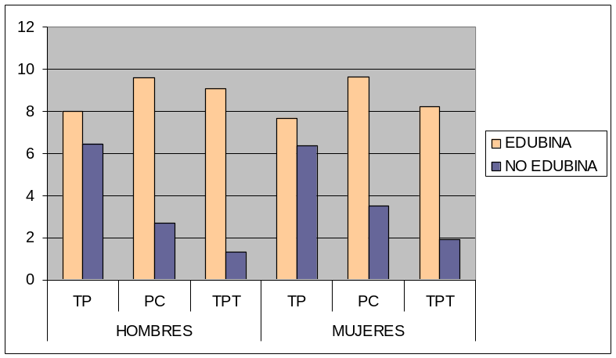  Sixth grade – Quechua: With respect to matching, 100% of boys also scored AD in the three evaluations. In the case of women, 70% scored AD in 2003, while 100% did so in 2005 and 2006. In terms of reading comprehension, in 2006, 100% of boys and girls scored AD, compared to only 7% boys and 0% girls in 2003.  As regards text production, most of the tested group scored NL (64% boys and 90% girls). This situation improved by 2005, when 8% of boys and 0% of girls failed to meet expectations; and in 2006, 0% of boys and 1% of girls were graded NL but improved to C, B or A (none achieved AD).  Sixth grade – Spanish: With respect to Matching, 100% of boys and girls scored AD in all three evaluations (2003, 2005 and 2006). In reading comprehension, in 2003, only 7% of boys and 0% of girls scored AD, compared to 85% of boys and 67% of girls who achieved this grade in 2005. The situation improved further in 2006, with 89% of boys and 100% of girls obtaining AD, which marks significant progress. As for text production, in 2003, 80% of boys and 67% of girls scored C (Has Difficulty). In 2006, the percentages of students who scored C dropped to 22% for boys and 25% for girls, who instead scored Bs and As. (No student has yet scored AD in this component).  STATISTICAL SAMPLE OF OTHER SCHOOLS IN THE REGION COMPARED WITH EDUBINA SCHOOLS.  This readily understood comparison is revealing. In 2006, the same tests were applied in four schools in the region with similar socioeconomic characteristics (Chavín, Chaquecyacu, Cariampampa and Coirocsho). In all, tests were taken by 147 students.  The results, shown in bar graphs, demonstrate significant differences in favor of the EDUBINA schools. For example, in text production among fourth graders, for the EDUBINA schools the highest score was 12 while for the non EDUBINA schools the highest score was 02. With a few exceptions, the same proportion (always in favor of EDUBINA) was repeated across all grades in all three components, in both Quechua and in Spanish.
  TP | Total Matching
  PC | Reading Comprehension Score
  TPT | Total Text Production
  ORG | Organization
  COH | Coherence
  LEG | Legibility
  ORIG | Originality
  ORT | Spelling
  EXT | Length
  VOC | Vocabulary
  TP | Total Matching
  PC | Reading Comprehension Score
  TPT | Total Text Production
  ORG | Organization
  COH | Coherence
  LEG | Legibility
  ORIG | Originality
  ORT | Spelling
  EXT | Length
  VOC | Vocabulary
   |  | EDUBINA | NON EDUBINA
  BOYS | TP | 8 | 7
  BOYS | PC | 12 | 4
  BOYS | TPT | 15 | 3
  GIRLS | TP | 8 | 7
  GIRLS | PC | 11 | 5
  GIRLS | TPT | 14 | 5
  BOYS | TP | 8 | 6
   |  | EDUBINA | NON EDUBINA
   | PC | 12 | 3
   | TPT | 11 | 1
  GIRLS | TP | 8 | 6
  GIRLS | PC | 12 | 3
  GIRLS | TPT | 12 | 2
  TP | Total Matching
  PC | Reading Comprehension Score
  TPT | Total Text Production
  ORG | Organization
  COH | Coherence
  LEG | Legibility
  ORIG | Originality
  ORT | Spelling
  EXT | Length
  VOC | Vocabulary
  TP | Total Matching
  PC | Reading Comprehension Score
  TPT | Total Text Production
  ORG | Organization
  COH | Coherence
  LEG | Legibility
  ORIG | Originality
  ORT | Spelling
  EXT | Length
  VOC | Vocabulary
   | TEST | EDUBINA | NO EDUBINA
  HOMBRES | TP | 8 | 8
  HOMBRES | PC | 12 | 7
  HOMBRES | TPT | 14 | 8
  MUJERES | TP | 7 | 8
  MUJERES | PC | 12 | 7
  MUJERES | TPT | 13 | 7
   | TEST | EDUBINA | NON EDUBINA
  BOYS | TP | 8 | 6
  BOYS | PC | 10 | 3
  BOYS | TPT | 9 | 1
  GIRLS | TP | 8 | 6
  GIRLS | PC | 10 | 3
  GIRLS | TPT | 8 | 2

Results in the teachers, experts and directors of the schools that took part in the project

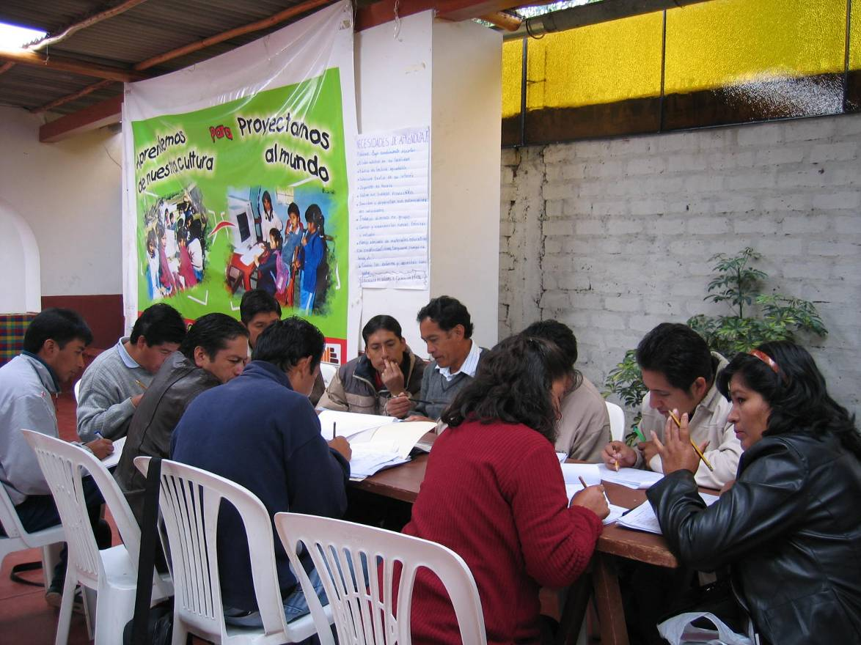
Teachers who took part in the EDUBINA project

Indicator 1.3
Number of schools that diversify their curriculum in keeping with the local and regional reality.

Source:
Surveys of teachers and directors.
Monitoring sheets for teachers and directors.
Teachers’ work dossiers

BASELINE - 2003 | EX POST EVALUATION – 2007
85% of schools do not diversify.  15% of schools in the project area diversify their curriculum is in keeping with the local and regional reality. Of these, 7.5% did so adequately and 7.5% were initiating. | 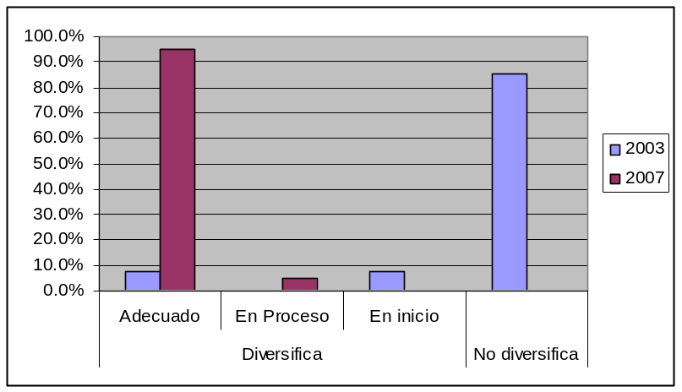  - The change observed since the baseline is considerable. In 2003, 15% of teachers diversified the curriculum; in 2007, 95% of teachers taking part in the EDUBINA teacher-training plan adequately implemented curricular diversification and 5% were developing. The latter percentage corresponds to newly hired teachers who joined the project.
  Diversifies |  |  |  | Does not diversify
  Progress | Adequate | Developing | Initiating
  2003 | 7.5% | 0% | 7.5% | 85%
  2007 | 95% | 5% | 0% | 0%

Indicator 1.4
Change in the percentage of teachers who use new instruction methodologies in bilingual intercultural education (in Quechua and Spanish).

Source:
Monitoring sheets for teachers and directors.
Teachers’ work dossiers

BASELINE - 2003 | EX POST EVALUATION – 2007
100% of teachers did not use methodological sequences for instruction in bilingual intercultural education (in Quechua and Spanish) | 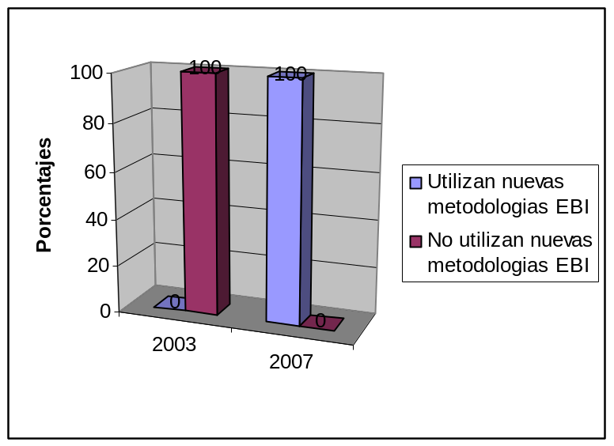  - The baseline shows that in 2003 no teacher had introduced BIE methodological sequences. In 2007, 100% of teachers were using new teacher-training methodologies for BIE, as corroborated by CARE, DREA and UGEL observation sheets.  - This outcome shows the weight and importance given in the project to the BIE teacher-training aspect and, in particular, to the use of BIE methodologies, as well as the considerable change brought about in the role of the teacher.  - It is important to point out that not all teachers are at the same level in terms of the use of these methodologies and that while some use them appropriately, others are still in process of consolidation.
   | Use new BIE methodologies | Do not use new BIE methodologies
  2003 | 0 | 100%
  2007 | 100% | 0

Indicator 2.1
Change in the percentage of teachers who use methodological sequences, encouraging equitable interaction among boys and girls and using materials with non-stereotype images.

Source:
Monitoring sheets for teachers.
Teachers’ survey
Educational materials observation sheet

BASELINE - 2003 | EX POST EVALUATION – 2007
In 2003, at the baseline reflected zero progress in the development of gender equity methodological sequences. | 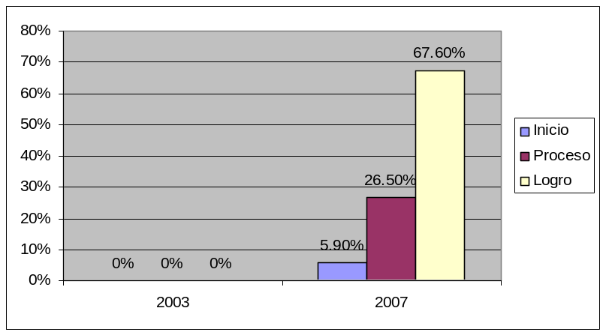  - In 2007, our sources showed that 100% of teachers used these sequences; of those, 67.60% have managed to build these methodologies into their teaching sessions, 26.50% are in process of doing so and, 5.90% have initiated their incorporation.
   | Incipient | Developing | Achieved | Total
  2003 | 0% | 0% | 0% | 0%
  2007 | 5.90% | 26.50% | 67.60% | 100.00%

Indicator 6.2
Change in the number of teachers who organize the classroom into separate Quechua and Spanish environments.

Source:
Observation manual.

BASELINE - 2003 | EX POST EVALUATION - 2007
- 58.8% of the teachers do not organize the classroom into separate Quechua and Spanish environments.  - 38.5% of teachers organize the classroom as a Spanish-only environment  - 7.7% organize the classroom as a Quechua environment. | - 78% of teachers organize the classroom as a Quechua and Spanish environment  - 22% of teachers organize the classroom as a Spanish-only environment.
3.
Results in the community: Community leaders, parents.

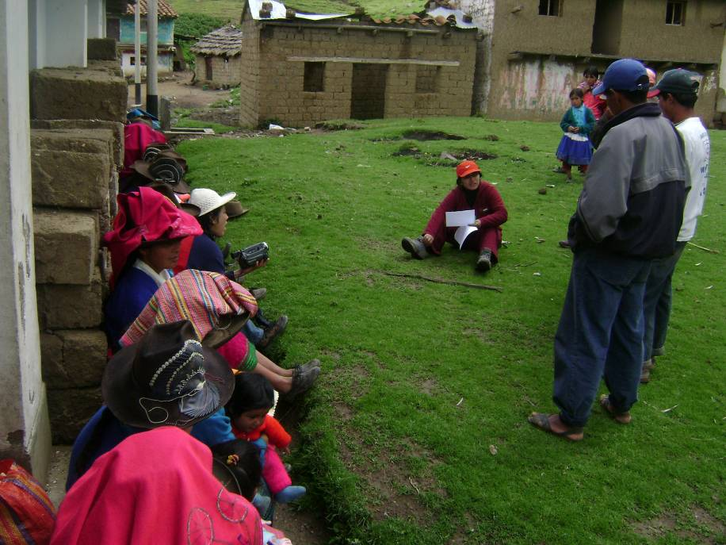
Parents’ focus group in the Anta

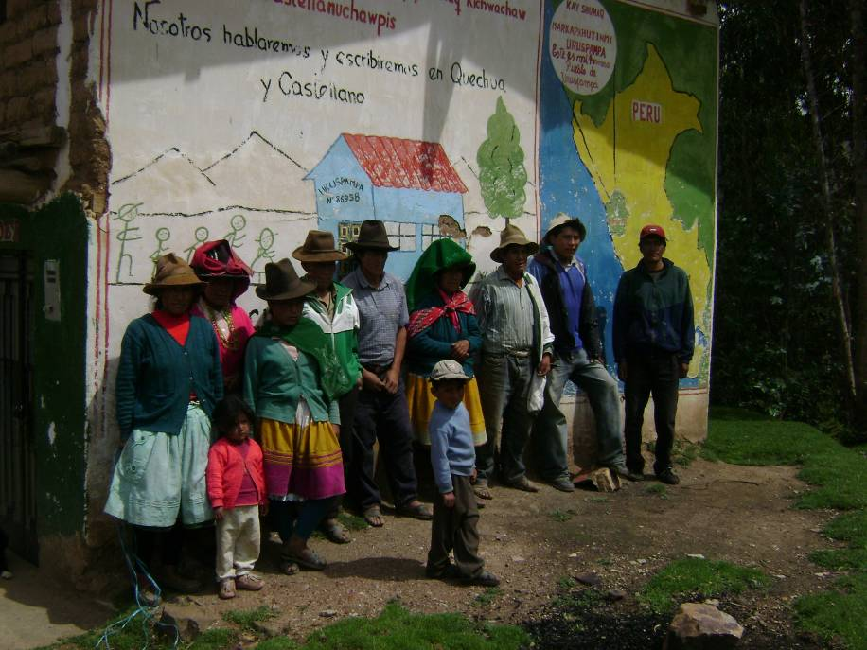
Parents’ focus group in Uruspampa
Indicator 3.1
Number and type of proposals and activities developed by leaders and parents which are adopted by the school system.

Indicator 11.1
Number of women who participate in Community Education Review and Planning Assemblies.

Source:
Attendance records at meetings and community workshops
Workshop reports
Focus group on women in the community

BASELINE-2003 | EX POST EVALUATION - 2008
- In the communities that took part in the project, the PTA would meet to address specific school-related issues: classroom maintenance, payment quotas for feast days, etc. These were the only meetings, and were only attended by parents with children in school. | - Our evaluation found that the project has implemented two major activities in which the community has played a leading role and been actively involved:  1. Community Education Review Meetings (DEC) and  2. Community Education Planning Meetings (PEC)  - Participants:  - In both cases, the participants were not only parents who were members of the PTA. These gatherings would involve the whole community: men, women, young people, and community leaders and authorities.  - The threefold role of women is particularly visible in the community. Women are responsible for childcare and are actively involved in the school. However, the men are the visible breadwinners and they are the ones registered with the PTA.  - The women are reticent about expressing opinions and consider the men to be responsible for the children's education. They say that the men are also responsible for continuing to attend the PEC and for ensuring that the undertakings adopted in their framework are met.  - The women think that the DEC and the PEC are important for their community. For the first time they have access to a forum where they can offer an opinion about their aspirations in the community and how the school can advance those aspirations. They say they feel that they have contributed with their opinions and not simply with payments or community labor in infrastructure works, as is usually the case.  - Women continue to have a less say than men. Families divide their time between chores and the school, which is why only one of the parents attends the community meetings. The idea still persists that men, due to a higher level of instruction, are more qualified than women and therefore are the ones who should attend and offer opinions at meeting, relegating the social role of women to a secondary position.
  PARTICIPANTS | WOMEN |  | MEN |  | Total
  PARTICIPANTS | No. | % | No. | % | Total
  Parents | 449 | 42% | 620 | 58% | 1069
  Leaders | 53 | 35% | 98 | 65% | 151
  Young people | 13 | 37% | 22 | 63% | 35
   | 515 | 41% | 740 | 59% | 1255

Indicator 11.2
Number of women who take on responsibilities and lead the implementation of Community Education Plans.

Source:
Review of 16 Community Education Plans
Community leaders’ focus groups
Parents’ focus groups.

BASELINE - 2003 | EX POST EVALUATION – 2008
- 0 suggestions offered by women at PTA meetings and implemented in the school.  - Women more familiar with the needs and problems of their children at school.  - School directors largely ignore the opinions of women at school meetings.  - 17% of school directors say they received recommendations from women on how to improve the school.  - 5.9% of directors said they had received a BIE proposal from student’s mothers.  - Schools work in relative isolation from the community. There is only coordination on specific issues with the PTA and community authorities.  - No community has a Community Education Action Plan. Very few schools figure on the Community Public Agenda and when they do it is only in connection with the infrastructure aspect.  - The community does not contribute proposals on the education that children receive in school. | 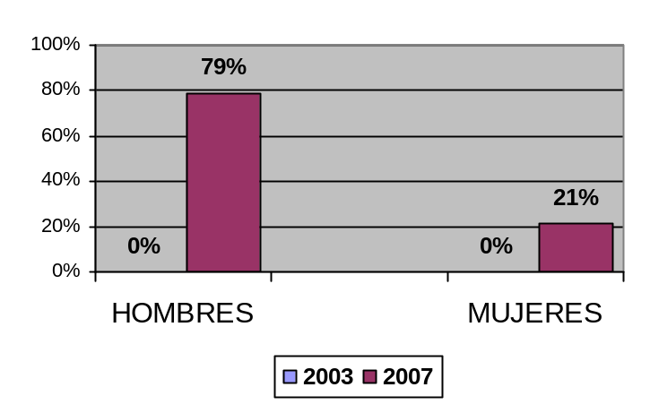  - The 18 communities that took part in the project have a Community Education Plan (PEC), which contains all of the proposals of the organized community for improving the education offered by the school.  - These PEC have been prepared at community meetings with the participation of parents, community leaders and authorities, and young people, boys and girls at school.  - The most recently prepared PEC monitored by the project show that in all the organized community has proposed 147 activities to improve education in their community, of which 117 (79%) are led by men and 30 (21%) by women.  - The various women-led activities include: school attendance committee, school vegetable garden, weaving workshops for students, organization of psychological assistance for boys and girls, etc.  - It is clear that there has been a significant change in the women’s role in the school. Although most activities are of a domestic type, in some case women are initiating managerial measures.  - Men and women recognize that responsibility for the education of their children falls on both of them and that decision-making authority does not belong solely to the man. An attitude change was visible in one third of the parents interviewed.  - Women who assume responsibility for spearheading an activity or proposal feel committed and demonstrate the desire to perform their task efficiently.  - Women’s involvement is still very limited because of the marked difference between men and women in rural areas. This puts women in a secondary position and denies them a say in community decisions. This is a very deeply rooted reality that will take a long time to change.  - Despite this situation women have taken significant strides in terms of leadership and decision making. The foregoing are very specific but important cases: the school attendance committee in Quinranca; School-age children’s census in Collón.  - It is important to note that many women committed to domestic measures, such as sending their children clean and fed to school, or treating boys and girls with respect and encouraging both to perform household chores. At first sight, such measures might appear simplistic and insignificant; however, they entail a genuine attitude change on the part of the women, who are directly responsible for raising the children.

LIST OF WOMEN-LED ACTIVITIES
IN COMMUNITY EDUCATION PLANS

COMMUNITY | No. ACTIVITIES LED, BY SEX |  |  | TYPE OF ACTIVITIES LED BY WOMEN
COMMUNITY | MEN | WOMEN | TOTAL | TYPE OF ACTIVITIES LED BY WOMEN
QUINRANCA | 8 | 2 | 10 | - Dissemination of messages in Quechua and Spanish  - School attendance committee
COLLON | 10 | 1 | 11 | - School-age children’s census
SHINUA | 4 | 1 | 5 | - School vegetable garden
PASHPA | 8 | 3 | 11 | Commitments:  - Send boys and girls to school clean  - Educate by example  - Encourage boys and girls to complete their primary and secondary education
BUENOS AIRES | 8 | 1 | 9 | - Periodic visits to the school to check on children's progress.
SAN MIGUEL ACO | 10 | 3 | 13 | - Promote self-esteem workshops  - Organize youth clubs  - Promote gender workshops
LABORPAMPA | 6 | 2 | 8 | - Weaving competition  - Promote self-esteem and leadership workshops
HUAPRA | 6 | 2 | 8 | Commitments:  - Send boys and girls to school clean  - Help them with their homework
ANTA | 9 | 1 | 10 | - Psychological assistance for boys and girls in school
AHUAC | 3 | 1 | 4 | - Weaving workshops
HUACRAN | 7 | 1 | 8 | - Treat boys and girls with respect
PAMPACANCHA | 10 | 1 | 11 | - Equal opportunities for boys and girls
CANTAR | 6 | 5 | 11 | - Treat boys and girls without distinction and give them the same opportunities  - Send boys and girls to school clean  - Treat boys and girls with respect  - Voice opinions at meetings without fear
PACCHA | 10 | 5 | 15 | - Equal opportunities for boys and girls  - Treat boys and girls with respect  - Share household chores between sons and daughters  - Set up a community kitchen
LA ESPERANZA | 8 | 1 | 9 | - Speak to children in Quechua and Spanish in the home
PARIAHUANCA | 4 | 0 | 4

Indicator 12.1
Number of BIE school parents who participate in community education review and planning meetings as well as awareness raising in BIE and Gender Equity.

Source:
Workshop attendance roster (participants in the least two workshops per item)
Parents’ focus group
Boys’ and girls’ focus group
Workshop report review

BASELINE - 2003 | EX POST EVALUATION - 2007
0 Community Education Review and Planning Activities | The EDUBINA project has held:  - 36 Education Review and Planning Workshops in which the whole community, including parents, have actively taken part.  - 41 community workshops to monitor and follow up on community education plans, which had been implemented in a participatory manner, providing an opportunity for feedback and new proposals.  - 36 BIE awareness-raising workshops. The BIE issue has been included in Education Review and Planning Workshops, prompting analysis and discussion on the importance of bilingual intercultural education.  - Four gender and self-esteem workshops per community, targeting parents.  - PARTICIPANTS:  - The workshops covered the most important aspects of gender, including the distinction between sex and gender, gender stereotypes, gender roles, and gender in education from the point of view of personal experience.  - The gender and self-esteem workshops concluded with the adoption of practical commitments on the issue, which were included in the Community Education Plan.  BILINGUAL INTERCULTURAL EDUCATION:  - Parents regard bilingual education as an advantage for their children, who start school only speaking Quechua and understanding no Spanish.  - The parents' desire is for their children to master reading, writing and oral expression in both languages.  - They have noted that the children master both languages by the time they reach fifth and sixth grade and that this opens greater opportunities for them in both the rural community and the city.  - They say that the boys and girls have difficulties reading and writing in Quechua and that it is easier for them to do so in Spanish.  - Parents consider it positive that local issues are included in what the children learn. They are proud of things like the history of their community, their geography, their natural resources, their organization, there village festival, their patron saint, etc., in particular because these things have been produced by them and it promotes their cultural identity.
  ITEM | TOTAL | TRAINED
  ITEM | TOTAL | MOTHERS | % | FATHERS | %
  DEC AND PEC | 1069 | 449 | 42% | 620 | 58%
  BIE AWARENESS RAISING | 1069 | 449 | 42% | 620 | 58%
  GENDER AND SELF-ESTEEM | 875 | 504 | 58% | 371 | 42%

Indicator 13.1
Number of community leaders who participate in the Community Education Review and Planning process.

Source:
Attendance rosters
Community leaders' focus groups

BASELINE - 2003 | EX POST EVALUATION – 2003
0 plans as of November 2003 | - 151 leaders have taken part in Community Education Review and Planning Activities; of those, 98 (65%) are men and 53 (35%) are women.  - The community leaders who took part held various positions: deputy governor, municipal agent, president of the Glass of Milk committee, health outreach worker, president of the JASS (community water and sanitation board), member of the PTA and a number of private individuals with influence in the community. Despite their separate responsibilities, these persons have contributed with proposals for improving education in their communities.  - The community leaders are familiar with the DEC and the PEC. It was noted that the most influential authorities are the president of the community, the deputy governor, and the PTA, who are in charge of implementing the Community Education Plan.  - The community leaders regard the DEC and PEC as important management documents for improving education in their community, that they express the aspirations and concerns of community members, and that school can make a worthwhile contribution.

Indicator 13.3
Number of communities that generate financial revenue to improve BIE and Gender Equity in their communities.

Source:
Interviews with community leaders
Review of Community Education Plans

BASELINE – 2003 | EX POST EVALUATION - 2007
0 Community Education Plans | - Of the 18 Community Education Plans in place, nine (50%) have a budget for carrying out the activities they propose.  - These budgets are allocated by the District Municipality through the participatory budget planning process, in which the participating communities have requested support for implementing a number of measures proposed in their Community Education Plans.  - The communities organized sports activities to raise funds and implement a number of measures proposed in their PECs, such as the purchase of a voltage stabilizer, sports equipment, and books.
  COMMUNITY | PEC APPROPRIATION | FINANCING
  Anta | S/. 300.00 | The district municipality of Anta will allocate S/.300.00 to community authorities for implementing activities under their Community Education Plans.
  Pampacancha | S/. 300.00
  Paccha | S/. 300.00
  Cantar | S/. 300.00
  La Esperanza | S/. 300.00
  Huacrán | S/. 300.00
  Quinranca | S/. 1800.00 | The district municipality of San Miguel de Aco has procured three computers for schools.
  San Miguel de Aco | S/. 1800.00
  Huapra | S/. 1800.00

Indicator 13.4
Number of schools that stage campaigns, paint murals, and put up posters in Quechua and Spanish with the participation of the community

Source:
Observation of murals
Interviews with parents, community leaders and students

BASELINE - 2003 | EX POST EVALUATION - 2007
0 campaigns and murals in Quechua and Spanish | - All six communities visited had murals displaying positive messages in Quechua and Spanish.  - The parents think these murals are very important for everybody because they contain nice messages in Quechua and Spanish that refer to their village and customs.  - The murals are the result of collaboration between women, men, boys and girls, who drew, painted and wrote the phrases. They felt proud of this work, which they have done for the school and the community.  - The interviewees said that they would paint fresh murals when the current ones have deteriorated and that it would be good to change them more frequently so that everyone could read new messages.  - The boys and girls interviewed said they were involved in the creation of these murals. It was noted that they could read the messages in Spanish quite clearly, but not those in Quechua. They said that reading and writing in Quechua is more difficult than in Spanish.

Results in Education Management and Advocacy.

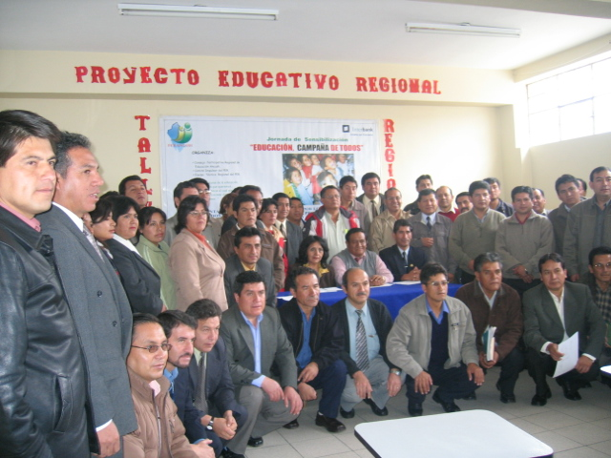
Participants in Regional Education Project

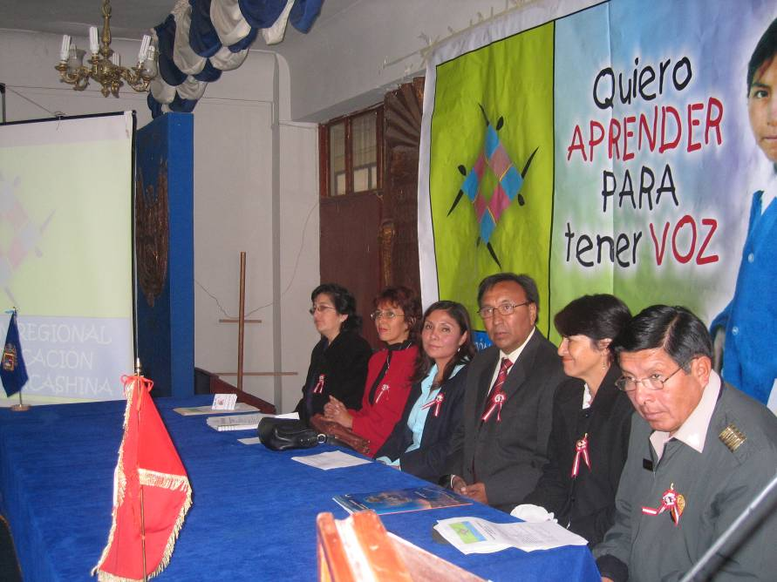
Leadership of the Association for Girls’ Education in Ancash
Indicator 4.1
Number and type of new and updated pro-BIE policies

Indicator 14.1
Number and type of proposals in favor of BIE and gender equity formulated and negotiated by local networks and consensus-building committees composed of key public sector stakeholders and civil society organizations.

Source:
PER review
Interviews with members of the PER Committee

BASELINE – 2003 | EX POST EVALUATION – 2007
- No known proposals in favor of BIE and gender equity generated by civil society organizations, networks, or local consensus-building committees. | - In 2006, the Regional Education Department of Ancash (DREA), on its own initiative, adopted resolution R.D.R. Nº 2070-04, creating the Participatory Regional Education Council (COPARE), which is composed of 23 representatives of civil society organizations and government institutions.  - COPARE designs the Regional Education Plan (PER) in a participatory manner and is also on the PER Implementation Committee (CIPER), which is composed of the most committed institutions and actors in COPARE, including CARE Peru (through the EDUBINA project).  - CIPER is composed of local government representatives from the District of Independencia, CARE Peru, DRE Ancash, National Council for the Environment, and the Consensus-Building Committee to Fight Poverty, supported by a DREA education expert.  - The PER includes Interculturality and Bilingualism as a core strategy that consists of the following measures:  - Establish regional and multisectoral (government, civil society, media, and private sector) mechanisms and strategies to promote cultural diversity and interculturality in all public forums in the region.  - Ensure the social use of Quechua in public and private entities in the region, providing training and encouraging personnel, as well as supporting institutions in promoting its teaching.  - Encourage research on the knowledge, technology, values, language, history, etc. of Andean populations, Afro descendants, and coastal peoples as part of a preset agenda.  - Ensure that the regional teacher-training plan and the curriculum design guidelines for the entire education system are founded on the principle of interculturality.  - Create a Multisectoral Committee to direct and monitor promotion policy on interculturality and bilingualism in the region.  - Progressively bring about the widespread adoption of bilingual intercultural education for Quechua-speaking and bilingual students in the region, treating Quechua as the first language and Spanish as the second.  - Progressive implementation of the Quechua as a Second Language Program in Spanish-speaking areas, at all levels of education (primary to tertiary).  - Creation of the Bilingual Resources and Materials Center (CREMBI) with a regional team and provincial teams for each Quechua dialect (Huaylas, Conchudos and Bolognesi), in order to design and produce bilingual materials in Quechua and Spanish.  - Creation of a support network for the implementation of BIE in the region with the participation of NGOs, government institutions, and civil society (community-based organizations, farmers organizations, professional organizations, teachers unions, etc.)  - Strengthen implementation of the foreign language program in elementary and higher education at public and private institutions  - Establish agreements with specialized institutions, technical cooperation agencies, and embassies to promote language teaching.  - EDUBINA has also played a key role in the design of the Carhuaz Local Education Plan (PEL), which is under review and expected soon to be approved and distributed.  - One of the strategic lines of action of the Carhuaz PEL is “Cultural diversity and environmental protection,” the objective which is to promote respect for cultural plurality and the use of our ancestral knowledge to contribute to positive social coexistence and harmony with nature. This line of action proposes the following measures:  - Appropriate diversification following the inclusion of ancestral knowledge in the curriculum based on the local cultural worldview.  - Promote comprehensive networks for different levels of schools, by watersheds, with a view to joint diversification.  - Active parental participation in the diversification process based on the calendar of local agricultural festivals and play activities.  - Training in cultural mediation for teachers at all levels and in all fields.  - Promote the use of peasant farmers’ knowledge to improve their individual, household, and social quality of life in an environmentally sound manner.  - The population learns to look after sanitary infrastructure and environmental conservation tools.  - Authorities support the process through adoption of laws, ordinances, and regulations on appropriate use of resources and environmental protection, as well as outreach activities.  - Promotion and organization of book, video, and games libraries for students, in order to support a well-rounded acquisition of literacy skills.  - Population progressively produces and compiles texts on their community, district, province, and region.  - Promote the participation of authorities and parents to ensure comprehensive acquisition of literacy skills.  - Population develops bilingual skills (Quechua and Spanish) based on the widespread use of both languages in all public and private institutions.

Indicator 16.1
Frequency of radio programs and community newsletters disseminated in Quechua and/or Spanish which rescue Andean knowledge and encourage debate on education policy and BIE and Gender Equity.

BASELINE - 2003 | EX POST EVALUATION – 2007
The names of radio stations are identified but the names of programs or messages are not recognised. | - Radio Fuego broadcast the program “RIQCHAKUTSUN” in Quechua.  - Most men and women in the community say they have listened to “RIQCHAKUTSUN”  - Parents confirm that they have listened to the radio program and recall the following aspects:  - It was broadcast in Quechua.  - They liked the music and it was in Quechua.  - There was a lot of talk about the value of campesino men and women.  - The importance of education for development.  - The importance of bilingual education for students to receive a better schooling.  - EDUBINA has collaborated with the program “Escuelita del Aire” promoted by the Ministry of Education, in which themes to do with BIE and Gender are broadcast as part of an agreement.  - The teachers write a newsletter called “Willakuq” which contains different information about BIE that is circulated among the participating and other communities.

Results in Gender Equity and

Equality of Opportunities

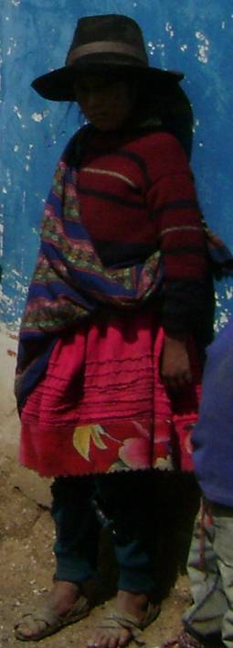
Interviewed Girl - Uruspampa

Indicator 9.1
Number of boys and girls who attend instruction sessions at a school workshop on gender equity and self-esteem.

Source:
Review of workshop reports
Focus groups with boys and girls

BASELINE - 2003 | EX POST EVALUATION – 2007
0 training sessions on gender and self-esteem | - EDUBINA has promoted gender and self-esteem training workshops at the 18 participating schools, which are held during tutorial periods imparted by teachers and experts on the subject.  PARTICIPANTS:  - The workshops on gender and self-esteem and the initiatives with gender equity were held in order to encourage the active participation of girls, boys, and adolescents; create environments in which to visualize democratic relationships between boys and girls; and encourage equality of opportunities in both groups.  - Focus groups held to consult boys, girls and adolescents revealed the following:  - They recall having very much enjoyed taking part in events and meetings where "they were helped to understand" that men and women have the same rights and should, therefore, have the same opportunities.  - They were listened to and treated with a great deal of affection and felt less fear each time they spoke.  - They best remember the workshops held by the expert who visited them sporadically. They would sing and play with her, and girls, boys and adolescents would all join in the activities.  - The activities held during the tutorial periods by teachers were recalled with less enthusiasm. Evidently their lack of familiarity with the issue and the methodology was not conducive to effective assimilation.  - Uruspampa is a community where girls seemed very relaxed and were unafraid to express their opinion.  - They say that most teachers treat them all the same and that only some jobs were reserved almost exclusively for the girls, such as tidying the classroom and preparing the school breakfasts.  - The girls have fond memories of the weaving workshops for boys and girls.  - The boys are somewhat averse to domestic chores. They still say that they are a woman's work.  - In the course of the focus groups it was noted that in most cases boys and girls interacted with members of their own sex, forming subgroups.  - Girls at still feel embarrassed about expressing themselves, especially when the dialogue is in Spanish. A clear difference was noted when the conversation was held in Quechua: the girls express themselves better, initiate the dialogue and lose their fear.  - The boys express themselves better in Spanish and their communication is more fluid. They have a better mastery of both languages.  - Initial steps are being taken towards promotion of gender equity. However, these have yet to manifest themselves in equitable practices; they are still at the level of knowledge and, to a lesser extent, of attitudes in the boys and girls.
  SUBJECT | GIRLS | BOYS | ADOLESCENT WOMEN | ADOLESCENT MEN | TOTAL
  GENDER AND SELF-ESTEEM | 774 | 760 | 20 | 39 | 1593
  INITIATIVES WITH GENDER EQUITY | 402 | 540 | - | - | 942

Indicator 6.1
Number of teachers trained in the application of new methodologies for bilingual intercultural education and gender equity promotion.

Source:
- Teachers’ survey
- Review of workshop reports
- Teachers’ work dossiers

BASELINE - 2003 | EX POST EVALUATION - 2007
- No information recorded on the subject. | - The EBUBINA project has held 27 training workshops and/or events in connection with BIE and Gender, which had been attended by 63 teachers: 21 women and 42 men.  - The teachers attended the training sessions on a regular basis, with all 63 teachers going to at least 95% of the training events.  - The workshop centered on capacity building in bilingual intercultural education and gender equity, addressing important aspects for a teacher’s work, including:  - Curricular Diversification in BIE  - Annual Curricular Planning  - Methodological Strategies in BIE  - Basic Quechua Grammar  - BIE Evaluation Instruments  - BIE in Single-Teacher, Multi-Grade and Multi-Teacher Schools.  - Gender Equity  - Mistreatment in the Classroom  - Preparation of BIE Educational Materials  - BIE Curricular Planning  - Design of BIE Learning Indicators  - The majority of teachers have a clear idea of gender equity but there are still weaknesses in terms of handling of the issue and use of strategies and techniques.  - The majority of teachers have included a gender equity approach in their work, using different strategies, methodologies, and techniques. These include:  - Promotion of games that involve girls and boys equally.  - Inclusion of the subject in curricular programming (tutorial periods)  - Use of graphics and images to visualize equitable work between men and women.  - Motivational dynamics in which boys and girls interact.  - Encouragement for girls to take part in all classroom activities.  - Organization of the classroom by means of democratic elections in which women take part.  - Inclusion of gender equity content in curricular programs.  - The clearest changes noticed by the teachers in the classroom are:  - Increase in the active participation of girls in different school activities.  - Greater respect shown to girls by boys, who very often adopted dominant attitudes because of the difficulty that girls had communicating in Spanish.  - The girls are less afraid about of expressing themselves and communicating.

Indicator 8.1
Number of schools that incorporate BIE and Gender Equity in their administrative instruments

Source:
Directors monitoring sheets
Review of PEIs

BASELINE – 2003 | EX POST EVALUATION – 2007
0 schools could demonstrate that they gave priority to BIE and Gender Equity | 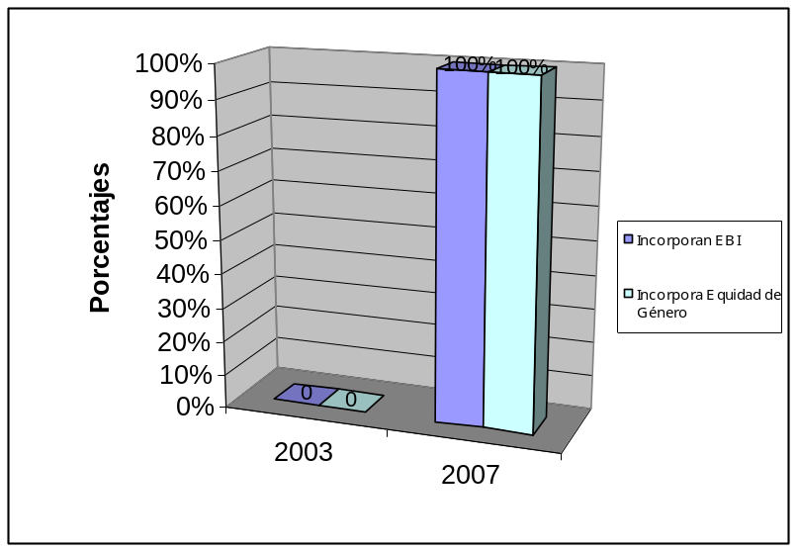  - The project has successfully persuaded 100% of schools in its target area to incorporate gender equity in their PEI and annual curricular programs, as well as in training sessions.
   | 2003 | 2007
  Incorporate BIE | 0 | 100%
  Incorporate Gender Equity | 0 | 100%

Indicator 2.2
Increase in the proportion of women elected to officer positions in PTAS.

Source:
School technical/teacher reports

BASELINE  - 2003 | EX POST EVALUATION - 2007
- 19 (20%) women and 74 (80%) men in the PTAs in the 18 participating communities.  - All the officer positions (president, secretary, treasurer) are held by men.  - The only positions held by women are those of member. There are no women PTA presidents or vice presidents.  - The majority of registered PTA members are men. | Presence of women in PTAs:  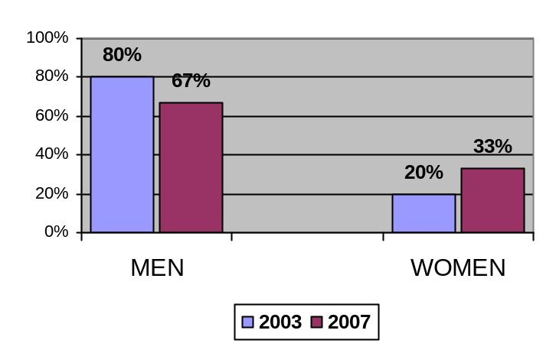  - 27 (33%) women and 56 men (67%) in PTAs.  - Of the 27 women with officer positions in PTAs:  - 2 (7%) are presidents  - 3 (11%) are secretaries  - 5 (19%) are treasurers  - 17 (63%) are members.  - There has been a slight increase in the presence of women in PTAs.  - Parents say that both can hold officer positions.  - The men say that women are more responsible and better at managing money; that they should hold officer positions. However, the women themselves do not share this view because they do not feel qualified.  - The bulk of women hold the position of PTA member but there has been a slight increase in the number of women in decision-making positions, such as president, secretary and treasurer.

Indicator 13.2
Number of measures to improve BIE and Gender Equity implemented by community leaders, parents

Source:
Focus groups with community leaders
Focus groups with parents
Review of Community Education Plans

BASELINE - 2003 | EX POST EVALUATION – 2007
0 measures as of November 2003 | - In the 16 Community Education Plans (PECs) reviewed it was found that there were 77 specific measures designed to help in some way to improve BIE and Gender Equity, of which 30 (39%) correspond to BIE proposals and 47 (61%) to gender equity proposals.  - These measures or proposals came from the communities themselves.  - An examination of the PECs revealed that most of these activities have not yet been carried out.  - Some activities are difficult to measure owing to the personal commitment and attitude change that they entail.  - It is important to mention that if these activities appear in the plan, that means they have been the subject of discussion at community assemblies and, therefore, BIE and gender equity have been items on the agendas of these gatherings.  - Interviews with parents showed that:  - They regard Community Education Review and Planning Meetings as forums where they can state their opinions without fear.  - Issues were addressed the "supported" women.  - Mention was constantly made of equality of rights.  - They very much enjoyed the competitions in Quechua (singing, poetry, storytelling, riddles, etc.), and regard them as an activity that reaffirms their community’s values and knowledge.  - They helped in the preparation of education aids by supplying local materials.  - The meetings always addressed the value of Quechua and of campesino customs and knowledge.  - The behavior of parents is still strongly dictated by stereotypical gender roles. Household chores are assigned exclusively to girls with men taking little part.  - Women consider themselves to be beneath men because of the amount of education they have completed. Women are reluctant to accept community roles because, according to them, they cannot read and write well.  - Men are the main decision-makers in the home and the community. Women do not yet play a prominent role except in special cases.  - Both fathers and mothers considered that both girls and boys, without distinction, should complete their primary and secondary education.  - The parents say that men and women have the same rights. According to some, “It is important to promote respect for women and little by little share the work and decision making evenly.”  - They believe that boys and girls say that both have the same rights: to life, to be loved and protected, to education, to health, etc.  - They are told that in the school boys and girls play the same games without distinction, and they agree with this.  - In practice, household chores are assigned to the girls and farm work to the boys. The boys do not perform such household chores such as cooking and looking after children. These tasks are exclusively for girls.

COMMUNITY MEASURES THAT PROMOTE BIE AND GENDER EQUITY

COM-MUNITY | BIE MEASURES | GENDER EQUITY MEASURES
QUINRANCA | - Encourage the use of Quechua in the home.  - Poetry Festival in Quechua and Spanish for the whole community. | - Leadership and gender workshop targeting boys, girls and young people.  - School attendance committee  - sacking embroidery workshop for boys and girls
COLLON | - Knowledge and singing competition in Quechua.  - Storytelling, singing, and riddles competition in Quechua.  - Mural painting in Quechua and Spanish | - Conduct a census of school-age children in the community.  - Leadership and self-esteem workshops for women and girls.
SHINUA | - Mural painting in Quechua and Spanish | - School attendance committee  - Leadership and gender workshops for girls and boys.
PASHPA | - Mural painting in Quechua. | - Leadership workshop for girls and boys.  - Respect and consider the opinion of women in community meetings.  - Commitment to promote the completion of elementary education by girls and boys.
BUENOS AIRES | - Mural painting in Quechua and Spanish  - Parents’ and children’s craft making competition | - Leadership workshops with children and young people.  - School attendance committee.  - Share house work and farm work without discrimination or demeaning the work of women.
SAN MIGUEL ACO | - Set up a municipal radio with speakers so that boys and girls can have the opportunity to express themselves in Quechua  - Cultural evenings in the school  - Dancing, singing competition in Quechua and Spanish. | - Leadership workshop for boys and girls  - Involve young people, boys and girls in community meetings.  - Self-esteem events for mothers.  - Gender equity workshop for parents.
LABOR-PAMPA | - Storytelling competition in Quechua (oral and written)  - Drawing competition | - Leadership workshop for girls and boys  - School attendance committee.
HUAPRA | - Commitment to learn to read and write in Quechua and Spanish  - Mural painting in Quechua
ANTA |  | - Organization and strengthening of the leadership club for boys and girls.  - School attendance committee.
AHUAC | - Commitment to encourage boys and girls to complete their education without distinction.  - Leadership workshop for girls and boys  - Weaving workshop
HUACRAN | - Awareness raising workshops on the importance of bilingual education  - Preparation of a community calendar | - Leadership workshops for girls and boys  - Commitment to provide equal opportunities in children's education  - Respect for the opinions of women at community meetings  - School attendance committee.
PAMPA-CANCHA |  | - Leadership workshops for girls and boys  - Provide the same opportunities for men and women and share activities in the school and the home.  - School attendance committee  - Provide the same opportunities for men and women at community meetings.  - Prepare a list of students that dropped out of school and those that completed the year.
CANTAR | - Presentation of local works of art at the road opening ceremony  - Commitment to learn to read and write in Quechua.  - Commitment to feel proud of speaking Quechua | - Commitment to encourage boys and girls to complete their elementary education.  - Provide the same leisure opportunities for girls and boys.  - Commitment to treat girls and boys with respect.  - Women express opinions without fear and men will have the duty to respect the opinions.  - School attendance committee.  - Leadership workshops for girls and boys  - Embroidery workshop for girls and boys
PACCHA | - Encourage visits by boys and girls to places where the Andean culture is kept alive. The example weaving workshops in the district. | - Practice of sports by boys and girls without discrimination  - Leadership workshops for boys and girls.  - Encourage the election of women members to the various school committees.  - Share household work and childcare activities evenly.  - Commitment to encourage boys and girls to complete their elementary education.  - School attendance committee.  - Weaving workshops
 | - Crafts festival and exhibition.  - Mural painting in Quechua and Spanish  - Poetry festival in Quechua and Spanish  - Sacking embroidery workshop. | - Include men and women in community activities without discrimination against women.  - Leadership and gender workshops for girls and boys
PARIA-HUANCA | - Andean storytelling competition open to students and parents | - Leadership workshop for girls, boys and young people.
TOTAL | 30 BIE MEASURES | 47 GENDER EQUITY MEASURES.

Indicator 14.2
Number of regulations adopted by public agencies in favor of BIE and Gender Equity.

Source:
UGELES BIE Experts
DREA BIE Expert

BASELINE - 2003 | EX POST EVALUATION – 2007
- 0 policies as of November 2003  - The members of the Ancash Regional Education Department recognize the Education Law (Law 28044), which provides for Bilingual intercultural education in areas where Quechua is the first language. | - The following regulations were issued during the project's lifetime:  - Regional Director’s Decision 0094 recognizing EDUBINA as a pilot project of the Regional Education Department of Ancash.  - Regional Director’s Decision Nº 0090 approving the agreement between EDUBINA and the Regional Education Department of Ancash.  - Directive 03-05 of the Carhuaz Local Education Management Unit which governs and introduces rules on the teacher-training activities of EDUBINA, which is considered a priority teacher-training initiative.  - Directive 01-07 of the Huaraz Local Education Management Unit Huaraz which governs and introduces rules on the teacher-training activities of EDUBINA, which is considered a priority teacher-training initiative.  - Directive 02-08 of the Regional Education Department of Ancash which introduces rules and guidelines for the expansion and systematization of the EDUBINA project.  - No directive was found that specifically promotes gender equity.

Indicator 9.5
Number of meetings to organize/strengthen a network of public sector, private, and civil society actors that promote girls’ education.

Source:
Board of Directors of the Regional Association for Girls’ Education in Ancash

BASELINE - 2003 | EX POST EVALUATION - 2007
- No community-based organizations were identified that implement activities that encourage children to attend school.  - Glass of Milk is an organization that indirectly encourages girls to attend school because that is one of the requirements to be a beneficiary of the program. However, it only covers girls under seven years old.  - In Ancash promotion of girls’ education depended on the education sector, which, through teachers, made efforts to ensure that all girls in rural areas went to school.  - The sector had little idea of the extent of school absenteeism in girls.  - Teachers were aware that, based on local customs, families gave priority to education for boys. Girls would devote their time to watching herds, domestic chores, and tending crops. It "was not worth it" for them to finish their studies. Boys would go on to become community authorities and migrate to the city to join organizations and work, and they “need” to study more for that.  - This situation was to some extent considered "normal" in rural communities, owing to local traditions and customs. | - In 2005, on EDUBINA’s initiative, an Implementing Committee for Girls’ Education in Ancash was set up, which gave rise to the Regional Association for Girls’ Education in Ancash (ARENA), an organization composed of more than 25 public-sector, private, and civil society institutions in the region.  - These organizations include the Regional Education Department, Regional Health Department, Ministry for Women and Social Advancement (MIMDES), teachers’ union, National Police, Office for Protection of Women and Children's Rights (DEMUNAS), judicial branch, and private individuals, among others. It has a strategic plan and separate operating plans.  - The principal objective of this organization is to promote education for girls’ in rural and urban areas of Ancash.  - ARENA has legal standing and is registered with the Huaraz Public Records Office as a nonprofit civil association that promotes education for girls in deprived rural and urban areas.  - ARENA is recognized by the Chavín Region as an association that provides important altruistic support for girls’ education in rural areas and has been formally congratulated by MIMDES for its work on behalf of girls in rural areas.  - During the project’s lifetime, ARENA has held 15 work meetings led by boards of directors.  - ARENA’s members have a very clear idea of what they want to accomplish. However, this has not yet translated into impact on key indicators such as dropout rate, girls’ absenteeism, average years of study, et cetera. The work is still at the planning and promotion stage.  - ARENA has centered its efforts on consolidation measures as an organization and promotion of girls’ education in rule areas.  - Until now ARENA has supported itself financially by means of voluntary contributions from its members.  - ARENA’s most significant accomplishment is the design of the project “WIÑAKUSHUN WARMIKUNA,” with financing provided by the district municipalities of San Miguel de Aco, Shupluy, Cascapara and Matacoto, Ataquero and Pariahuanca, which are situated in the provinces of Carhuaz and Yungay. The project has been submitted to the Antamina Mining Fund and is currently under review. ARENA has been working hard to make corrections and adjustments to the project.  - ARENA has become an independent organization that stands on its own two feet, maintains a good level of representation, is well positioned in the zone and has succeeded in getting the district and regional governments to include girls’ education in rural areas in their agendas.  - ARENA succeeded in persuading the Chavín Region to adopt a resolution that has established September 23 hours the “Regional Day for Girls Education in Ancash.”

Indicator 10.1
Number and type of gender equity awareness-raising measures introduced by school directors and experts.

Source:
School directors
BIE experts from the UGELs in Carhuaz and Huaraz
DREA BIE expert

BASELINE - 2003 | EX POST EVALUATION - 2007
- 0 BIE and Gender Equity measures as a result of the efforts of school directors and experts. | - There is an absence of any specific measures to promote gender equity at this level.  - Directors and experts have a clear idea about gender equity; however, they remain at the ‘knowledge’ stage. Weaknesses still exist in terms of attitudes and practices.  - Equality of opportunities has remained at the discourse stage without any significant measures adopted in that respect.  - They believe that the gender approach starts with a change of paradigms and convictions in people. However, the habits and perceptions regarding inequity between men and women are very deeply rooted, even among teachers.  - Experts consider that the gender approach has more to do with people's attitudes and, therefore, each teacher should be able to address the issue appropriately in the classroom as long as the matter has been internalized. Resolutions and directives are important but of little help when it comes to practice.

Indicator 9.6
Number of measures in favor of girls’ education implemented by public-sector and private institutions.

Source:
Board of Directors of the Regional Association for Girls’ Education in Ancash
Carhuaz and Huaraz UGELs BIE experts
DRE Ancash BIE expert
Review of Ancash Regional Education Plan

BASELINE - 2003 | EX POST EVALUATION - 2007
- 0 measures as of November 2003. | - The president of the Regional Association for Girls’ Education in Ancash says that guidelines had been issued to reduce the school dropout rate in girls. The physical document could not be located.  - EDUBINA is an important player in the design and implementation of the Ancash Regional Education Plan (PER), one of the core strategies of which is Equity in Education. Among other things, this strategy seeks equality of opportunities in access, continuation, and quality of education.  - One measure proposed by the PER is implementation of mechanisms to ensure that girls and adolescents satisfactory complete basic education.  - Another of the PER's core strategies is Interculturality and Bilingualism, which includes such measures as use of methodologies, strategies, and the Quechua language that promote girls’ inclusion in school. The EDUBINA evaluation has shown that younger girls are more open to and interested in going to school when they can communicate in their first language.

Indicator 15.1
Number of BIE and Gender Equity technical advisory visits made to schools by experts from the education authorities.

Source:
Carhuaz and Huaraz UGELs BIE experts
DRE Ancash BIE expert
Monitoring Sheets

BASELINE – 2003 | EX POST EVALUATION – 2007
- 3 BIE experts who perform BIE functions and other functions.  - None of the three BIE experts advised schools targeted by the EDUBINA project. | - The Carhuaz and Huaraz UGELs BIE experts made a total of 25 advisory and mentoring visits to the teachers at the 18 schools that took part in the project.  - The visits were mostly carried out jointly with the project expert, which facilitated the mentoring process.  - The monitoring sheets gave limited consideration to the gender approach. A great deal of emphasis was put on the use of non-stereotypical images but no specific further activities suggestions or other measures were implemented to promote gender equity.

VI. GENERAL OPINIONS ON THE EDUBINA PROJECT

(Opinions put forward at focus groups with parents, community leaders, teachers, experts, consensus-building committees)

Positive aspects of the EDUBINA project:
- Promotion of bilingual intercultural education meets an urgent need of boys, girls, and in general, the entire population in rural areas.

- Promotion and affirmation of cultural identity.

- Promotion of gender equity and equality of opportunities, an issue largely disregarded in the area, has built up great expectations in the different groups taking part.

- Introduction of computers in the schools targeted by the project.

- Committed and qualified staff to implement the project.

Negative aspects of the EDUBINA project:

- Does not address schools’ needs in terms of infrastructure and materials, which are very often urgent (e.g. lack of toilets).

Suggestions:

- Greater mentoring and strengthening of the issue of curricular diversification.

- Transfer of methodologies and tools for application of the gender approach in classrooms.

- Raise public awareness about the project.

- Management capacity building for teachers and experts.

- Mentoring and implementation of specific commitments on BIE and gender equity contained in the Regional Education Plan and Local Education Plans.

VII. CONCLUSIONS AND RECOMMENDATIONS

CONCLUSIONS | RECOMMENDATIONS
- EDUBINA has made satisfactory progress in almost all of its lines of action.  - There has been a slight improvement in almost all end-of-project indicators, such as promotion, grade repetition, dropout rate, and remediation; however, these problems remain acute in all of the communities that took part in the project.  - Important progress has been made in the area of teacher-training: the design and organization of the teacher-training plan proposed after implementation of the EDUBINA project, provides teachers, directors and experts with the opportunity to acquire and put into practice knowledge about curriculum planning and classroom teaching.  - With respect to integral communication in Quechua and Spanish (reading comprehension and text production), a comparison was made of the baseline and the results in 2006 and 2007 in this area, as well as of EDUBINA schools and comparable non-EDUBINA schools, and significant strides were found. (This evaluation was assigned to a separate consultant.)  - A substantial number of teachers (63) have developed capacities in BIE, curricular programming, and training sessions, connecting the Community Education Plans with their teaching work.  - Community participation, a core element of the project, succeeded in making education a priority issue and a task that concerns everyone, leading the community to develop its own proposals that make the school are part of the development processes.  - The Community Education Reviews and Plans have been important opportunities in the framework of a participation strategy and a process that has encouraged the recognition and affirmation of community members’ “pride” in their identity. However, they are still at the initial stages of consolidation.  - There has been an increase in women's participation in community life. Their organized response to the commitments and challenges posed by the Education Plans, PTAs, and community-based organizations are a significant stride. Gender equity at the community level is still incipient and there is still much work to be done in that respect. Important progress has been made, such as familiarization with certain knowledge and awareness of the issue, as well as attitude changes (to a lesser extent). However, this still needs to be materialized in practice, which is the strongest indicator of fundamental change.  - The BIE experts are somewhat limited in their handling of the gender approach. They have the right knowledge but lack specific tools and instruments to address and monitor the issue.  - The gender equity approach in the classroom has made significant strides due to the predisposition of teachers and students. Also pending are the tasks of consolidation of the changes already seen, such as democratic organization with the participation of girls/women. It is important to bear in mind that the issue requires the use of specific and appropriate methodologies that hve been validated in rural Andean areas, since they go against customs and positions that are deeply rooted, not only in the community, but also in school actors.  - EDUBINA has successfully influenced policies through its active participation in Regional and Local Education Plans. These are aspects that help guarantee the sustainability of the project since they dictate the course of all the education measures to be implemented and maintain BIE and gender equity as core strategies.  - La Regional Association for Girls’ Education in Ancash is an organization that was formed and promoted by the EDUBINA project. It currently operates independently and implement projects designed to improve girls’ education in different rural areas.  - By means of various strategies EDUBINA has succeeded in including bilingual intercultural education in the public agenda at the regional, district, and community level. | - Include a stage for methodological strengthening and consolidation of results and processes in the target zones.  - Direct the main efforts at correcting these indicators and implement measures and processes specifically designed to improve them.  - Incorporate the teacher-training plan produced by the project with specific indicators to improve its evaluation and harness its results.  - Systematize this experience and disseminate the lessons learned at the regional level in participation with the Huaraz and Carhuaz UGEL and the DREA.  - Generate mechanisms for strengthening the capacity is acquired by teachers.  - Teachers could encourage effective community participation in the design of curricular programs. The project should include the transfer of community participation methodologies and strategies to teachers with the support and backing of the UGELs to that end.  - Complete and update the Community Education Reviews and Plans. The community still needs a certain amount of technical assistance to enable it to improve and refine processes for identifying problems and shortcomings as well as strengths and challenges in the school.  - The gender approach must be addressed from the point of view of personal experiences, focusing more on attitudes than on knowledge teachers, students, parents, community leaders etc. It is necessary for this approach to impact on the lives of people without their feeling that their customs, perceptions, and images are being infringed.  - Provide training to experts in the use of strategies, instruments, tools, etc., in order more effectively to promote gender equity in the classroom. Include these proposals in the monitoring sheets to be implemented and provide the necessary mentoring.  - Provide effective mentoring for teachers in the use of gender equity-specific methodologies and techniques for work with the children. Strengthen teachers’ gender approach capacities.  - The regional consolidation of the Regional Education Plan (PER) should be supported and steps taken to ensure that all schools in the region are supplied with a copy of the PER so that they can invite students and parents to offer their opinions on it. This decision and responsibility headed by the organs of the sector should be a concerted activity undertaken by agencies like CARE that work for regional development.  - CARE should permanently support and participate in this initial stage of the Regional Association for Girls’ Education in Ancash, until it is fully consolidated as an organization.  - Systematize the experience and disseminate the results.

