

CARE Myanmar

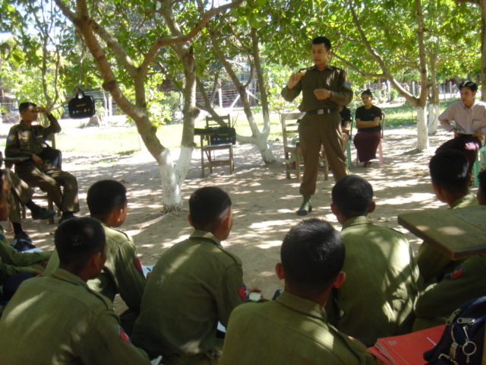

HIV/AIDS Prevention for Police Force in Myanmar

CARE Project MMR052
Funded by UNAIDS

ANNUAL REPORT
Reporting Period
June/2004 to May/2005

UNITED NATIONS OFFICE ON DRUGS AND CRIME (UNODC)

FINAL REPORT

June. 2004 – May. 2005

1. GENERAL PROJECT INFORMATION
Project Title: | HIV/AIDS prevention for Police Force in Myanmar
Project Number: | MMR 052
Duration: | 12 months
Executing Agency: | UNODC field office, Myanmar
Implementing Agency: | CARE International in Myanmar
Budget: | US$ 56,811
Donor: | UNAIDS

II.EXECUTIVE SUMMARY

  - IMMEDIATE OBJECTIVE:

To improve the knowledge on HIV/AIDS prevention among the police personnel and their families, especially new recruits so that they are able to protect themselves and continue the HIV/AIDS education activities by themselves.

  - OBJECTIVES:

- To increase knowledge, awareness and reported safer behaviour amongst new recruits in the police force who have been exposed to the educational activities;
- To increase knowledge, awareness and reported safer behaviour in police personnel including those in border towns, who have been exposed to educational activities.
- To increase knowledge of and positive attitudes towards harm reduction and how this can be applied to police work, particularly in dealing with groups with high risk behaviors.
- To institutionalize HIV/AIDS education and prevention and principles of harm reduction within the police force.

2.3 CONTEXT

The aim of this project is to increase the awareness of HIV/AIDS and STI among police personnel and their families. In addition to that, the training schools for police personnel incorporate the HIV/AIDS and STI lessons in their existing curriculum. Educators and counselors are trained so that the education programmed could be continued in Myanmar Police Force after this project.
The project was implemented in partnership between United Nations Office of the Drug and Crime (UNODC), and CARE International Myanmar with the assistance of Central Committee for Drug Abuse Control (CCDAC) under Myanmar Ministry of Home Affaires.

The project covered the following sites:
1. Central Police Training Institute (Zeepingyi-Mandalay Division)
2. No.1 Police Training Depot (Yamaethin Township –Mandalay Division)
3. No.2 Police Training Depot (Wethtikan –Bago division)
4. Taunglaylone police training Depot (Southern Shan State)
5. Muse Border Police station (Northern Shan State)
6. Tarchileik Border Police Station (Eastern Shan State)

The target beneficiaries of the project were 400 new recruits both officers and other ranks, 100 in-service police personnel as direct beneficiaries and 1000 immediate family members and batches of new recruits to be trained with the materials developed.

Strategies

The UNODC and CARE International implemented this project with the coordination assistance from CCDAC.

- Using the lessons learnt by CARE and UNODC and expand their pioneering work with the police force in Myanmar
- Advocacy to promote supportive environment for risk groups.
- Developing/modification of education modules on HIV/AIDS prevention for the police personnel based on initial need assessment
- Training of a number of selected personnel as educators
- Building the capacity of existing police personnel and instructors from the Police Training Department and Depots
- Initial planning workshops with officers and other key personnel
- Knowledge, attitude and practice study before and after the project among the police personnel (new recruit as well as in service police personnel).
- Development of curriculum on HIV/AIDS prevention for police training institutions.
- Training of educators selected within the police training institutions
- Training of educators selected within the police force (police personnel and family).
- Implementing education activities by trained educators.
- Trial of counseling services by counselors trained in the project
- Developed training modules (one for TOT and one for HE sessions and part of existing training curriculum of police training depots)
- Developed of BCC materials and distribution in Myanmar police force setting.
- Condom promotion
- Establishing core group of trainers (educators and counselors).

2.4 MAIN ACTIVITIES AND ACHIEVEMENTS FOR YEAR UNDER REVIEW

Output 1 Improve knowledge and awareness on HIV/AIDS among new police recruits and reported safer behavior.

Activities
- Incorporating the HIV/AIDS prevention curriculum into the existing police training
- Training of educators selected for and within the police training institutions
- Training of counselors selected within the police personnel
- Implementing education activities by trained educators
- Trial of counseling services by counselors trained in the project

Final achievements

- KAP questionnaire/guidelines were developed both qualitative and quantitative study.
- Total number of (192) new recruits were studied with KAP questionnaire at Yamaethin,Zeepingyi,Wethtikan , Taunglaylone police training depots, Muse and Tarchileik border townships.
The age of the sample population ranged from 18 to 59 with a mean of 27.63 years.Thirty percent are officers.Half of them attained higher education and 61.59 percent are not married.They usually spend their leisure time by reading or chatting.
Majority rated themselves that they have only little knowledge on HIV/AIDS and only 34 percent expressed they have a fair amount.Major sources of information were Health staff,IEC materials,and Health talks and discussions.About 94 percent could identify all 4 correct modes of transmission and more than 85 percent rejected at least 4 common misconceptions.About 98 percent agreed that HIV/AIDS could be prevented and majority knew that there is no vaccine or treatment to cure AIDS.They had a fairly good amount of knowledge on safer sex,STIs, and condom.But correct use of condom required further discussion and demonstration.
- Total number of (81) new recruits were discussed with group(focus group discussion)for their knowledge, attitude and practice on HIV/AIDS at Yamaethin,Zeepingyi , Taunglaylone police training depots, Muse and Tarchileik border townships.
There were (16) focuss group discussions ,in service police,new recruits and family member were discussed separately at police training depots and inservice police and family member were discussed at border townships.
- Total number of (6) police person were interviewed as key informants from police training depots.
(2) Curriculums developed based on existing CARE’s training curriculums and used at TOT of police training depots and border townships. one for TOT and one for continuous HE session of police training depots.
Developed curriculum(for TOT) was used at Training of trainer course at Yamaethin,Wethtikan , Zeepingyi and Taunglaylone police training depots, Muse ,Tarchileik police stations and Training for police and family from CCDAC.
- Total number of (100) trainers among the police officer of training depot (most of them are teachers of training depot) and (104) family members were given by TOT course at Yamaethin,Wethtikan , Taunglaylone Zeepingyi police training depot , Muse ,Tarchileik border police stations and CCDAC training. Family members were more than police because of request of principle of Yamaethin police training depot.

TOT training were conducted as three days training sessions by using the TOT trainer’s manual. At the end of the each training session, trainees developed an action plan for continuous education sessions. CARE provided IEC materials and condom for continuous education sessions.
After completion of the project, responsibilities to conduct the continuous education sessions will be handed over to police and family members.They will continue the health education sessions by themselves and report to CCDAC and one of the police officer of CCDAC will follow up these activities

Output 2 Improved knowledge and awareness on HIV/AIDS among police personnel stationed in the border areas and reported safer behaviors

Activities
- Training of educators selected within the police force (police personnel and family)
- Training of counselors selected within the police force(police personnel and family)
- Implementing education activities by trained educators
- Trial of counseling services by counselors trained in the project

Final achievements :
- KAP questionnaire/guidelines were developed both qualitative and quantitative study.
- Total number of (40) in-service and (40) immediate family members were trained as trainers at Muse and Tarchileik border police stations.
- Total number of (18) counselors were selected by project sites themselves ,with the criterias of those who are completed the TOT and active, interested in counseling service and keep confidential to other people’s personnel issue within the core group of trainers and trained about the basic counseling.
- Total number of (3159 ) police personnel were given health education by CARE trainers and police trainers .
- Trial of counseling services by counselors in project sites, that’s why police and family members of project sites know how to seek the counseling service when they need.
At the end of the project, developed curriculum ,based on CARE’s existing curriculum and consultation made with consultant was introduced into the existing training programmed for police personnel , these training sessions were conducted at night study time most of the training depot.So all police personnel who attending these training depot were exposed these HIV/AIDS prevention training.
For family members, HIV/AIDS education sessions were conducted during monthly organizational committee meetings.

Output 3 Positive attitudes towards harm reduction and application of the positive attitudes in their police work particularly in dealing with groups with high risk behaviors.

Activities
- Initial planning workshops with officers and other key personnel
- Development of a curriculum on HIV/AIDS prevention for police training institutions
- Knowledge, attitude and practices study before and after the project among police personnel(new recruits as well as in service police personnel)
- Training for interviewer on collecting information for KAP study
- Data entry, analysis and report on KAP study

Final achievements :

- Total number (91) of higher ranking officers participated in the workshops.
- HIV/AIDS prevention education materials(Two flip charts, one emphasized on HIV/AIDS/STIs and one emphasized on law enforcement were developed).
- Law enforcement effectiveness approach including the harm reduction concepts,100% condom usage (project specific flip chart) were developed and used at TOT of police training depot and two border police stations.
Police personnel are willing to share the knowledge and new concept concerning the harm reduction to their colleague and new recruits.
- (110,400 pieces) of condoms were distributed at police training depot and two border police stations (during the project implementing period.
- Data entry, analysis and report on KAP study both baseline and end project.

Output 4 Sustained HIV/AIDS education and prevention activities in Myanmar police force.
Activities
- Establishing core group of trainers(educators and counselors)
- Development of BCC materials and distribution in Myanmar police force settings
- Condom promotion
- Carrying out refresher training on counseling skills and peer support
- Development and distribution of curriculum and teaching aid for police training schools

Final achievements :
- Established core group of trainers (educators and counselors) at each and every police training depots and two border police stations altogether (6) trainer core groups.
- According to reports sent by police training depot , education session were started and total number of participants for health education session are (2349) new recruits and ( 810 ) family members.
- IEC materials were modified based on existing CARE’s IEC materials and widely available in police training depot.
- Pamphlet for increased awareness of HIV/AIDS among the Uniformed Services personnel were developed and distributed at TOT of police training depots.

BCC materials were developed based on the existing materials designed by CARE and lesson learnt from previous initiatives together with the input from Myanmar Police Force, were also be incorporated into the new materials. These materials were made widely available to the project areas.
Developed BCC materials were reviewed with core trainers group by the end of the project for future references and utilization.

Sr. | Type of IEC materials | Main message | Quantities
1. | Pamphlet | Basic info of HIV/AIDS/STIs | 20000
2. | T shirt | Project title | 965
3. | Note book | Basic info of HIV/AIDS/STIs | 2000
4. | Wallet | Project Title | 2000
5. | Wallet | Basic info of HIV/AIDS/STIs, Reduce stigma &discrimination about PLWHA | 5000
6. | Towel | Project Title | 300
7. | Planner | Basic info of HIV/AIDS/STIs | 1000
8. | Bag | Project Title | 350
9. | Ball Pen | Care logo,Condom promotion | 300
10. | Key chain | Project title and Condom promotion | 1000

III MAJOR PROBLEMS AND STEPS TAKEN TO SOLVE THEM
There was frequent turn over of staff at administrative level and some activities could not be implemented in time.

IV MONITORING AND EVALUATION
Monitoring and evaluation plan was developed with indicators, role and responsibilities of the project staff for monitoring and evaluation of the project sites. Monitoring trips and activities were carried out by project staff using the forms, reports and matching with action plans and actual activities and achievements.

The CARE health programme coordinator visited to the project sites and gave feed back on project concept and progress of the project. CARE Design, Monitoring and Evaluation Coordinator made regular monitoring by checking the monthly reports and gave feed back for progress and procedure regarding the monitoring and evaluation plan.

For the final evaluation, CARE Myanmar and CCDAC facilitated a final survey to assess the end of project outcome (project duration was very short and could not measure the impact of the project).

A project final evaluation and lesson learnt workshop was conducted in 6th and 7th June 2005.All the stakeholder, representatives from CCDAC,UNODC,CARE evaluation team, one police and one family member from core trainer groups of all project sites were attended the final evaluation workshop. At the workshop, all participants shared and discussed the project activities, lesson learnt, strength, weaknesses and experiences when conducting the education sessions and future activities and how to do better continuation of the health education sessions and introduced curriculum.

V FINDINGS, LESSON LEARNT AND RECOMMENDATIONS

Strength:
- Due to good coordination, CCDAC assigned a higher ranking police officer to accompany the team and conducting advocacy meetings at police training depot found no difficulties. As a result of good advocacy meetings implementation of the project was smooth.
- UNODC provided additional funding for implementation in Muse township as proposed by the CCDAC.
- The project could use the outreach workers of previous project which was closely related with this project (Entertainment & Enforcement project) as focus group discussion facilitators and volunteers for training team.
- One more TOT for police and family members of CCDAC.
- One more refresher training to newly appointed teachers from central police institute, Zeepingyi by the request of principle.

Weakness:
- In the project there were only two staff (one senior project officer and one junior project officer), that’s why implementation of project faced some difficulties
- According to project site condition ,need to do coordination meetings at field level ,the budget for one coordination meeting which will be done at Yangon was divided into transportation cost for going to each and every project sites, so time and money spending for field visit was more than estimated before.
- Most of the Core person of CARE training team were occupied many things at the time of project training period, so most of the TOT were implemented by SPO and JPO.
- In uniformed project, there is two project staff, but SPO is assigned at Yangon and JPO is assigned at Mandalay.
- Faced some difficulties when studied the KAP survey(both baseline & EOP)
Eg.1) could not do face to face interview due to man power shortage
2) Could not trace all study population who were interviewed at baseline because of heavy duties such as security problem, transfer out & others especially at border townships.

Opportunities:
- According to the good results, outcome and impact of the project need to expense the other uniformed services personnel further more.
- There will be implemented at border townships rather than two border townships covered by this project.
- By building better understanding among the higher ranking officials of uniform services, it will be easy to implement other activities.
- Implementation can be extended to other difficult operating environments such as prisons through better understanding with Ministry of Home Affairs.
- Lesson learned can be shared with new project with same nature(GFATM, round 3)

Threat:
- Turn over of staff at administrative level - need to do more advocacies and negotiation to implement the rest of the project activities.
- Because of the operating environment and nature of the job, success of the project depends on diplomacy of the project staff.

Future plans
  - Implementing continuous education activities by trained educator (police & family).
  - Implementing counseling service when need by trained police and family member who attended the counseling training.

LESSON LEARNT AND RECOMMENDATIONS

Care Myanmar has successfully implemented it’s programme towards HIV/AIDS prevention for Myanmar Police Force.
The following lesson learnt and recommendations were described by the CARE Myanmar evaluation team, project staff and beneficiaries.
- Own concern on HIV/AIDS (self-perception of risk) among police force lead to participation of beneficiaries in the project
- Assistance and participation of the police force was remarkable
- Discussions were not freely due to their job position .
- Again that culture made supportive for conducting activities
- Women or family members have more interests on activities ,they perceive they also have HIV/AIDS problems.
- Using existing networks/personnel relation enhanced the trust building and commitment for future programmes (i.e. care’s image has been stuck in police force)
- HIV/AIDS awareness raising and health education activities were seemed to be continued (even by themselves)
- The successful continuity of the activities is very much dependent upon higher ranking police official’s commitment
- Approval or permission of head quarter is crucial for the activities.
- Limited funding and other resources made implementation sometime difficult.

Recommendations

.
- The Home Ministry is a strong and efficient ministry in Myanmar and therefore any work that is implemented within this ministry has the potential to be a model for other departments, and as such can have a substantial impact.
- The project developed BCC materials which will be for future reference and utilization.Need to supply more IEC materials to police training depots to do the continuous health education sessions .It should be done by other projects with same nature (GFATM)
- Refresher TOT should be given to sustain the core group of trainers at least once a year.
- Official instruction from central training department is needed to introduce the developed curriculum into the existing training programme for police personnel. Through this, all new police recruits in Myanmar will be exposed to this training.
- Time contrain, too short, knowledge level can be improved but behaviour change may be limited. So need to do follow up activities to assess the impact of the project later.
- Scope of the project is very wide and extends up to community polism, that’s why sustainability is very important.
- HIV/AIDS education network has already established with force education and pilot counseling services which is new to existing situation.
- All activities of the project that should be sustained by Myanmar Police Force itself after end of this project.
- KAP study was conducted with strict anonymity and confidentiality so that no one could trace back individual’s risk behaviour. But trace of eligible population is very difficult when doing the end project survey, according to this experiences some consideration will be needed to solve this problem in later surveys with same nature.
- Need to build good personnel relationship, trust between CARE Myanmar and counterpart to implement successful implementation of the projects with same nature.

V FINANCIAL REPORT FOR YEAR UNDER REVIEW

Financial report is attached by separate sheet.

VII SUSTAINABILITY

All activities of the project ( continuous HE sessions,condom promotion,IEC promotion and counseling service) that will be sustained by Myanmar Police Force itself after end of this project.
Providing some support for continued activities by GFATM project.

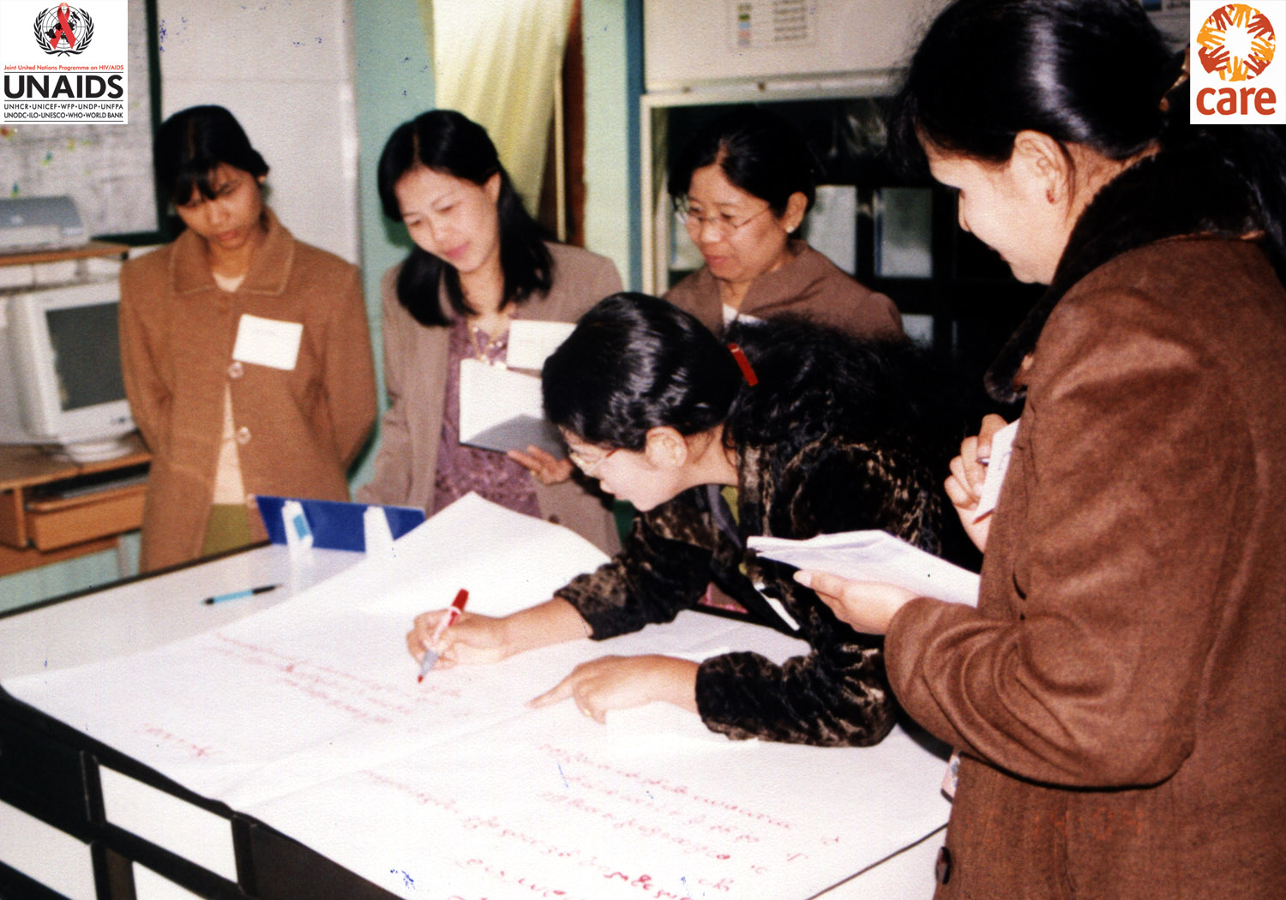
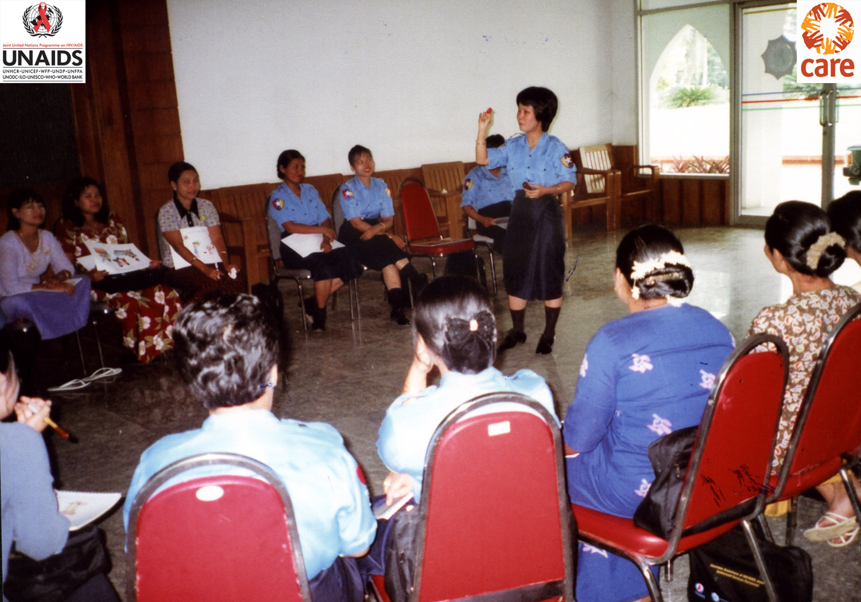
Counseling Role-play
TOT for In-Service Polices
Groupwork at TOT (Family Members)
Condom Demonstration at TOT
TOT for In-Service Polices
Groupwork at TOT (Family Members)

