CARE International in Rwanda



Strengthening Community-Organized
Responses to HIV/AIDS – Umutara

(SCORE-AIDS - Umutara)

Annual Report

(October 2004 – December 2005)

Submitted to

Africa II Division
Programme Management Department
IFAD

Contact persons:

Philip Christensen: Country Director, philipc@care.org.rw
Andrew Jones: Deputy Country Director, andrewj@care.org.rw
Delphine Pinault: HIV/AIDS Program Manager: delphinep@care.org.rw

January 2006
Table of Contents

 | Table of content
 | Acronyms and abbreviations
 | Project executive summary sheet ………………………………………………………………… | 1
I. | Introduction ………………………………………………………………………………………….. | 2
II. | Goal – Objectives – Indicators – Results – Activities …………………………………………... | 4
III. | Key Partners ………………………………………………………………………………………… | 5
IV. | Target groups ……………………………………………………………………………………….. | 5
V. | Achievements per Objective……………………………………………………………………….. | 6
1. | Objective 1 ………………………………………………………………………………………….. | 6
1.1. | Joint planning and coordination meetings with local authorities and health services officials: ……………………………………………………………………………………………… | 6
1.2. | Conduct a baseline survey ………………………………………………………………………… | 6
1.3. | Community sensitization campaigns on HIV/AIDS……………………………………………… | 6
1.4. | In partnership with the District Commissions for Fighting AIDS (CDLS) ……………………... | 7
2. | Objective 2 ………………………………………………………………………………………….. | 7
2.1. | Causal - responsibility analysis of HIV/AIDS situation and development of community response plans……………………………………………………………………………………… | 7
2.2. | Training needs assessment and delivery: | 8
2.3. | Networking between communities and stakeholders ………………………………………… | 8
3 | Objective 3…………………………………………………………………………………………… | 9
 | CARE Rwanda’s comprehensive Palliative care package to PLWHA | 9
3.1. | Provide care and support services to facilitate access and adherence to ARVs, OI treatment, palliative and home based care to targeted PLWHA: ……………………………… | 14
3.2. | VCT facilitation for the CBO members……………………………………………………………. | 14
3.3. | Economic security initiatives: microfinance and IGAs: | 15
VI. | Consolidated achievements per quarter, data disaggregated by sex ………………………… | 16
VII. | Challenges and lessons learned ………………………………………………………………….. | 19
VIII. | Project Performance appreciation ~ Geoffrey success story………………………………… | 20
IX. | Conclusions and perspective for the second year ……………………………………………… | 22
X | Statement of Expenditures ………………………………………………………………………… | 23

ACRONYMS AND ABBREVIATIONS

ABC | Abstinence, Be-faithful and Condom use
AIDS | Acquired Immune Deficiency Syndrome
ART | Anti-Retroviral Treatment
ARVs | Anti Retro Viral drugs
AWPB | Annual Work Plan and Budget
BCC | Behaviour Communication Change
CARE | Cooperative for Assistance and Relief Everywhere
CBO | Community Based Organization
CDLS | Commission du District pour la Lutte contre le SIDA
CHH | Child headed household
CLASSE-B | Community Learning and Action for Savings Stimulation and Enhancement of Business
CPLS  HBC | Commission Provinciale pour la lutte contre le SIDA  Home Based Care
HIV | Human Immuno-deficiency Virus
IEC | Information, Education and Communication
IFAD | International Fund for Agricultural Development
IGA | Income Generating Activity
MAP | Multisectoral Approach Project
OI | Opportunistic Infection
OVC | Orphan and Vulnerable Children
PEPFAR  PLWA | Presidential Emergency Plan For AIDS Relief  People Living With AIDS
PMTCT  PPPMER | Prevention of Mother to Child Transmission  Rural Small and Micro-Enterprise Promotion Project
RRP+  SCORE-AIDS | Réseau Rwandais des Personnes séropositives  Strengthening Community Organised Responses to HIV/AIDS
TOT  UCRIDP | Training of Trainers  Umutara Community Resource and Infrastructure Development Project
UNOPS | United Nations Office for Projects Services
USG  VCT | United States Governement  Voluntary Counselling and Testing
WFP | World Food Program

PROJECT EXECUTIVE SUMMARY SHEET

Title : Support of Strengthening Community
Organized Responses to HIV AIDS (SCORE AIDS)

Duration : Two years, September 2004 – September 2006.

Location : Four Districts in Umutara province; KAHI, KABARE,
BUGARAGARA and Umutara Town.

Executive Agency: CARE International in Rwanda

Donor: International Fund For Agricultural
Development (IFAD)

Grant Agreement n°: GRANT NO.SUPPL-DE-002-CARE INTL

Budget: € 470 558

Target group : - People Living With HIV AIDS Associations, at least 10
- CLASSE-B / Economic Security CBOs, 15 groups

Project Objectives: The project overall objective is to enhance community-driven responses to reduce the incidence and mitigate the impact of HIV/AIDS in the four districts described above.

Period covered by this report: October 2004 – December 2005.

I. Introduction

Based on its HIV/AIDS programming strategy, CARE Rwanda, in collaboration with IFAD developed and is implementing the “Strengthening Community Organized Responses to HIV/AIDS (SCORE AIDS)”, started in October 2004. This annual report covers the period from the beginning of the project up to December 2005, or 5 quarters in total.

The SCORE AIDS project focuses on building the capacities of communities (hereby described as community groups with common interests and goals) experiencing an increase of the disease burden and challenges of resource depletion associated with the progression of the HIV/AIDS. The project is implemented in 4 Districts located in the province of Umutara. These are Umutara Town, Kabare, Bugaragara and Kahi.
With the territorial reform, currently taking place in Rwanda beginning of January 2006, the project zone names has changed. There is no longer “Umutara Province”, rather “Eastern province”, which covers the former Umutara, Kibungo and Kigali Ngali provinces. Also the four former SCORE AIDS districts have been merged in one District NYAGATARE Nyagatare, with a possibility for some beneficiaries to be now located in the neighbor district now named GATSIBO. See next page the new Rwanda ‘s administrative map.

Under this project, main interventions in the HIV/AIDS component include HIV/AIDS awareness raising campaigns; information, education, and communication campaigns through associations of people living with HIV/AIDS and community based organizations who are participating in economic security activities. As result, community members are detecting and getting aware of their serologic status that leads potentially to a sexual behavior change. The bedridden patients received a range of services from the project such as facility to access CD4 count test, ARV, support for health insurance scheme, clinical care and hospitalization.

With regard to the community HIV/AIDS causal analysis, response planning and implementation, the project has facilitated in the four districts the HIV/AIDS community vulnerability mapping and response planning sessions – results are attached to this annual report. The response plans designed have been used as coordination and implementation framework at district level where local authorities can guide interventions to be undertaken by stakeholders as well as resource allocation. SCORE AIDS is supporting the implementation of the community response plans due to the fact that the planned activities have actually been identified as key priorities in the response plans.

It is known that populations living in poverty face some of the greatest risks of all and are often the least equipped to cope with the consequences of HIV/AIDS, which include discrimination and economic devastation. Considering that CARE beneficiaries come from very poor communities, in efforts to alleviate poverty, to promote gender equity and human rights, and to respond to HIV/AIDS impact, the project has successfully introduced an interesting model of savings and loans which uses a methodology named “Intambwe” into partners’ associations. After intensive trainings organized in favor of some associations’ members, the savings and loans culture is progressively integrated into families and the associations are increasingly capable of monitoring the system.

CARE’s experience shows that continuous dialogue with communities, flexibility, and adaptation of participatory methodologies to various contexts are pivotal to establishing community ownership of projects that are truly responsive to people’s needs and rights. CARE believes that successful community mobilization is a process based on trust and confidence-building between people that leads to lasting community empowerment that is not dependent on outside support. That is why the project has built all of its actions and decisions with full participation and integration of beneficiaries, mainly associations and the partners like the Provincial Commission for AIDS Controls (CPLS) and Rwanda Network for People living with HIV/AIDS (RRP+).

For the upcoming year, the objective of this project will remain to mitigate the disastrous effects of HIV/AIDS epidemic on the families, and to enable the communities to respond to the crisis. Central to this program will continue to be the grassroots mobilization and capacity building to analyze and respond to HIV/AIDS impacts.

As key events for the project, it’s here important to recall that in June 2005, SCORE-AIDS got the opportunity of being visited by an IFAD consultant Mr David Cownie who was asked to conduct a mid-term review of the project.
Later on, in September 2005, SCORE AIDS has also been visited by a supervision mission from UNOPS. Their recommendations have guided CARE in preparing the next annual work plan.

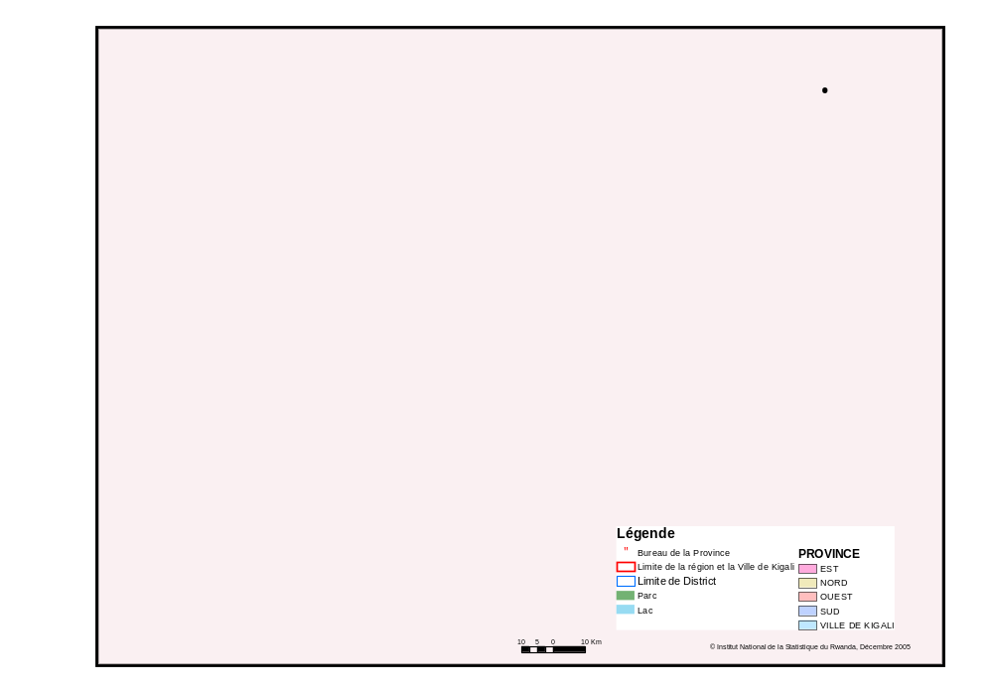
II. Goal – Objectives – Indicators - Results - Activities

II.1 Project goal

As mentioned above, the final goal of this project is to enhance community-driven response to reduce the incidence and mitigate the impact of HIV/AIDS in four administrative districts of Umutara Province. These are Bugaragara, Kabare, Kahi and Umutara Town.

II.2 Specific objectives

The three specific objectives assigned to the project are:

- Raise awareness on HIV/AIDS and its consequences to enable the communities to take positive steps for reducing its incidence and impact.
- Enhance communities’ capacities to analyze the underlying causes of HIV/AIDS and how they are affected in order to develop effective, community-driven responses.
- Operationalize community HIV/AIDS response plans that provide protection through solidarity networks and build on local partnership for sustained interaction and support.

II.3. Key progress indicators:

- 25 community groups have analyzed the impact of HIV/AIDS, the current situation and gaps within existing community response plans;
- 25 community groups have developed multi-sectoral response plans;
- 25 community groups have developed management and operational structures for the response plans;
- 25 community groups have developed formats and system of reporting implementation progress;
- 25 community-managed response plans operatinalised; concrete actions visible;
- Enhancement of services received by community groups from local leaders and service providers; concrete actions visible;
- 2,000 community members have access to “solidarity health Schemes”
- 10,000 community members have known their serologic status;
- 500 community members have access to ARVs, including at least 250 women.

II.4. Expected results for the first year:

- 10 community groups have analysed the impact of HIV/AIDS, the current situation and gaps within existing community responses, with active participation of PLWA from that community (where applicable).
- 10 community groups have developed multi-sectoral response plans
- 10 community groups have developed management and operational structures for the response plans
- 10 community groups have developed formats and system of reporting implementation progress
- 10 community-managed response plans operationalised; concrete actions visible
- 1,000 community members have access to “Solidarity Health Schemes”
- 5,000 community members have known their serologic status
- 250 community members have access to ARVs, including at least 250 women
- 15 CBOs and at least 5 people living with HIV/AIDS Associations (among whom 250 CBO members and 250 people living with HIV/AIDS are targeted) selected and trained to implement awareness raising campaigns on HIV/AIDS threats with active participation of local civic, social and decentralised government leaders.

II.5 Key activities for the first year

The following activities will be carried out to produce the expected outputs:

- Baseline survey
- Joint planning with local authorities, health staff and beneficiaries
- Selection of PLWA associations
- Selection of CBOs
- HIV/AIDS vulnerability mapping and response planning
- IEC and ARV literacy training
- VCT referrals mechanisms in place to community members in need
- Training in saving and loans activities through the CLASSE Intambwe methodology
- Training on IGA
- Disbursement of IGA funds
- Provision of health insurance scheme to needy PLWA
- Identification and facilitation of PLWA in need of ARV
- Selection and training of volunteers on ARV adherence
- Monitoring and evaluation.

III. Partners

Different partners are involved in the implementation of this project, depending on their know-how or their position and influence on the project target audience. They most intervened in sensitization campaigns and trainings that targeted the project clients.

Main partners have been:

- Provincial and districts’ administrative authorities,
- Provincial and districts’ commission for AIDS control: CPLS and CDLS,
- Health districts,(Hospitals and Health centers);
- Rwandan network of people living with HIV/AIDS, (RRP+) at provincial level.
- HIV/AIDS NGOs Forum in Umutara
- Other IFAD funded projects UCRIDP and PPPMER;

IV. Target group

At the end of the first year of implementation, the project beneficiaries are as follows:

- 10 Community groups named Intergroupements gathering 262 CBOs (associations) with 4 578 members, already engaged in economic security and microfinance activities supported by CLASSE-B project.
- 18 associations of PLWHA. The total number of HIV positive and HIV negative people within these 18 associations are 955.
V. Achievements per objective

Objective # 1: “Raise awareness on HIV/AIDS and its consequences to enable the communities to take positive steps for reducing its incidence and impact”

  - Joint planning and coordination meetings with local authorities and health services officials:

As reported after the first quarter, project launching meetings have been organized at provincial level and district level. Key partners and beneficiary representatives participated actively. These meetings have contributed mainly to create ownership of the project from different stakeholders by getting their commitment and active participation and involvement during the implementation phase.

An advisory committee was formed which meets on a quarterly basis to monitor and advice the project team. It is composed of the Director of health Services at Provincial level - president, the Director of Nyagatare Hospital, the coordinator of Nyagatare health District, the executive secretary of CPLS, the PLWA associations network’s president, a representative from FBOs, a representative from one administrative district and SCORE AIDS project manager.
Monthly coordination meetings have been regularly organized at Nyagatare health district level, where the health services are managed, for a better coordination of VCT/ARV services as well as other clinical treatment services.

  - Conduct a baseline survey

The baseline survey has been conducted in SCORE AIDS zone along with all areas where CARE was implementing HIV AIDS programs (7 provinces). A team from the National University has been contracted under USG-PEPFAR funds. Unfortunately, results were not satisfactory, with many relevant data missing to allow a proper measurement or evaluation of the outcome and impact of the project.

1.3. Community sensitization campaigns on HIV/AIDS.

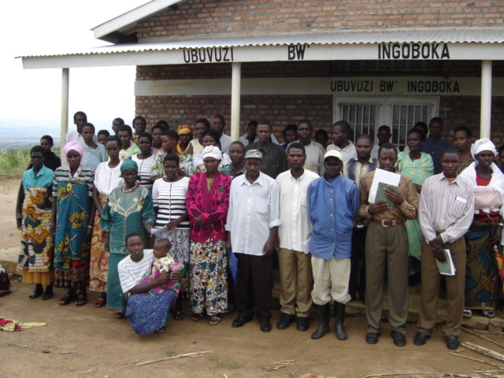
Targeting the CBO members, in the four districts covered by SCORE AIDS, sessions on Information, Education and Communication on HIV AIDS have been conducted. Up to 2,275 CBO members were reached during the first year. The main themes of discussions were on general knowledge on HIV/AIDS and its transmission, and a sensitization for VCT.
One PLWHA association’s members after IEC training
As a result, 2037 CBO members have been facilitated to access VCT services, among whom 8.7 % were found HIV +.
An other important activity to be reported on under prevention efforts has been training of 144 peer educators (70 % women), selected from the 10 intergroupements (14 from each), who facilitate discussions on related HIV/AIDS issues during Intergroupements and CBOs meetings and usual activities.
They are the focal persons for prevention messages among the CBO members. They also make a close follow up to their peers tested positive so that they can join ART program at an early stage. The 144 peer educators have been motivated with T-Shirts.
SCORE AIDS Field staffs provide to them a technical assistance through supervision field visits and meetings.
1.4. In partnership with the District Commissions for Fighting AIDS (CDLS), facilitate the access and utilization of HIV/AIDS information by local leaders and other key actors in the policy-making area.
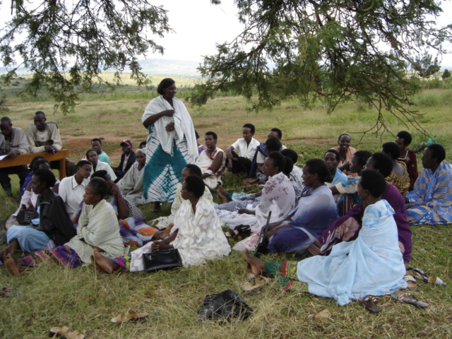
Community members discussing about the HIV/AIDS in their communities.
At district level, Pubic dialogues were organized by the project where local leaders and community member representatives (church leaders, other local NGOs, Intergroupement committees, PLWHA associations and networks representatives) participated. The main purpose was to raise awareness on HIV/AIDS by the local leaders and key actors. Themes, like prevention, stigma & discrimination, care and support for people living with AIDS, implementation of community response plans etc. were on the agenda.

A positive effect from these public dialogues has started to be visible, local authorities are being progressively more aware and more sensitive to HIV/AIDS, that is shown in an increasing amount planned in the District annual budget for HIV interventions. It’s also important to mention that this situation is not only a merit for CARE, but in general, at national level, there is a political will and a strong leadership towards the fight against AIDS.

Objective #2: “Enhance communities’ capacities to analyze the underlying causes of HIV/AIDS and how they are affected in order to develop effective, community-driven responses”

2.1. Causal - responsibility analysis of HIV/AIDS situation and development of community response plans.

The project did more than raising the community members’ awareness alone and facilitated them to analyze the situation of HIV/AIDS and its socio-economic impact in their region. This enabled them to undertake preparedness measures and to design response plans to implement selected prevention strategies as well as care & support interventions for infected and affected people.

A three day participatory meetings (community HIV/AIDS vulnerability mapping) took place in each of the 4 ex-districts: Umutara town, Kabare, kahi and Bugaragara.
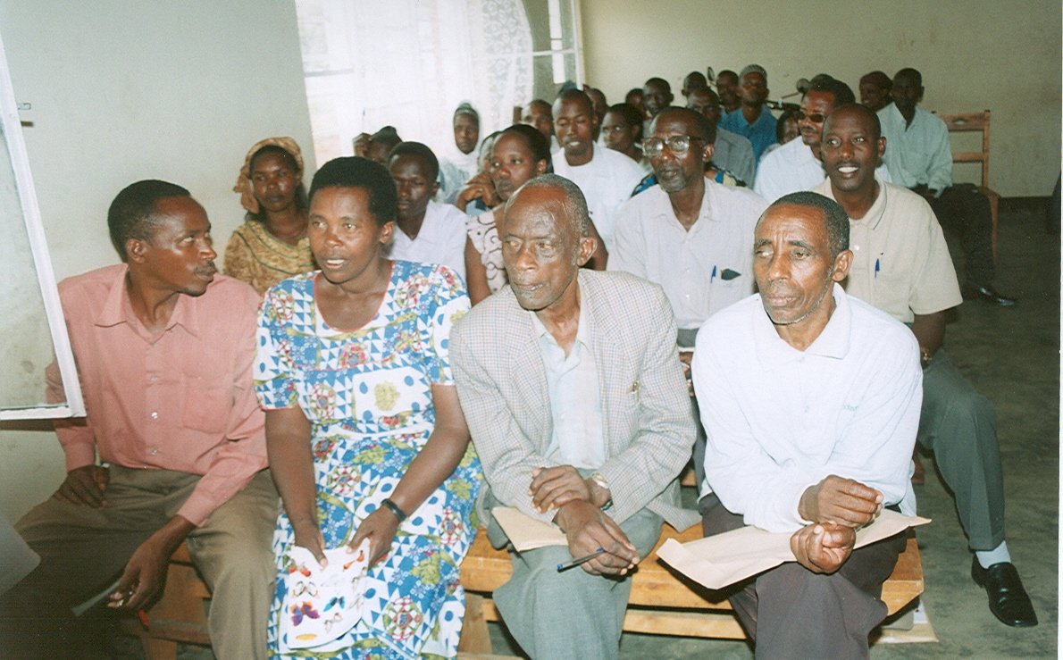
Participants on mapping session in Bugaragara district
A total of 277 opinion leaders, local authorities and PLWHA associations’ representatives attended those meetings which consisted in analyzing the HIV/AIDS causes in their area, identifying serious weaknesses in tackling it, the responsible actors and their respective responsibilities, identifying and prioritizing required solutions and then developing community-based response plans.

The designed response plans are now being implemented by all stakeholders where SCORE AIDS has found its part to support and strengthen the community initiatives of fighting the spread of HIV infection and care after PLWHA. Local authorities and other actors take part and contribute to implementing the community based response plans. This enables to strengthen networking and to promote partnership between all local services providers as well as other stakeholders that are involved in the fight against HIV/AIDS.

A report of one District on the above mentioned community HIV/AIDS vulnerability mapping and response planning sessions are attached to this annual report. They have been translated and edited both in English and Kinyarwanda (the local language) in order to ease their use by local community.

2.2. Training needs assessment and delivery:

At the early stage of the implementation of the project, during the consultation meetings and the participatory community HIV/AIDS response plans, key areas of capacity building for the project beneficiaries both PLWA groups and Intergroupements have been identified. Based on that, related trainings have been designed and delivered.

As mentioned above, general knowledge on HIV/AIDS has been one of the main themes during IEC sessions, peer education trainings, ARV literacy for PLWHA and their care takers, home based care for volunteers etc.

In addition to those themes focused on HIV/AIDS prevention and care & treatment, a great need of organizational capacity building for PLWHA associations and their networks have been identified and appropriate trainings have been organized, focusing on association management and administration, book keeping, IGA selection, planning and management etc.

Not only beneficiaries, also SCORE AIDS field staff have been trained in psychosocial counseling, home based care, case management and in CLASSE Intambwe (CARE savings and loans scheme methodology).

  - Networking between communities and stakeholders

The project provided both technical and financial support to the Provincial Network of PLWHA by organizing and facilitating planning and coordination workshops, advocacy efforts to different partners, local authorities and donors. Representation committees at District level were elected and put in place with the facilitation of the project and the coordination of PLWHA associations has now been improved.

The PLWA associations network (RRP+) has a mission of ensuring the reduction of HIV/AIDS-related socio-economic impact in the lives of people living with HIV/AIDS, through coordination and advocacy initiatives. Its administrative structure is represented from National level, to district level via the provincial level. All registered PLWA associations are ipso facto members of RRP+.

At community level, PLWHA associations have been regularly supported from organizational capacity strengthening perspective. Different meetings organized with Intergroupements and CBOs, PLWA associations and networks have facilitated exchange of views and experience and strengthened the community participation and mobilization.

The project provided to the CPLS technical and financial support to put in place at district level, anti-AIDS committees to coordinate HIV-AIDS interventions at community level and facilitate dialogue between local authorities, actors and communities.

Objective #3: “Operationalize community HIV/AIDS response plans that provide protection through solidarity networks and build on local partnership for sustained interaction and support”

SCORE AIDS has benefited from a large experience of CARE in its HBC model, implemented in 7 provinces under different funding such as USG-PEPFAR, MAP-World Bank, and including IFAD.

A summary of CARE’s care and support package including Home Based Care services is presented below:

CARE Rwanda’s comprehensive Palliative care package to PLWHA

- Description of activities in each of the following categories :

  - Basic medical/nursing care :
    - Hygienic care
  - Nutritional support
  - Referral to facilities for medical care, ARVs, VCT, PMTCT, CD4
count and other tests
  - ARVs adherence
  - Health insurance (mutuelle de santé)
  - Provision of transportation allowance from house to hospital / health
Center;

    - Psychosocial/spiritual support :
      - Home visits by community volunteers and case managers for counseling / emotional support to the patient and families, using among other techniques Helpful Active Listening.
      - Prayers conducted for the sick without any discrimination of religion
      - Bible reading of some encouraging verses

  - Socioeconomic and food support :
- Promotion of income generating activities and microfinance (through CLASSE INTAMBWE methodology)
- Provision of food for bedridden PLWHA and all association members in partnership with WFP;
- PLWHA associations’ organizational & management capacity building;

  - Legal support (will writing, succession planning) :

Legal support provision towards:
- succession planning,
- orphans placement,
- advocacy / interventions when people’s rights are abused eg. help to gain land and properties back, etc.

2. HBC Services

2.1: Description of activities / services delivered as HBC package:
  - Basic management of illness (ORS preparation, provision of basic pain relief medication, provision of creams for skin infections).
  - Adherence counseling for TB patients
  - Adherence counseling for ARV patients
  - Spiritual counseling/emotional support
  - Referrals to health facility for PLWHA
  - Nutritional counseling
  - Prevention counseling (risk reduction, HIV education)
  - Promotion of VCT, PMTCT, ART
  - Provision of food
  - Household help, help with children
  - Training of family members/primary caregiver in HBC
  - Training of PLWHA in self-care
  - Provision of mosquito nets and water treatment chemicals (sûreau);

2.2. HBC Kits.
HBC Kits are provided to community volunteers and hygienic kits to bedridden
PLWHA (see content below and approximate cost).

Kit for Community Volunteers (~ 50 USD)

# | Description | Unit | Quantity
1 | Gloves for cleaning | pair | 2
2 | Surgical gloves | pair | 5
3 | Thermomètre | pc | 1
4 | Savon antiseptique | pc | 2
5 | Torche en plastique | pc | 1
6 | Piles pour torche | pc | 2
7 | Umbrella | pc | 1
8 | Towel | pc | 4
9 | A polyethylene bag for waste disposal | pc | 20
10 | pair of sussors | pair | 1
11 | Sac à dos moyenne | boite | 1
12 | Pens bic | pc | 2
13 | Registre A4 | pc | 1

THE BASIC HYGIENE KIT FOR BEDRIDDEN PLWHA (~ 30 USD)
# | Description | Unit | Quantity
1 | Detergent | l | 5
2 | Soap antiseptique 100 g | pc | 4
3 | Shampoo | l | 1
4 | Nail cleaning, cutting material (simple) | set | 1
5 | Toothbrush | pc | 2
6 | Toothpaste (Colgate 250 mg) | pc | 2
7 | Toilet paper | pc | 4
8 | Talc | pc | 1
9 | Condoms (4 pieces) | set | 10
10 | Permaganate pills | pc | 5
11 | Towel | pc | 2
12 | Plastic containers for sputum/ARV | pc | 2
13 | Disposable blades | pc | 5
14 | Polythlene medium bag | pc | 10
15 | Polythlene small bag | pc | 10
16 | Gant de toilette | pc | 2
17 | Pot adulte en plastique | pc | 1
18 | Mosquito net (ITN) | pc | 1
19 | Sur'Eau | box | -
20 | Sac à dos moyenne | pc | 1

  - : Length of trainings for volunteers and curriculum used :
- Five days training.
- SWAA and FHI curricula are used depending on the choice of the facilitators.

  - : Number of patients cared for by each volunteer? : 5 patients per volunteer on
an average.
2.5: Incentive packages provided to the volunteers and their estimated cost :
- Volunteers are provided with Bicycles, T-shirts and caps, boots, raincoats…
- some have benefited from cross visits to established HIV/AIDS organization like TASO Uganda
- Volunteers do benefit from different kinds of trainings like HBC, counseling, interpersonal communications etc.
- Care staff organizes monthly meetings for information sharing and problem solving
- Volunteers have on their own been facilitated to access VCT and CD4 count testing and to access ARVs.
- Estimated incentive cost per volunteer is 150 USD.

2.6: Monitoring and supervision of volunteer activities and its frequency:

CARE Field Supervisors Staff based at Health District level and case managers (nurses or social workers based at health center level are in charge of monitoring and supervision of community volunteers.
The regular frequency of supervision is done on a monthly basis and during home visits to bedridden PLWHA.

2.7: Description of the referral and linkage system between the health facilities
and HBC volunteers:

“METHODOLOGICAL APPROACH OF THE CASE MANAGEMENT MODEL”

In partnership with health districts, qualified health care professionals and social workers are recruited, trained and deployed as “case managers”. They are integrated in the health district from which they receive their salaries (funded by CARE) and to whom they report. They are physically based in a health facility that provides VCT (and if possible PMTCT) services and participate in clinical and supervision activities. They provide technical support to the VCT and PMTCT services of the health facility where they are based.

They identify PLWHAs to be enrolled in the case management program through the VCT/PMTCT services and through PLWHA associations and community volunteers who help identify PLWHAs in the community. They identify available services for PLWHAs and advocate for the creation of non available services. They promote the ‘case management” program to PLWHAs, partners and other service providers. After having identified a potential client, case managers assess the client’s and his/her family’s needs as well as their socio-economic support network. Based on this assessment an individual plan to access the various necessary services is developed, implemented and regularly evaluated and adjusted by and with the patient. The case manager arranges, coordinates, monitors, evaluates and advocates for a package of multiple services to meet the specific client’s complex needs. They provide Home-Based-Care services and psycho-social support with the help of community volunteers with whom they work very closely. Case managers are like a spin in the web, they are responsible for contacting other service providers identified as part of the plan and for coordinating the services to ensure they are delivered in a timely, client-friendly and cost-effective manner. Case managers also technically supervise community volunteers, mainly in the field of ARV adherence, in monitoring the possible side-effects of the treatment and in Home-Based-Care. They hold regular meetings and carry out joined home visits. In addition, case managers are available in case of an emergency and may be called any time by community volunteers who are from time to time faced with problems exceeding their own competencies. If a client is referred to the case manager through a community volunteer, the need for emergency assistance will first be assessed and organized if necessary. Later, the eligibility of the PLWHA to be enrolled in the case management program will be evaluated. One can therefore consider that Case Managers serve as a first referral point from where the patient is further oriented to the most appropriate service given his/her condition and specific need.


How does continuum of care to PLWHAs work out?
HEALTH DISTRICT
Case Manager
Case Manager
Case Managers
Identify all existing services in area; establish contacts with service providers and advocate for/coordinate access of PLWHAs to these services, with a priority to referring PLWHAs to ARV selection committee;
Identify Clients to be enrolled in Case Management; Design, implement and evaluate individualized plan jointly with client; Ensure and coordinate timely referrals to other service providers; Participates in clinical care at household level (HBC) and in health facilities;
Train PLWHAs and care takers (Community volunteers and family members) in HBC;
Supervise and technically support Community Volunteers mainly in HBC and ARV adherence; Immediately report adherence problems and/or side effects of ARV treatment to ARV manager;
Tour around health centers, VCT, PMTCT and PLWHA associations for counseling and referral assessment under health district supervision; Conduct home visits to PMTCT Clients.
VCT/PMTCT SERVICES
Community Volunteers:
Conduct home visits (HBC, palliative care, moral support, verification of adherence to ARV treatment), call Case Managers when health condition of PLWHA deteriorates, if they observe problems in ARV adherence, etc;
Help in identification of PLWHAs and bedridden colleagues in need of case management;
After case is managed, help PLWHAs and case managers in implementing the individualized action plan for PLWHA clients under CM’s indications (e.g. accompany clients to service providers, make appointments, etc).
PLWHA
PLWHA
PLWHA
PLWHA

ARV LITERACY, VCT TO FAMILY MEMBERS, ONGOING PSYCHOSOCIAL SUPPORT, COUNSELING ON POSITIVE LIVING AND INFANT FEEDING, IGAs & ENROLLEMENT IN SAVINGS AND LOANS ASSOCIATIONS, HEALTH CARE SUBSIDIES & MUTUELLES DE SANTE, FOOD & NUTRITION SUPPORT, LINKAGE WITH ARV SELECTION COMMITTEE, PROVISION OF MOSQUITO NETS, WATER PURIFICATION KITS, CONDOMS. ASSOCIATIONS DEVELOPMENT, TRAINING ON ADVOCACY, EDUCATION GRANTS,
REFFERALS, ETC
Package of provided services
PLWHA Associations are also involved in providing care & support
reduction of stigma & discr.

2.8.: Data collection / analysis and its channel of dissemination:
Data collection is done on monthly basis, during monthly planning and coordination meetings. CARE field office records and analyses all monthly data and then on a quarterly basis submits reports to Kigali Head Office as well as provincial stakeholders. Volunteers have registers for recording home visits findings.
Achievements under objective 3:

3.1. Provide care and support services to facilitate access and adherence to ARVs, OI treatment, palliative and home based care to targeted PLWHA:

Under this component, which is the most comprehensive, a series of activities have been implemented such as:
- IEC and ARV literacy trainings to PLWHA and their care takers: 1369 PLWHA and their family members have been reached with general information, education and communication on HIV/AIDS pandemic and its impact. 802 PLWHA and care takers have been reached with ARV literacy trainings, positive living and sensitization on fighting stigma and discrimination for PLWHA.

- Facilitation for CD4 count test and other clinical tests: 834 PLWHA among the 955 PLWHA association members have been facilitated for CD4 count test, by organizing appointments at hospital and providing transport from home to the hospital and back.

- ART referral for eligible clients: 397 PLWHA (124 males and 273 females) have been referred and supported for ART enrollment and are continuously benefiting from HBC services.

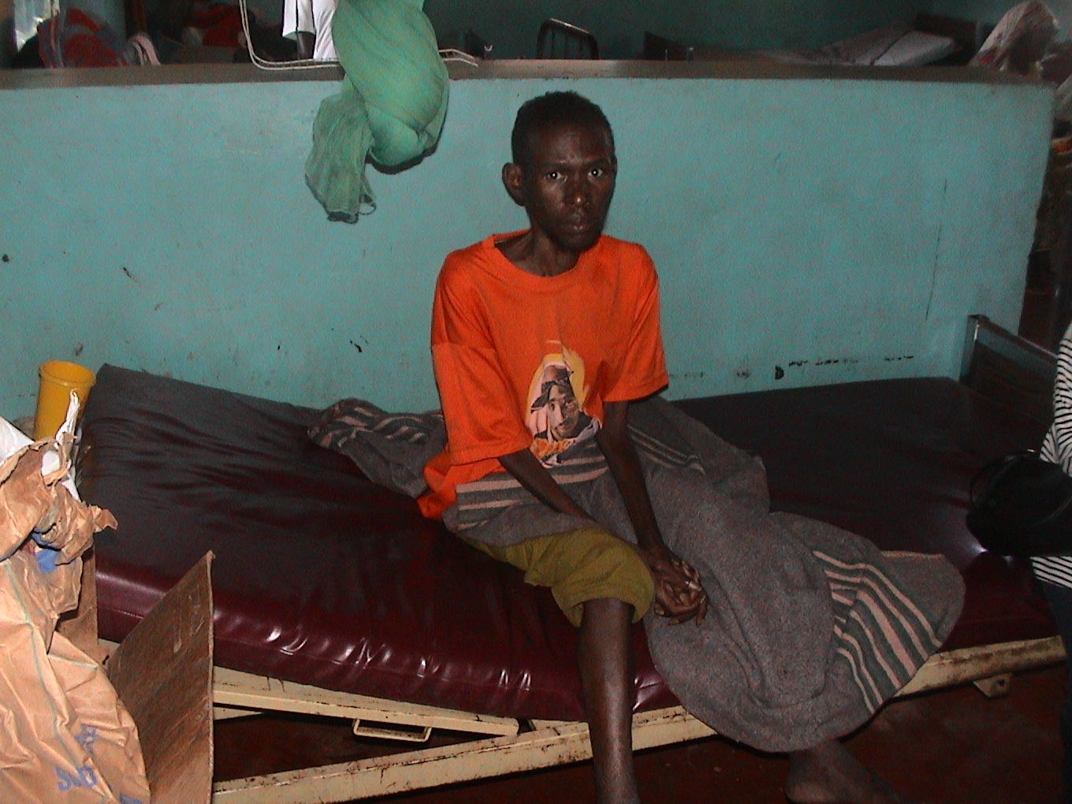
- Emergency support to bedridden PLWHA: community volunteers have been active in identifying and referring to health centers and hospitals bedridden PLWHA in an emergency situation. During this first year, 229 have been facilitated for transport, hospitalization and received food assistance and hygienic kits.
A positive patient facilitated by CARE with hospitalization

- Selection, training, equipment and motivation of community volunteers: community volunteers are key actors in CARE’s home based care model. 47 CV have been identified and trained to deliver HBC services and monitor adherence of PLWHA under ART. They received HBC kits with basic hygienic equipments as well as motivating equipments such as bicycles, raincoats, boots etc. As explained above, they do receive ongoing support by case managers.

- Health insurance scheme access facilitation: 333 vulnerable PLWHA have been financially facilitated to access health insurance scheme. A total of 1278 households members have been benefiting from that support.

3.2. VCT facilitation for the CBO members

With the end of the first year, a total of 2037 CBO members who were sensitized to attend VCT services either directly by SCORE AIDS staff or peer educators, were tested. 178 or 8.7 % were found HIV + and have been referred to ART and prophylactic treatment. So far 45 clients have done their CD4 count test to find out whether they are eligible or not to start ART.

3.3. Economic security initiatives: microfinance and IGAs:

139 PLWA associations’ members have been trained as TOT on CARE savings and loans methodology “CLASSE Intambwe”. They are now capable of designing and implementing income generating activities in their local areas. Ever since Intambwe methodology was initiated, 18 PLWA associations comprising 37 small groups developed new initiatives related to savings and loans schemes. Follow-up is regularly provided by SCORE/AIDS project staff that, thus, provides technical support to these groups.
At the end of December 2005, consolidated figures within these groups show that a total amount of 1,803,000 Rwandan francs was mobilized as savings, while 989,000 Rwandan francs was distributed as credit to 902 members with an interest rate of 10% every month.

Group members in saving & loan activity
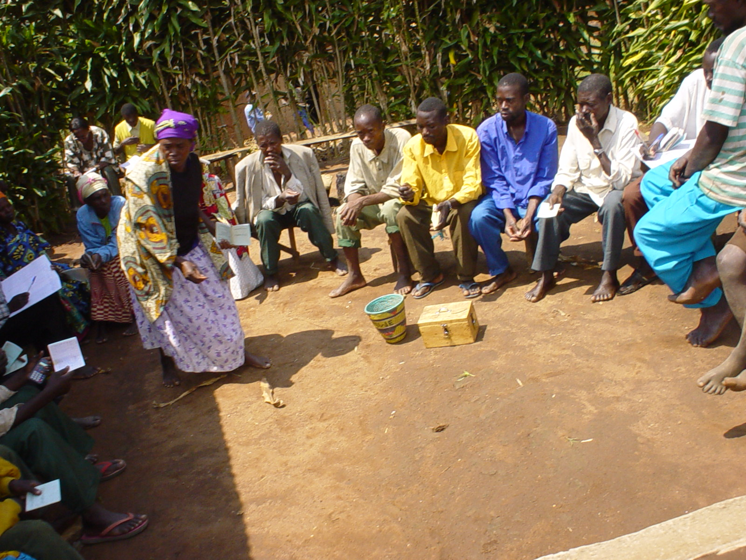
Another characteristic of the Intambwe model worth mentioning, is the inclusion of a solidarity and mutual support fund. This fund is made of contributions given by association members and is different from the savings and loans fund. The solidarity and mutual support funds is typically social and its role is to assist any member who necessitates to be supported. Using this fund depends on the type of social cases as presented by needy members and approved by the association leaders. Such cases relate mostly to funeral of a member, social visits and supporting a sick member, school fees advance for children, etc. Another advantage related to this fund is that no interests are requested on advances it consents to the beneficiary. As of December 2005, a total amount of 318,000 Rwandan francs was collected within the social funds of the SCORE covered associations of PLWHA.

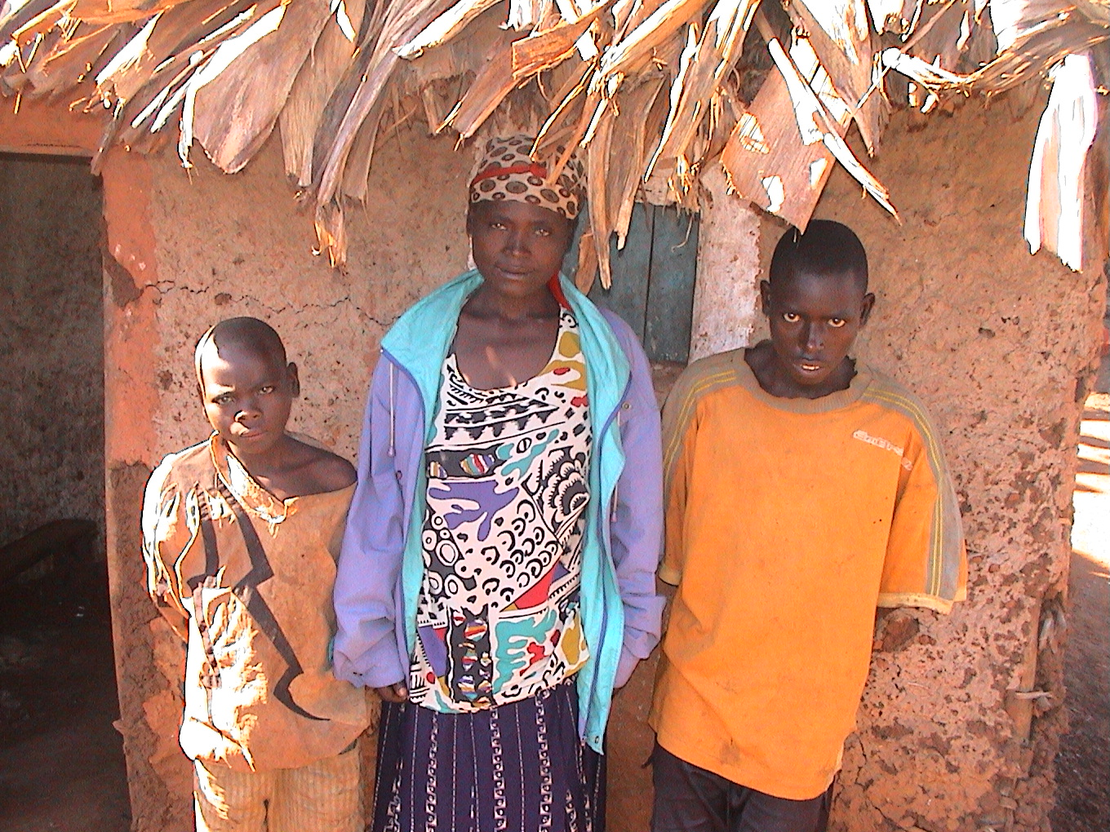
The main challenge remains the lower economic capacities of communities and PLWHA members to generate income so to be able to contribute the saving-and-loan and solidarity funds. Yet, the average weekly contribution is 100 Rwf for saving and 50 Rwf for solidarity fund for each member. This is also due to the fact that most PLWHA join associations when already ill and use their low income more in drugs than in savings. Their productive capacity is therefore reduced.
Olive Kabatesi with her two boys live under unprotected shelter

In that regard, the project has facilitated selection of IGAs to be funded by SCORE AIDS. At the end of December, 14 IGAs were selected for an amount of ~ 15,000 USD. Sub grants contracts have been signed and disbursement of funds are planned to start in January.
VI. Consolidated achievements per quarter with data segregated by sex. M: male F: Female T: Total

Activity |  | Achievements |  |  | Indicators |  | Quart 1: Oct-Dec 04 |  |  |  |  |  |  |  |  |  | Quart 2: Jan – Mar 05 |  |  |  |  |  |  |  | Quart 3: Apr-Jun 05 |  |  |  |  |  |  |  |  | Quart 4: Jul-Sep 05 |  |  |  |  |  |  |  |  |  |  | Quart 5: Oct-Dec 05 |  |  |  |  |  |  |  |  |  | Annual results
 |  |  |  |  |  |  | F |  |  | M |  |  | T |  |  |  | F |  | M |  |  | T |  |  | F |  |  | M |  |  | T |  |  | F |  |  |  | M |  |  | T |  |  | F |  |  |  | M |  |  | T |  |  | F |  |  | M |  |  | T
Objective 1: “Raise awareness on HIV-AIDS and its consequences to enable the communities to take positive steps for reducing its incidence and impact”

1.1. Joint planning & coordination meetings with local authorities, health services officials and beneficiaries representatives |  | Local authorities and communities participated in project launching meetings and joint planning. An advisory committee has been put in place. |  |  | # of local authorities participating in the joint planning and advisory committee |  | 6 |  |  | 10 |  |  | 16 |  |  | 5 |  |  | 3 |  |  | 8 |  |  | 2 |  |  | 5 |  |  | 7 |  |  | - |  |  |  | - |  |  | - |  |  | - |  |  |  | - |  |  | - |  |  | 11 |  |  | 18 |  |  | 29
1.2. Conduct a baseline in the four districts of Umutara |  | The baseline has been conducted, though without satisfaction. It has been covered by USG funds. |  |  | Survey completed, report available
1.3. Identification and selection of PLWA associations |  | The project is now supporting 18 PLWA associations with 955 members. |  |  | # PLWA associations selected |  |  |  |  |  |  |  | 11 |  |  |  |  |  |  |  |  | 6 |  |  |  |  |  |  |  |  | 1 |  |  |  |  |  |  |  |  |  | - |  |  |  |  |  |  |  |  |  | - |  |  |  |  |  |  |  |  | 18
 |  |  |  |  | # members |  |  |  |  |  |  |  |  |  |  |  |  |  |  |  |  |  |  |  |  |  |  |  |  |  |  |  |  |  |  |  |  |  |  |  |  |  |  |  |  |  |  |  |  |  |  |  |  | 594 |  |  | 361 |  |  | 955
1.4. Selection of CBOs |  | 10 Intergroupements gathering 262 CBOs with a total of 4578 members where 4248 are female and 330 male |  |  | # of CBO members |  |  |  |  |  |  |  |  |  |  |  |  |  |  |  |  |  |  |  |  |  |  |  |  |  |  |  |  |  |  |  |  |  |  |  |  |  |  |  |  |  |  |  |  |  |  |  |  | 4248 |  |  | 330 |  |  | 4578
1.5. HIV/AIDS prevention & VCT IEC sessions |  | 2,275 CBO members reached by prevention & VCT IEC sessions |  |  | # of CBO members sensitized |  | - |  |  | - |  |  | - |  |  | - |  |  | - |  |  | - |  |  | 52 |  |  | 16 |  |  | 68 |  |  | 552 |  |  |  | 122 |  |  | 674 |  |  | 1378 |  |  |  | 155 |  |  | 1533 |  |  | 1982 |  |  | 293 |  |  | 2275
1.6. Training and motivation of peer educators |  | 144 Peer educators trained to continue prevention activities within the 10 Intergroupements and 262 CBOs. Motivation kits were distributed. |  |  | # of peer educators trained and motivated |  | - |  |  | - |  |  | - |  |  | - |  |  | - |  |  | - |  |  | 87 |  |  | 27 |  |  | 114 |  |  | 16 |  |  |  | 14 |  |  | 30 |  |  | - |  |  |  | - |  |  | - |  |  | 103 |  |  | 41 |  |  | 144
Objective 2 : “ Enhance communities’ capacities to analyze the underlying causes of HIV/AIDS and how they are affected in order to develop effective, community driven responses”

2.1. Facilitate and support local communities to conduct HIV/AIDS vulnerability mapping and response planning |  | 4 sessions of 3 days each for HIV/AIDS community vulnerability mapping (one for each District) have been conducted in December 2004 and January 2005. A total of 262 community representatives and opinion leaders (65 in Kahi, 70 in Kabare, 67 in Bugaragara, and 70 in Um |  |  | # community maps and response plans |  |  |  |  |  |  |  | 2 |  |  |  |  |  |  |  |  | 2 |  |  |  |  |  |  |  |  |  |  |  |  |  |  |  |  |  |  |  |  |  |  |  |  |  |  |  |  |  |  |  |  |  |  |  |  |  | 4
 |  |  |  |  | # participants in community mapping & response planning |  |  |  |  |  |  |  | 140 |  |  |  |  |  |  |  |  | 137 |  |  |  |  |  |  |  |  |  |  |  |  |  |  |  |  |  |  |  |  |  |  |  |  |  |  |  |  |  |  |  |  |  |  |  |  |  | 277
Objective 3 : “ Operationalize and strengthen community HIV/AIDS response plans to provide protection and access & adherence to ARVs through solidarity networks and build on local partnerships for sustained interaction and support”

3.1. IEC on HIV/AIDS and ARV literacy trainings to PLWHA and family members / care takers |  | IEC to 1369 PLWHA and family members |  |  | # of PLWHA reached by IEC |  |  |  |  |  |  |  |  |  |  |  | 219 |  |  | 133 |  |  | 352 |  | - |  |  | - |  |  | - |  |  |  | 217 |  |  | 172 |  |  | 389 |  |  | 511 |  |  |  | 117 |  |  | 628 |  |  |  | 947 |  | 422 |  |  | 1369
 |  | ARV literacy to 802 PLWHA and care takers |  |  | # of PLWHA reached by ARV literacy sessions | - |  |  |  |  | - |  |  | - |  |  | - |  |  | - |  |  | - |  | - |  |  | - |  |  | - |  |  |  | - |  |  | - |  |  | - |  |  | - |  |  |  | - |  |  | - |  |  |  | 506 |  | 296 |  |  | 802
3.2. CD4 count test facilitation to PLWHA |  | 834 PLWHA were facilitated for CD4 count test |  |  | # of PLWHA facilitated |  |  |  |  |  |  |  |  |  |  |  | 32 |  |  | 15 |  |  | 47 |  | 59 |  |  | 58 |  |  | 117 |  |  |  | 69 |  |  | 58 |  |  | 127 |  |  | 369 |  |  |  | 174 |  |  | 543 |  |  |  | 529 |  | 305 |  |  | 834
3.3. ART referral for eligible patients |  | 397 PLWHA were referred for ART enrollment |  |  | # of referred PLWHA |  |  |  |  |  |  |  |  |  |  |  |  |  |  |  |  |  |  |  |  |  |  |  |  |  |  |  |  |  |  |  |  |  |  |  |  |  |  |  |  |  |  |  |  |  |  |  |  |  | 273 |  | 124 |  |  | 397
3.4. Emergency support to bedridden PLWHA by providing transportation, hospitalization support, nutrition and HBC kits. | 121 received emergency food support |  | # of bedridden PLWHA supported with food assistance |  |  |  |  |  |  |  |  |  |  |  |  |  |  |  |  |  |  |  |  |  |  |  |  |  |  |  |  |  |  |  |  |  |  |  |  |  |  |  | 85 |  |  |  | 36 |  |  | 121 |  |  | 85 |  |  | 36 |  |  | 121
 | 299 were supported through OI treatment and hospitalization |  | # of bedridden assisted with hospitalization |  |  |  |  |  |  |  |  |  |  |  |  |  |  |  |  |  |  |  |  |  |  |  |  |  |  |  |  |  |  |  |  |  |  |  |  |  |  |  | 159 |  |  |  | 140 |  |  | 299 |  |  | 159 |  |  | 140 |  |  | 299
3.5. Selection, training and HBC kits provision to community volunteers |  | 47 community volunteers trained and equipped |  | # community volunteers trained |  |  |  |  |  |  |  |  |  |  |  |  |  |  |  |  |  |  |  | 29 |  | 18 |  |  | 47 |  |  |  |  |  |  |  |  |  |  |  |  |  |  |  |  |  |  |  |  |  |  | 29 |  |  |  | 18 |  | 47
3.6. Support for Health insurance scheme (mutuelles de santé) |  | 333 households with 1228 family members have been supported |  | # households supported with mutuelles de santé |  |  |  |  |  |  |  |  |  |  | 224 |  |  | 109 |  |  | 333 |  |  |  |  |  |  |  |  |  |  |  |  |  |  |  |  |  |  |  |  |  |  |  |  |  |  |  |  |  |  | 224 |  |  |  | 109 |  | 333
3.7. VCT facilitation and follow up on HIV + |  | 2037 CBOs members (44.5%) have been facilitated to attend VCT services, among whom 178 (8.7%) were found positive. 45 have been facilitated for CD4 count test. |  | # VCT clients facilitated |  |  |  |  |  |  |  |  |  |  | 424 |  |  | 142 |  |  | 566 |  |  | 719 |  | 158 |  |  | 877 |  |  | 100 |  |  |  | 8 |  |  | 108 |  |  | 455 |  |  |  | 31 |  |  | 486 |  |  | 1698 |  |  |  | 339 |  | 2037
 |  |  |  | # HIV tested positive |  |  |  |  |  |  |  |  |  |  |  |  |  |  |  |  |  |  |  |  |  |  |  |  |  |  |  | 112 |  |  |  | 32 |  |  | 144 |  |  | 32 |  |  |  | 2 |  |  | 34 |  |  | 144 |  |  |  | 34 |  | 178
 |  |  |  | # of new HIV+ facilitated for CD4 count test |  |  |  |  |  |  |  |  |  |  |  |  |  |  |  |  |  |  |  |  |  |  |  |  |  |  |  | 38 |  |  |  | 7 |  |  | 45 |  |  |  |  |  |  |  |  |  |  |  |  | 38 |  |  |  | 7 |  | 45
3.8. Integrate microfinance (CLASSE Intambwe model into PLWHA associations and support IGAs. |  | 18 PLWHA associations restructured into 37 small groups, 139 PLWHA trained in CLASSE Intambwe methodology and received CLASSE kits. Intanbwe operational. |  | # PLWHA involved in savings and loans activities |  |  |  |  |  |  |  |  |  |  |  |  |  |  |  |  |  |  |  | 393 |  | 31 |  |  | 424 |  |  | 362 |  |  |  | 25 |  |  | 387 |  |  | 71 |  |  |  | 20 |  |  | 91 |  |  | 826 |  |  |  | 76 |  | 902
 |  |  |  | Savings mobilized (x1000 Rwf) |  |  |  |  |  |  |  |  |  |  |  |  |  |  |  |  |  |  |  |  |  |  |  |  | 72 |  |  |  |  |  |  |  |  |  | 787 |  |  |  |  |  |  |  |  |  | 944 |  |  |  |  |  |  |  |  | 1,803
 |  |  |  | Loans distributed (X1000 Rwf) |  |  |  |  |  |  |  |  |  |  |  |  |  |  |  |  |  |  |  |  |  |  |  |  |  |  |  |  |  |  |  |  |  |  | 334 |  |  |  |  |  |  |  |  |  | 655 |  |  |  |  |  |  |  |  | 989
 |  |  |  | Solidarity funds mobilized |  |  |  |  |  |  |  |  |  |  |  |  |  |  |  |  |  |  |  |  |  |  |  |  |  |  |  |  |  |  |  |  |  |  | 105 |  |  |  |  |  |  |  |  |  | 213 |  |  |  |  |  |  |  |  | 318
 |  |  |  | # small savings and loans groups |  |  |  |  |  |  |  |  |  |  |  |  |  |  |  |  |  |  |  |  |  |  |  |  | 11 |  |  |  |  |  |  |  |  |  | 22 |  |  |  |  |  |  |  |  |  | 4 |  |  |  |  |  |  |  |  | 37
 |  |  |  | # PLWHA trained in CLASSE Intambwe |  |  |  |  |  |  |  |  |  |  | 14 |  |  | 14 |  |  | 28 |  |  | 21 |  | 21 |  |  | 42 |  |  | 34 |  |  |  | 35 |  |  | 69 |  |  |  |  |  |  |  |  |  |  |  |  | 69 |  |  |  | 70 |  | 139

VII. Challenges and Lessons learned

- People affected and infected by HIV/AIDS in the context of Rwanda do face multiple and complex livelihoods needs, especially those who are already impoverished and vulnerable living in remote areas without any access to health care and live in a chronic economic and food insecurity.

In such conditions, a holistic approach and comprehensive package of services has shown its merits, joining access to health care services and socio economic development with a special attention to the critical needs of PLWHA including spiritual and psychosocial counseling, advocacy & legal aid, food assistance etc.

- In the same context of high demands, a single project seemed to be a “drop in the ocean”. Coordination and synergies with other stakeholders in order to cumulate resources and join efforts should be unconditional.

- The fact that CARE has mobilized funds from various donors in the same zone (IFAD, MAP/WB, USG/PEPFAR, private donors) has benefited to SCORE AIDS in the perspective to use efficiently available resources and deliver a set of comprehensive package to beneficiaries. This has been at the same time a challenge to manage such portfolio by charging different expenses adequately and remaining accountable vis-à-vis each donor. This is also true for monitoring and reporting, sticking to each donor’s indicators and avoiding “double counting”.

- By targeting the same beneficiaries for CLASSE-B (community based microfinance and IGA activities), by introducing HIV-AIDS prevention and ART component, SCORE AIDS has shown a model of mainstreaming HIV-AIDS interventions in classic development programs, for the simple reason that no sustainability in such development programs without taking HIV/AIDS into account.

- It has not been possible to disburse the IGA sub grants during the first year, due to the fact that the PLWHA associations who should benefit from those funds were not ready to manage them. Many have been established to benefit from various assistance with a dependency mind. It took time to prepare them, introduce the mutual savings & loans methodology, trainings in selection, planning and management of IGAs etc. Also, the social fund bearers a high potential for sustainability, where PLWHA themselves would pay for their basic health care such as health insurance, transport fees to attend ART sessions etc.

- Many PLWHA join associations at a later stage of the illness, in a non productive status. This situation has been a major constraint for the development of socioeconomic initiatives. The project has invested in VCT campaigns and mechanisms have been put in place to refer all HIV tested positive either to PLWHA associations and enroll ART program (by testing one’s CD4 count first) while asymptomatic. This is the only way to remain productive; caring after one’s family and live positively with the infection as long as possible.

- The project has started by dealing and trying to respond to many demands from beneficiaries. Less efforts and time have been invested in liaison with other IFAD funded project in Umutara which are UCRIDP and PPPMER. This will be a priority in the next year.

- As internal challenge, CARE’s HIV-AIDS program has experienced a high rate of turn over among its staff and has even gone through a restructuring due to the diminution of the USG-PEPFAR funding. This has affected SCORE AIDS in a sense that it is integrated in the overall CARE’s HIV-AIDS program, rather than a stand alone project. The SCORE AIDS project manager has been appointed at the country office level as “acting HIV/AIDS sector coordinator” during 4 months from July 05 to October 05, before definitively being appointed as “HIV-AIDS Deputy Program manager” starting with Dec 05. Meantime, despite that interim arrangements have been put in place, that situation has resulted in a delay of preparation and submission of regular quarterly progress reports and the second AWPB on time as agreed in the grant agreement between CARE and IFAD. Starting with January 06, a full time project manager has now been appointed for SCORE AIDS.

- As other internal constraint to mention has been for the field staff the lack of motorbike driving permit which has resulted in hiring temporary motorbike drivers, increasing operational costs. Also, SCORE AIDS has supported CLASSE-B project by providing vehicle fuel as this project didn’t have that line item, resulting in high consumptions of fuel compared to planned budget for that line item.

VIII. Project Performance appreciation ~ Geoffrey success story

A human success story—Geoffrey restored hope to live

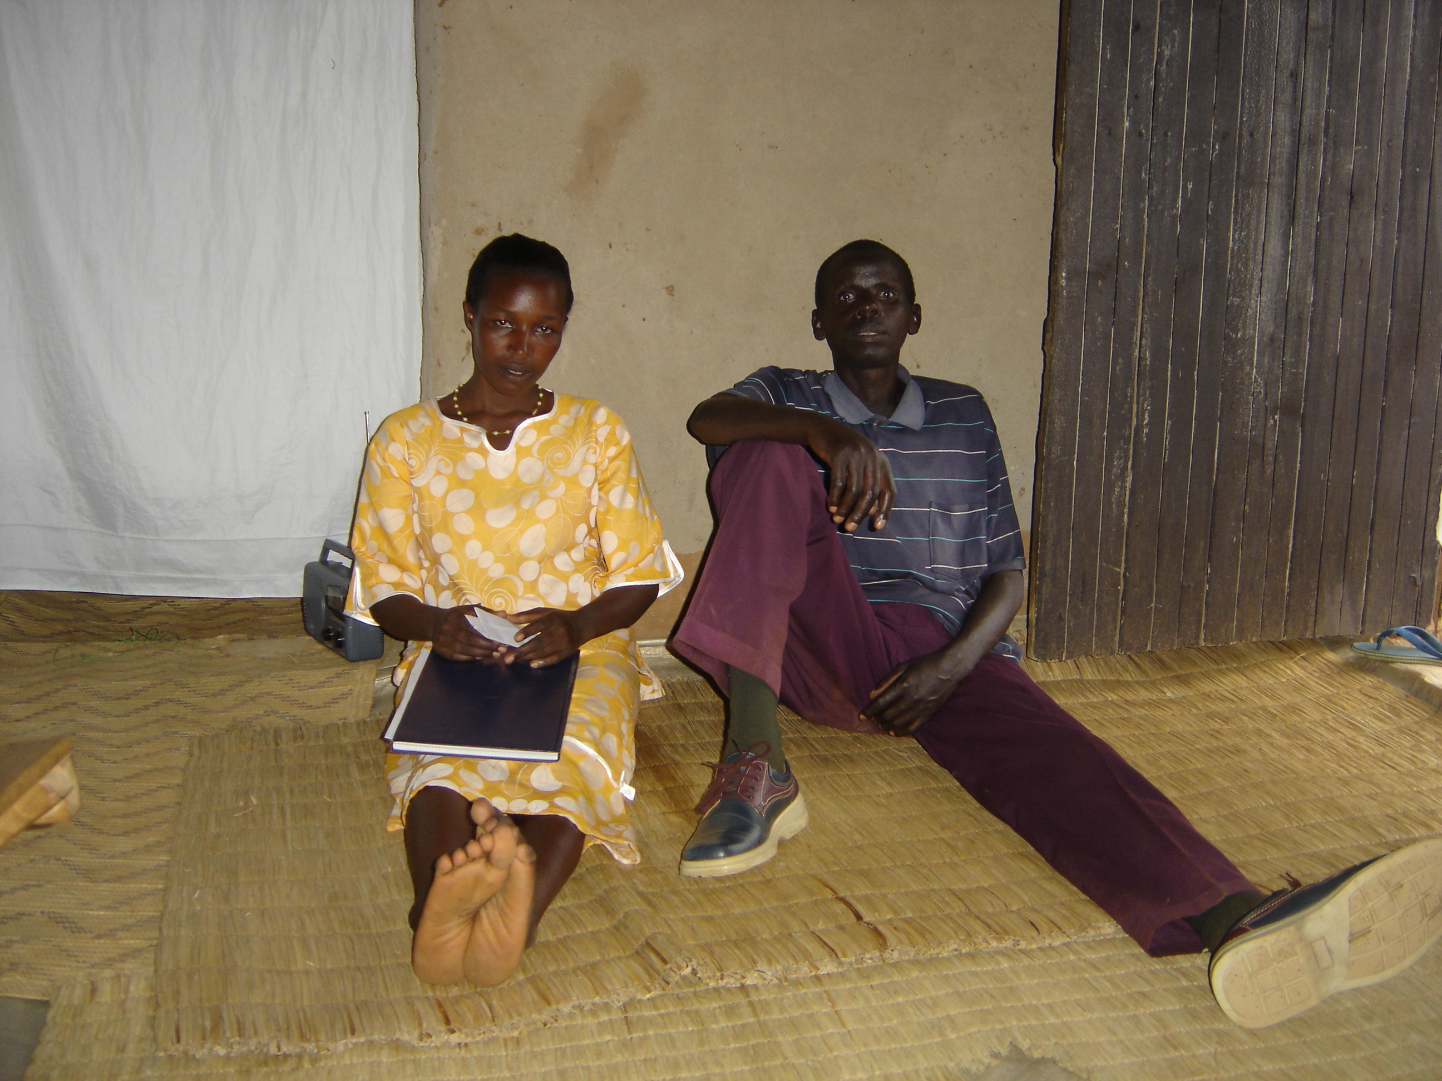
October 2005: Rwempasha sector – Umutara province/Rwanda
Jacqueline and Geoffrey, her husband in their house

Geoffrey Mbaraga and Jacqueline Mukanyemazi make a young married couple and know that they live both with HIV since 1999. They delivered three children who all died. To earn their family life, they are farmers. Jacqueline heads the ‘Kwisungana’ PLWHA association that draws together 39 people and of which her husband Geoffrey is a member. The association was funded in a bid to escape their isolation; “People discriminated themselves as they found it too hard to travel to Nyagatare town where we, only, could find treatment, and later on we decided to found a 5 people association”, claimed Jacqueline.

Subsequent to sensitization campaigns conducted within the SCORE-AIDS project, more associations were created in that displaced area and Jacqueline hosted new members and access to health care was no more a big issue. Meantime her husband felt ill until nearly dead. Laboratory tests showed that he had remained with only 0.8 CD4 and weighted only 24 kgs. The project supported him during ARV adherence process: VCT, CD4 related tests, ARV literacy, transportation, trained his care giver on HBC, nutritional and food support, HBC hygienic kits, psychosocial support through trained community volunteers, community health insurance subscription, etc. Six months later, Geoffrey scaled up his CD4 to 24 and weighted 54 kgs. Since then, he regenerated appetite and physics “… I gradually augmented”, said Geoffrey.

Members of this association were trained and adhered on CARE CLASS Intambwe (Loan and saving) system to strengthen their own driven projects. Today, they contribute every week to form a starting phase fund, while their designed small projects are in process of being funded by a CARE driven community credit fund and expectations are more fruitful to beneficiaries, “…my hair cut salon project will have to prosper as I have now known hints to manage money in a profitable way”, whispered Jacqueline, the president of Kwisungana association.
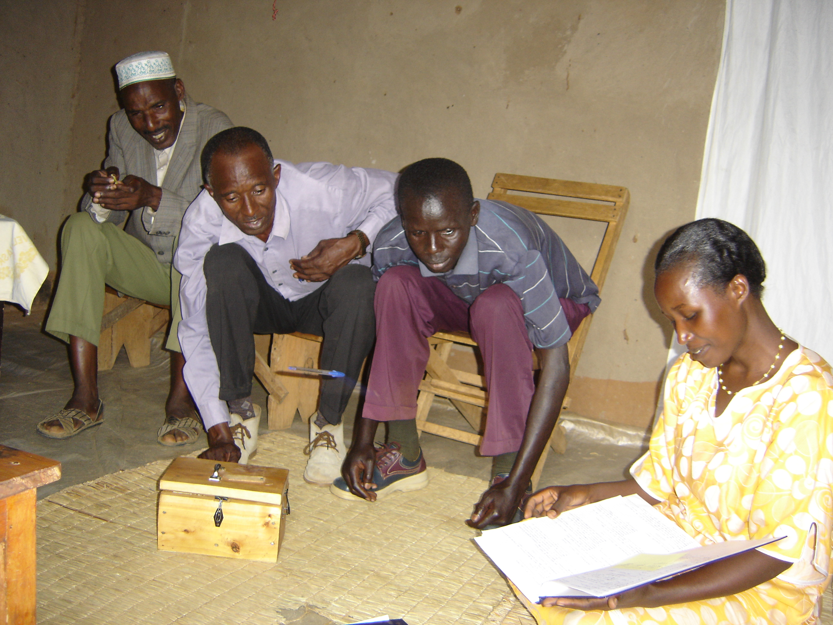
Hamad, Enock (both community volunteers) with the couple review their savings and loan fund bank account
Economic security strengthening seems to be more vital for their wellbeing; “they taught us how to save and loan… that’s the most important thing I am proud of”, précised Jacqueline. This component also enabled many to be accepted in their society: “… for instance, children among their classmates are facing menaces while many other known couples do not intend to disclose anything about their status as they fear to be excluded.. said Hamad Kamanzi, a community volunteer,... but as CARE supports our patients to build themselves, people get more familiar us.”
HIV/AIDS awareness was a key factor to this since many of this association believe that the acquired adequate knowledge about HIV/AIDS transmission to lead them to cooperate with PLWHA and do not fear to get infected by simply approaching them any more.

According to the association, more sensitization campaigns are required to attract a larger audience: “we would rather call for CARE officials to assist us in shouting and speaking out… by doing so, they would probably hear and change their attitudes, while HIV is withdrawing our people”, insisted Enock Ruyenzi, a community volunteer.

At the moment, Geoffrey is physically uplifted and slowly gets on his routine duties: “I am very thankful to God who brought these projects… I would not belong to this world any more if associations did not exist.” disclosed Geoffrey with honor.

IX. Conclusions and perspective for the second year

During this reporting period, which is the first year, several activities have been initiated and implemented according to the first annual plan towards achieving expected results and reaching objectives.

Most of the expected results have been met even expanded, unless the target for VCT due to lack of capacity on VCT service delivery side, disbursement of IGA funds due to long preparation period before the disbursement of funds itself and the linkages between SCORE AIDS and UCRIDP & PPPMER, as most time, energy and resources were dedicated to respond to a high demand to deliver services to beneficiaries.

Most of these activities will be continued during the following year. Challenges encountered and lessons learnt will guide the preparation of the second AWPB, taking into account the feedback and recommendations from beneficiaries, partners and local authorities, but also recommendations from outside by the IFAD evaluation mission and UNOPS supervision mission.

The main challenge will be about the adaptation to the new territorial reform as new institutions are being established and that will require new efforts to develop partnerships, update community response plans and integrate SCORE AIDS interventions in the new districts development plans.

A special emphasis will be put on the development of linkages between SCORE AIDS and other IFAD-funded projects in the Eastern Province to ensure sustainability and also documentation and sharing of experiences in linking HIV/AIDS and community based microfinance.
SCHEDULE 5
STATEMENT OF EXPENDITURES FORM
CARE INTERNATIONAL
(Support of Strengthening Community Organized Responses to HIV/AIDS in Umutara)
GRANT NO. SUPPL - DE -02 - CARE INTL
Statement of Expenditures
for the Reporting Period from September 04 to December 05
in USD (Currency)
Category | Cumulative Expenditures up to the Beginning of the Reporting Period | Expenditures During the Reporting Period
 | - | September 04 to December 05
I. Project personnel |  | € 81,798.56
II. Equipment |  | € 37,924.62
III. Office and running costs |  | € 34,131
IV. Capacity building, Health Services |  | € 45,831.15
V. Community sub-grants |  | -
VI. Travel |  | € 7,767.44
VI. Auditing |  | -
Total | - | € 207,452.77
We hereby certify that the above amounts have been paid for the proper execution of the project in accordance with the terms and conditions of the Grant Agreement dated 11 August 2004. All documentation authenticating these expenditures has been retained by CARE INTERNATIONAL and shall be made available for examination in the course of the annual audit of Programme accounts and the periodic review by visiting missions of the Fund.
 | Certified by: Philip Christensen
 | Country Director

? David Cownie: Managing Director of SIAPAC Namibia (Social Impact Assessment and Policy Analysis Corporation)
The case management model is explained in details in the following pages.

